AKN4EU GuidelineS and modelling

History
Version 4.2 | - Complete the PART 1 – 0 Scope accordingly  - Replace “AN4EU_ZIP” by “AKN4EU_LEG"  - Council acts and proposals (WP 6.1.1)  - Add a new section PART 1 – 1.1.5 The act attached to another act  - Correction: PART 1 – 1.1.3.2 : info on attribute @href added.  - Code for multilingual document (WP 6.3.4)  - Modification of PART 1 – 9.2.7 (<FRBRlanguage>) and PART 1 – 9.2.8 (<FRBRtranslation>)  - PART 1 – 1.2.3.1 regarding the language code in the filename  - PART 1 – 9.3 regarding the @showAs of <TLCReference name=”language”>  - Soft page break (WP 6.3.3)  - New section PART 1 – 7.7 Inline and marker elements for rendering  - PART 1 – 7.7.1 Soft page break  It cannot be inside <table>  - In the same occasion, add a PART 1 – 7.7.2 (soft line break) and a PART 1 – 7.7.3 other elements for rendering  - Table of Content (WP 6.2.5)  - New section PART 1 – 7.6 Table of content  - New section PART 1 – 1.1.4 The Table of annexes  - Modify PART 1 – 4 AKN4EU file: the mark-up for <preface> and PART 1 – 5 AKN4EU file: the mark-up for <coverPage>  - ANNEX 3 ELI naming convention: introduce the code for the subdivision “Table of content”  - Scientific Objects (WP 6.2.1 - 6.2.3)  - PART 1 – 2.3.3 The low-level structure  Add low-level structure for figure, table, scientific formula  PART 1 – 2.3.3.2.2 Modification of the structure of “point” to allow the figure, table and scientific formula mark-up inside.  PART 1 – 2.3.3.2.3 Modification of the structure of “indent” to allow the figure, table and scientific formula mark-up inside.  - PART 1 – 2.3.2.3 Modification of the structure of “independent point” to allow the figure, table and scientific formula mark-up inside.  - PART 1 – 2.3.2.2 Modification of the structure of “numbered paragraph” and “unnumbered paragraph” to allow the figure, table and scientific formula mark-up inside.  - PART 1 – 1.2.2 The structure of an AKN4EU zip package:  dedicated files for Scientific Object that are in a specific format or according to a specific XML schema.  - PART 1 – 1.2.3.1 : Naming convention for the files containing Scientific Objects  - New section PART 1 - 2.3.3.3  - PART 1 – 7.2 and PART 1 – 7.3 for the encoding of image and mathematical formula  - ANNEX 3 ELI naming convention: introduce the code for the subdivision “table”, “figure”, “image”, “scientific formula”, “legend” and “line of legend”  - Content model  - PART 1 – 2.3.1 Modify the structure of High level structures to allow independent subjects alone  - Correction  - Update the Annex 3 ELI naming convention  - add a point 2 on ELI-DL information  - add the code “anx” for annex (<doc name=”ANNEX”>)
Version 4.1.1 Errata
Version 4.1.1 | - New numbering of the sections of the specification, to include the PART number.  - Add a section PART 1 – 11 Linguistic variants and synoptism  - Add a section PART 1 – 7.5 Syntax for the @xml:id attribute  - Add a section PART 1 – 2.3.3.2.5 Special list: the “check” structure  - Modification of the section PART 1 – 0 Scope.  - Remove the “_” as first character of @xml:id everywhere  - Remove the alternative syntax for @xml:id (with or without “_” as start character)  - Modify in the examples, the syntax of @xml:id according to the new specification  - In PART 1 – 0 Scope, add the paragraph explaining that, to have clearer examples in the specification, the @xml:id is not always present even if every element that is not in <meta> MUST have an @xml:id attribute.  - Correction  - In PART 1 – 9.3, add <TLCReference name="procedureReference"> as an exception to the general rule for the value of @href and @showAs  - PART 1 – 1.2.1 Introduction, correct the sentences related to the structure of the section 1.2

Table of content
PART 1. AKN4EU GuidelineS and modelling 1
PART 1 - 0 Scope 7
PART 1 - 1 The AKN4EU_LEG package: a model for documents, components, annexes 9
PART 1 - 1.1 Documents and components 9
PART 1 - 1.1.1 Introduction 9
PART 1 - 1.1.2 The AKN4EU approach 10
PART 1 - 1.1.3 The annex of a document 12
PART 1 - 1.1.4 The Table of annexes 13
PART 1 - 1.1.5 The act attached to another act 15
PART 1 - 1.2 The AKN4EU_LEG package and the AKN4EU file naming convention 16
PART 1 - 1.2.1 Introduction 16
PART 1 - 1.2.2 The structure of an AKN4EU zip package 17
PART 1 - 1.2.3 The naming convention for AKN4EU_LEG file, AKN4EU file and other resource file 19
PART 1 - 2 The AKN4EU file: the mark-up for <body> and <mainBody> 31
PART 1 - 2.1 Introduction: the Akoma Ntoso families of elements for the <body>/<mainBody> 31
PART 1 - 2.2 The AKN4EU principles 32
PART 1 - 2.2.1 First principle: use of the hierarchical family of elements 32
PART 1 - 2.2.2 Second principle: restriction on the hierarchical structure 32
PART 1 - 2.2.3 Third principle: specialization of the hierarchical elements 32
PART 1 - 2.3 The AKN4EU content model 33
PART 1 - 2.3.1 The high level structures 34
PART 1 - 2.3.2 The core structure 38
PART 1 - 2.3.3 The low level structures 43
PART 1 - 2.3.4 The element <content> 56
PART 1 - 2.3.5 The independent subject 57
PART 1 - 3 AKN4EU file: the mark-up for <preamble> 59
PART 1 - 4 AKN4EU file: the mark-up for <preface> and <longTitle> 61
PART 1 - 5 AKN4EU file: the mark-up for <coverPage> 63
PART 1 - 6 AKN4EU file: the mark-up of the ‘notes’ 66
PART 1 - 7 AKN4EU file: the mark-up in the textual content 67
PART 1 - 7.1 AKN4EU representation of tables 67
PART 1 - 7.1.1 Akoma Ntoso mark-up 67
PART 1 - 7.1.2 AKN4EU structure in cell 69
PART 1 - 7.2 The mark-up for images 70
PART 1 - 7.2.1 The encoding of an image 70
PART 1 - 7.2.2 The <img> element 71
PART 1 - 7.3 The mark-up for mathematical formula 71
PART 1 - 7.3.1 The encoding of the scientific formula itself 71
PART 1 - 7.3.2 The <img> element 71
PART 1 - 7.4 Local reference 72
PART 1 - 7.4.1 Akoma Ntoso naming convention 72
PART 1 - 7.4.2 AKN4EU 72
PART 1 - 7.5 The syntax for the @xml:id in content 73
PART 1 - 7.5.1 Introduction 73
PART 1 - 7.5.2 Syntax of @xml:id 73
PART 1 - 7.5.3 @xml:id and linguistic variants 73
PART 1 - 7.5.4 Example 74
PART 1 - 7.6 Table of content 75
PART 1 - 7.7 Inline and marker elements for rendering 77
PART 1 - 7.7.1 Soft page break 77
PART 1 - 7.7.2 Soft line break 77
PART 1 - 7.7.3 Other elements for rendering 77
PART 1 - 8 AKN4EU file: the character set specification 79
PART 1 - 9 The AKN4EU metadata 80
PART 1 - 9.1 Attribute @source for the section of the metadata 80
PART 1 - 9.2 The <identification> section of the metadata 80
PART 1 - 9.2.1 FRBRWork/preservation 80
PART 1 - 9.2.2 FRBRWork/FRBRcountry 81
PART 1 - 9.2.3 FRBRWork/FRBRnumber 81
PART 1 - 9.2.4 FRBRWork/FRBRprescriptive 82
PART 1 - 9.2.5 FRBRExpression/preservation 82
PART 1 - 9.2.6 FRBRExpression/FRBRversionNumber 83
PART 1 - 9.2.7 FRBRExpression/FRBRlanguage 83
PART 1 - 9.2.8 FRBRExpression/FRBRtranslation 84
PART 1 - 9.2.9 FRBRManifestation/preservation 85
PART 1 - 9.3 The <references> section of the metadata 86
PART 1 - 9.4 The <analysis>/<otherReferences> 89
PART 1 - 9.4.1 <implicitReference> 89
PART 1 - 9.4.2 <alternativeReference> 89
PART 1 - 9.5 AKN4EU mandatory metadata 90
PART 1 - 9.5.1 Metadata that MUST be present in any AKN4EU file 90
PART 1 - 9.5.2 Metadata that MUST be present in AKN4EU file as th information is used in the filename of the AKN4EU_LEG package or AKN4EU file 91
PART 1 - 10 Amending acts in AKN4EU 102
PART 1 - 10.1 The organization of the amendments 102
PART 1 - 10.2 The reference to the amended act 103
PART 1 - 10.3 The overall structure of an amendment 103
PART 1 - 10.3.1 The description of the amendment 103
PART 1 - 10.3.2 The 'text of the amendment' 104
PART 1 - 10.4 The amendment of an annex 106
PART 1 - 10.4.1 The addition, insertion or replacement of a complete annex 106
PART 1 - 10.4.2 Modification inside an annex 107
PART 1 - 10.4.3 Deletion of an annex 107
PART 1 - 10.4.4 Special cases 107
PART 1 - 10.5 The AKN4EU mark-up for the amendment 108
PART 1 - 10.5.1 The reference to the amended act 108
PART 1 - 10.5.2 The mark-up of the text of an amendment 110
PART 1 - 10.5.3 The metadata associated to an amendment 112
PART 1 - 10.5.4 Examples: AKN4EU mark-up for amendments 116
PART 1 - 10.5.5 Special cases 122
PART 1 - 10.6 Summary: AKN4EU mark-up for amendments 137
PART 1 - 11 Linguistic variants and synoptism 144
ANNEXES 146
ANNEX 1. AKN4EU Characters set 147
ANNEX 2. Some Akoma Ntoso background 149
1 The Akoma Ntoso document types 149
2 The Akoma Ntoso parts of document 149
3 The Akoma Ntoso categories of content model 150
4 The Akoma Ntoso overall structure of metadata 150
ANNEX 3. ELI Naming convention 152
1 URI template for European Union legislation and preparatory acts (draft) 152
2 ELI-DL: URI template for preparatory documents associated to a legislative procedure 152
3 Reference to subdivision in ELI URI templates (!!! draft !!!) 154

Scope
The definition required for AKN4EU is carried out by the Formats subgroup of the Interinstitutional Metadata and Formats Committee (IMFC) on two levels:
- On the business level, the ‘Common Vocabulary’ (CoV) identifies and describes the semantic and logical concepts extracted from examples of the exchanged documents.
- On the technical level, the OASIS standard Akoma Ntoso serves as the basis for the specification of AKN4EU.
Akoma Ntoso is a rather generic standard that is designed to cover a big variety of legal documents, it has to be defined how the semantic and logical concepts that are described by the CoV have to be expressed in Akoma Ntoso. In other words, AKN4EU can be considered as the localisation of Akoma Ntoso for EU legislation.
This documentation explains in depth the general AKN4EU model applicable to every document analyzed, but also re-usable on any further documents. It covers the following subjects:
- The AKN4EU model for documents, components and annexes that is applied to the documents already analyzed and that can be reused for the analysis of any documents in the future;
- The structure and naming convention of the AKN4EU_LEG package and the naming convention of its AKN4EU files;
- Akoma Ntoso defines a common organization the Akoma Ntoso files with standardized sections (<meta>, <coverPage>, <preface>, <preamble>, section for the body of the document (<body>/<mainBody>), <conclusions>, <attachments>). For each content section, this specification details the AKN4EU rules and content model:
  - The AKN4EU content model of the main part of document (<body>, <mainBody>).
This is a unique model that is applicable to any document, legislative or not.
The content model guarantees a full use of the ELI URI for referencing the subdivisions of the document at any level of hierarchy and is fully aligned with the CoV structure;
  - The AKN4EU mark-up of the <preamble>, with a focus on EU acts and International Agreements;
  - The AKN4EU mark-up of the <coverPage> and of the <preface>. This section defines the relationship between these parts of text and the metadata of the document.
- The definition of AKN4EU specific metadata, with a focus on the context of the Ordinary Legislative Procedure;
- The way to mark-up amendments via AKN4EU, especially in Amending acts. This approach is based on the content model defined for the main part of the act.
In the current version, AKN4EU focuses on the documents pertaining to the Ordinary Legislative Procedure (OLP) and represents the intermediate result of the ongoing work of the IMFC’s Formats subgroup. At this stage, it covers the following document types:
- Regulation, Directive, Decision;
- Proposal for a Regulation, Proposal for a Directive, Proposal for a Decision, including the Financial Statement and the Digital and Financial Statement
- Some cases of EP Texts Adopted;
- Council documents including the Position and the Statements of Council reasons.
In addition to these documents and beyond the OLP, the following document types are also defined following the same principles:
- 'International Agreement'; .
- Council acts and proposals for Council acts;
- Council Implementing Decision (with addressees) and Proposal for a Council Implementing Decision
- Joint Proposal for a Council Regulation
- Council internal document with Draft Decision
In addition the following topics are covered:
- Specification for the AKN4EU_LEG package (.leg package) and the naming convention for the files inside;
- Rules for the synoptism between AKN4EU_LEG packages that are linguistic variants of a business document;
- The low level structure for the figure, the mathematical formula and the tables
- The mark-up for a table of content or a table of annexes
- The syntax for the mandatory @xml:id identifier ;
- The accepted character set and recommended font.
- The language code (2-letter and 3-letter) for multilingual document

NB: @xml:id attribute is mandatory since AKN4EU 4.1.1 for elements that is not inside <meta>. However, for the clarity of the examples in the specification, they don’t not follow this general rule: @xml:id only used if it is part of the topic illustrated by the example.

The AKN4EU_LEG package: a model for documents, components, annexes

Documents and components

Introduction
Many documents issued by the EU Institutions share the same structure:
- a cover page providing contextual information on the document,
- one or more components.
For example, when the Commission proposes a new EU act, it produces a document (the “Proposal for an act”, that can be a “Proposal for a Regulation”, a “Proposal for a Directive” or a “Proposal for a Decision”) with the following content:
- a cover page,
- an explanatory memorandum,
- the proposal for an act itself (a bill) – the main part of the document,
- optionally, a legislative financial statement or a legislative digital and financial statement,
Legal Text (Regulation, Directive or Decision)
Legislative Financial Statement
Or
Legislative Digital and Financial Statement
Explanatory Memorandum
Proposal for an Act
Each of these components (Explanatory Memorandum, Legal Text and Legislative Financial Statement/Legislative Digital and Financial Statement) can be seen as subdocuments with their own structure.
So we can consider the Proposal for an act as a collection of components, each with their own AKN document type and their own internal structure.
Similarly, this structure is applicable to the ‘EP Consolidated text’ which marks the Position of the European Parliament regarding the legal text included in the Proposal from the Commission. It represents a new version of this legal text in form of a text consolidating all amendments adopted by the Parliament (with all the changes appropriately marked).
Council documents are also composed of subdocuments to meet the needs of the internal workflow or for dissemination, internally or outside the institution.
Akoma Ntoso is a standard for the mark-up of documents: just after the standard root element <akomaNtoso>, the immediate subelement is a document type element.
Each document type element has a mandatory attribute @name to specify the type of document.
Akoma Ntoso provides different document type elements (<act>, <bill>, <doc>, …)as well as for
a collection of documents (<documentCollection>).
The main content of the <documentCollection> is the <collectionBody>. It is composed of a list of <component> elements, each of which allowing to link to the corresponding subdocument or put the content.

The AKN4EU approach
With these building blocks, AKN4EU defines a structural model for the "official documents" that are disseminated or shared, inside or outside the institution in the context of an internal or an inter-institutional workflow.

Structural model
- An "official document" mut be marked as a <documentCollection>, even if it has only one component.
- The <documentCollection> is a specific AKN4EU file, that serves as the entry point of the AKN4EU representation of an official document.
It always contains the <coverPage> of the Official document.
- Each subdocument MUST be referenced inside the <documentCollection> in a specific <component> element.
- One AKN4EU file MUST contain not more than ONE subdocument content.
Consequently, the <component> element of the <documentCollection> MUST have a <documentRef> element to reference each subdocument.
- Every subdocument can have its own document type (<act>, <bill> and <doc> … or even <documentCollection>),
General rule:
Each XML file MUST contain no more than ONE AkomaNtoso document type element.
The content of any included document MUST be in a specific file.
The inclusion of a document in an official document MUST be represented in AKN4EU by using the <documentRef> element.

The mandatory @showAs attribute of the <documentRef> MUST have the following content:
- If available in the target document, the content of the element <preface>/<longTitle>/<p>/<docStage>/<docType>;
- else, if available in the target document the content of the element <preface>/<longTitle>/<p>/<docType>;
- else, the content of the <preface>/<longTitle> element
For the example of a Proposal for an act, the AKN4EU files must be the following:
Or "Legislative Financial and Digital Statement"

<doc name="STAT_FINANC_LEGIS">
</doc>
<bill name="REG">

</bill>
Or "STAT_DIGIT_FINANC_LEGIS"
<component>
<documentRef href=""
showAs="Legislative Financial Statement">

<doc name="EXPL_MEMORANDUM">
</doc>
<component>
<documentRef href=""
showAs="Regulation of the European
Parliament and of the Council">

<component>
<documentRef href=""
showAs="Explanatory Memorandum">
<documentCollection name="PROP_ACT">
<coverPage>
</coverPage>
<collectionBody>

</collectionBody>

The attribute @name of an Akoma Ntoso document type element
The value of the @name attribute of any Akoma Ntoso document type element MUST be the authority code from the Authority table "resource-type".
For a Regulation, the Akoma Ntoso document type element will be
<act name="REG">
Or
<bill name="REG">
depending if the document is an act published in the Official Journal or an intermediate draft version.

The annex of a document

Introduction
For EU acts, the annexes are defined as following:
‘Annexes in the strict sense are used to present material separately from the body of the enacting terms, because it is voluminous or technical or both. Examples of such material might be rules to be applied by customs officers, doctors or veterinarians (such as chemical analysis techniques, sampling methods and forms to be used), lists of products, tables of figures, plans and drawings, etc.
An annex is by its very nature an integral part of the act, and there is, therefore, no need to state this in the provision referring to the annex.’
In Akoma Ntoso, the content of, or reference to annexes is put in the <attachments> section of a document type element. <attachments> is composed of a list of <attachment> elements, each of these elements can contain the link to, (or the content) of the corresponding annex.

The AKN4EU approach
In AKN4EU, the content of an annex MUST be in a <doc name=”ANNEX”>.
According to the general rule of AKN4EU, the content of each annex is in a specific AKN4EU file.
Each annex MUST be referenced in the master document in an <attachment> element, using a <documentRef> element.
- The @showAs attribute of the <documentRef> in <attachment> MUST comprise the content of the element containing the numbering of the annex (<block name=”num”>) in the <preface> of the corresponding file.
- A mandatory @href attribute containing the path to the file containing the annex;
Adding, for example, an annex to the bill in our Proposal for an act, the schema is the following:

<bill name="REG">
…
<attachments>
<attachment>
<documentRef href=”...” showAs=”ANNEX”/>
</attachment>
</attachements>
</bill>
<component>
<documentRef href="…"
showAs="Regulation of the European
Parliament and of the Council"/>

<documentCollection name="PROP_ACT">
…
<collectionBody>
…

</collectionBody>
<doc name=”ANNEX”>
<preface>
…
<block name="num">ANNEX</block>
…
</doc>

The Table of annexes
Sometimes, when there are a lot of annexes, all the annexes are preceded by a “table of annexes” that list these annexes.
For this content it MUST exist in the master document, a specific <attachment> element.
The <attachment> contains an <interstitial> element containing table of content.
<bill name="REG">
…
<attachments>
<attachment>
<interstitial>
<!-- the table of annexes -->
</interstitial>
</attachment>
<attachment>
<documentRef href=”...” showAs=”ANNEX 1”/>
</attachment>
...
</attachements>
</bill>
<doc name=”ANNEX”>
<preface>
…
<block name="num">ANNEX 1</block>
…
</doc>

The table of content is marked as described in AKN4EU PART 1 - 7.6 Table of content: a <blockContainer> with an optional <heading> following by the <toc> element for the mark-up of the Table of content.
Example:
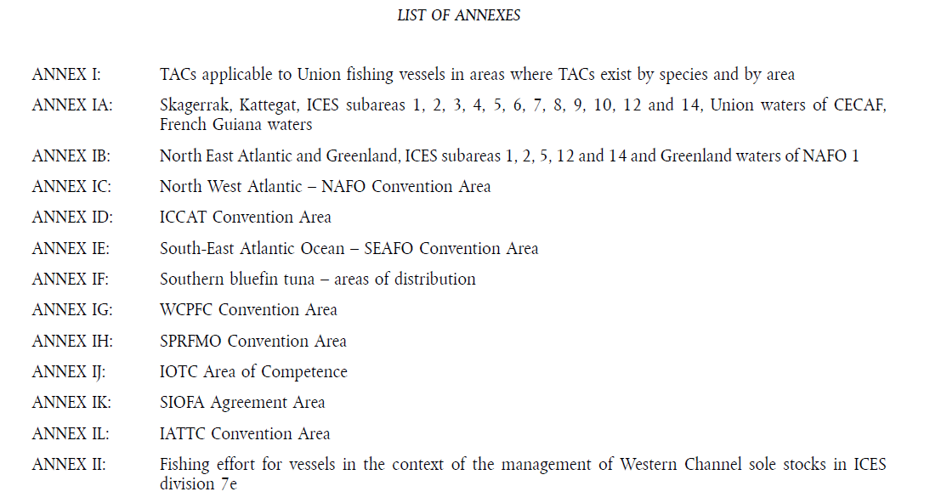
Will be marked as following:
<attachment>
<interstitial>
<blockContainer>
<heading>LIST OF ANNEXES</heading>
<toc>
…<!-- the mark-up of the TOC -->
</toc>
</blockContainer>
</interstitial>
</attachment>

The act attached to another act
An EU act or bill can also have attachment(s) containing other legal acts.
These are “attachments” and not “annexes”.
For each legal act attached to another act, there MUST exist an <attachment> element containing a <documentRef> element eventually preceded by a <num> element.
<bill name="DEC">
<meta>
…
<TLCReference xml:id="ATTACHMENT" name="docType"
href=http://publications.europa.eu/resource/authority/resource-type/ATTACHMENT
showAs="Attachment"/>
…
</meta>
...
<attachments>
<attachment refersTo=”~ATTACHMENT”>
<num>ANNEX</num>
<documentRef href=”...” showAs=”DECISION OF …”/>
</attachment>
...
</attachements>
</bill>
<act name=”DEC”>
<preface>
<longTitle>
<p><doctype>DECISION OF …</docType></p>
</longTitle>
</preface>
…
</doc>

The <attachment> containing an “attachment” has the following characteristics
- In order to differentiate an annex from an attachment, the <attachment> element for “attachment” MUST have an attribute @refersTo pointing to a <TLCReference name=”doctype”> for the ‘ATTACHMENT’ entry of the authority table ‘resource type’ .
- <attachment> CAN have an element <num> if the word “ANNEX” is used in the text to introduce the attachment.
- The <attachment> MUST have a <documentRef> with an @href that references the AKN4EU file with the content of the “attachment”.
The <documentRef> has as attributes:
- A mandatory @href attribute containing the path to the file containing the attachment;
- the content of the <longTitle>/<p>/<doctype> element of the corresponding attachment

The AKN4EU_LEG package and the AKN4EU file naming convention

Introduction
As seen in the previous section, a business document in one linguistic variant is composed of multiple AKN4EU files and resources in other format (ex: image in jpeg, png or svg or scientific formula in MathML); this manifestation is, a package in AKN4EU_LEG format. The properties of this concept are expressed by the file extension ‘.leg’
According to the authority table ‘File type’,
‘AKN4EU ZIP is a ZIP archive containing an AKN4EU manifestation of a document in one linguistic variant issued in the legal decision-making process. It must contain at least an AKN4EU file starting with the prefix ‘main-’, which constitutes the entry point, and may contain other associated files and subfolders.’
This section provides a detailed description of the structure and naming convention that is required for an AKN4EU_LEG package and for AKN4EU files inside. The metadata related to the naming convention are described in the “PART 1 – 9.5.2 Metadata that MUST be present in AKN4EU file as the information is used in the filename of the AKN4EU_LEG package or AKN4EU file”.
Remark
The name of any AKN4EU file must comprise information on its language.
Moreover it is mandatory that for two linguistic variants of the same business document, the name of the package and the name of every AKN4EU files inside the package are identical except for the part of the filename that contains the language code and information regarding the translation (original language, version of translation).
For example, if the English variant of an AKN4EU_LEG package is named
PROP_ACT-COM(2013)_824-final-en.leg (‘-en-‘ contains the 2-letter code of English language)
the corresponding AKN4EU_LEG package of the French variant MUST necessarily be named :
PROP_ACT-COM(2013)_824-final-fr.leg (‘-fr-‘ contains the 2-letter code of French language)

The structure of an AKN4EU zip package
The AKN4EU zip file is used for a complete business document but can also be used for a fragment of a business document (only some of the AKN4EU files that the business document is composed of).
The tables below provide an overview of the possible files and subfolders that an AKN4EU zip file can contain:
The possible files:
File | Description | Mandatory? (yes/no)
AKN4EU main file  (XML file starting with the prefix main-) | It is the entry point in the AKN4EU zip file.  According to the AKN4EU specifications, it is always a <documentCollection>.  Its cover page can contain a picture that can be stored in a specific file in the same directory | yes
File(s) associated to the AKN4EU main file | Each main component of a business document is a specific AKN4EU file. | yes
File(s) associated to a specific component | Inside an AKN4EU file, according to the AKN4EU specifications,  - the element <components> (available only in <documentCollection> or any other Akoma Ntoso “collectionStructure” type) contains the reference to the main components of this component.  - the element <attachments> (in AKN4EU, available in any Akoma Ntoso document type except <documentCollection>) contains the references to the annexes,  - In an amending act, the ‘text of amendment’ that is a complete annex is referenced in a <documentRef> inside a <quotedStructure>,  - Any resources that is in another format (ex: jpeg or png) is in a dedicated file,  - Any resource that is in XML format but that is using an external XML schema (for example, SVG or MathML) is in a dedicated file. | no

All AKN4EU files and referenced resources like images must be placed at the same level (root directory) in the AKN4EU_LEG file package
The possible subfolders in an AKN4EU_LEG package:
Folder | Description | Mandatory? (yes/no)
“media” | Contains annotations that can be added and rendered as comments in the document when it is converted to PDF or Word. | no
“renditions” | Contains the rendering of the leg file in different formats. | no
“renditions/html” | Contains the HTML rendering of the leg file. | no
“renditions/pdf” | Contains the PDF rendering of the leg file. | no
“renditions/word” | Contains the Word rendering of the leg file. | no

The naming convention for AKN4EU_LEG file, AKN4EU file and other resource file

General principles
- “-“ separates the components in the filename;
- The following characters are forbidden in filename:
  - < (less than)
  - > (greater than)
  - : (colon)
  - " (double quote)
  - / (forward slash)
  - \ (backslash)
  - | (vertical bar or pipe)
  - ? ( question mark)
  - * (asterisk),
When part of the filename is build on a metadata, and this metadata contains one or more of these forbidden character(s) or a “-“, a space or a “%” (percent), the rule for the replacement of the character will be the following:
  - “-“, space and “/” are replaced by “_”
  - All other characters are replaced by their URI escape code:
< (less than) | %3C
> (greater than) | %3E
: (colon) | %3A
" (double quote) | %22
\ (backslash) | %5C
| (pipe) | %7C
? ( question mark) | %3F
* (asterisk) | %2A
% (percent) | %25

- Any AKN4EU file, except the ‘main’ file must start with the /akomaNtoso/AkomaNtosoDocumentType/@name of the AKN4EU instance.
The name of the AKN4EU_LEG package must start with the /akomaNtoso/AkomaNtosoDocumentType/@name of the ‘main’ document
- Any resource file starts with the string “RSC_” plus the extension of the file (= authority code of the authority table “file type”), in uppercase.
The extension of the file will be:
jpeg | JPEG – Joint Photographic Experts Group
png | PNG – Portable Network Graphics
svg | Open standard for two-dimensional vector graphics.
mathml | mathematical markup language
tiff | TIFF – Tagged Image File Format
Example:
“RSC_SVG-… .svg”
“RSC_JPEG-… .jpeg
- One component of the filename MUST be the ‘technical identifier’. It will be
  - The official document identifier if already defined, eventually with the official version.
Only the AKN4EU_LEG file and the ‘main’ file of the package use it when available
  - The CUID (Collision Resistant Unique Identifier). This identifier (e.g. cjld2cyuq0000t3rmniod1foy) is composed by:
    - 'c' - identifies this as a CUID,
    - Timestamp - encrypted using Base36 encoding scheme,
    - counter - a single process might generate the same random string,
    - client fingerprint - to be defined by each Institution,
    - random string.
  - It is used for
    - the AKN4EU_LEG file name and ‘main’ filename when an official document identifier does not exist;
    - all other AKN4EU file name MUST have their own CUID in their filename.
- Optionally, the following information CAN be part of the filename:
  - the drafting version of the document, with or without the drafting version of the component,
  - the original language (lowercase ISO 639-1 2-letter code),
  - the translation version
- Each AKN4EU file, resource file and the AKN4EU_LEG file MUST have as last component of its filename (just before the extension), the ISO 639-1 2-letter code of the language of the document (‘mu’ for multilingual document).
All the information used for the name of an AKN4EU file MUST be part of the metadata of this file (see Metadata that MUST be present in AKN4EU file as the information is used in the filename of the AKN4EU_LEG package or AKN4EU file).

Example: Proposal for a Regulation
Suppose a Proposal for a Regulation, composed of an Explanatory Memorandum, a draft of the Regulation and one annex of this Regulation.
For the initial phase, we assume that the document has no official document identifier.
Therefore every filename is created using a CUID as ‘technical identifier’.

- Simple way: filename is based on document type, CUID and language.  Each component has its own CUID except the “main” file that sare the CUID of the leg file.  An SVG filename: RSC_SVG-ckylbnre200gj396boqslenq1-en.svg | - Leg filename CAN also contain the draft version of AKN4EU_LEG package  (in this case, the filename of the “main” file MUST also contain the same info)  An SVG filename: RSC_SVG-ckylbnre200gj396boqslenq1-en.svg
- a drafting version can also be defined at the level of the component;  the filename of each component CAN also contain this information.  When the “fileDraftVersion” is in the filename, the “docDraftVersion” is mandatory in the filename  An SVG filename: RSC_SVG-ckylbnre200gj396boqslenq1-1.0_5.0-en.svg | Alternative to build the file name: only the docDraftVersion is used, for the filename of each component of the package.  An SVG filename: RSC_SVG-ckylbnre200gj396boqslenq1-1.0-en.svg

- The document is finalized and receive a COM number (+ an official version).  The filename of the leg package (and the main filename) are build with this official number and official version (in place of CUID and draft version).  An SVG filename: RSC_SVG-ckylbnre200gj396boqslenq1-en.svg | Specific case: When the information on the official version is not available, it is not part of the filename.

- Translation
General principle: take the filename of the original language, remove the language (or consider it as the original language) and add information on the translation.
AKN4EU_LEG package in original language (en) | Translation of AKN4EU_LEG package (fr)
Case 1  An SVG filename: RSC_SVG-ckylbnre200gj396boqslenq1-en.svg | An SVG filename: RSC_SVG-ckylbnre200gj396boqslenq1-fr.svg
Case 2An SVG filename: RSC_SVG-ckylbnre200gj396boqslenq1-en.svg | An SVG filename: RSC_SVG-ckylbnre200gj396boqslenq1-fr.svg
Case 3  A SVG filename: RSC_SVG-ckylbnre200gj396boqslenq1-1.0_1.0-en.svg | A SVG filename: RSC_SVG-ckylbnre200gj396boqslenq1-1.0_1.0-fr.svg
 | If the original language and the translation versioning is not part of the filename:
Case 4: The document is finalized and receive a COM number (+ an official version)  A SVG filename: RSC_SVG-ckylbnre200gj396boqslenq1-en.svg | A SVG filename: RSC_SVG-ckylbnre200gj396boqslenq1-fr.svg

- A new document (for example, a Council internal document) is created and has, as component, some components of the Proposal (the bill and its annex).
The bill and the annex are part of a new document, they have a new fileCUID and, of course, a new docCUID.
The Proposal for an act | The Council internal document
A SVG filename: RSC_SVG-ckylbnre200gj396boqslenq1-en.svg | A SVG filename: RSC_SVG-cldk41fkw002b2a6ej1xw770c-en.svg

The AKN4EU file: the mark-up for <body> and <mainBody>

Introduction: the Akoma Ntoso families of elements for the <body>/<mainBody>
Akoma Ntoso defines two ways to mark up the structure of a text:
- The hierarchical family of elements gives names to the different structural elements, making a correspondence with a functional reference. This family of elements is proposed for the mark-up the legislative text. A hierarchical element has a <num> and <heading> and up to 3 possible containers :
  - the element <intro>, for introductory text, if any;
  - either the element <content>, for the content of the element,
or other hierarchical element(s) if the structure is more complex;
The hierarchical element with a sub-element <content> is the last level of the named structure. Inside the <content> element there are block elements containing the text.
  - the element <wrapUp>, for the final block if any.
The hierarchical family contains 27 elements, but the hierarchical relation between them is not predefined in the standard. It depends on each legal tradition.
- The family of ‘block elements’ enables the marking-up of content, without a clear naming of the structure elements but with a strong predefined relation between the elements.
The table below shows some mapping between these two categories of elements:
Block elements | Hierarchical elements
tblock | title, part, chapter, section, subsection, article
blockList | list
item | point, indent
listIntroduction | intro
listWrapUp | wrapUp
p | p

The AKN4EU principles

First principle: use of the hierarchical family of elements
For all documents, AKN4EU uses, inside the elements <body> and <mainBody>, only the model based on the hierarchical family of elements.
The only exception is the Explanatory Memorandum that uses the model based on block elements.

Second principle: restriction on the hierarchical structure
AKN4EU adds the following restriction to the hierarchical structure:
- The <intro> element is not used and is replaced by <subparagraph refersTo="~INP">.
- The <wrapUp> element is not used and is replaced by <subparagraph refersTo="~WRP">
These restrictions were introduced to have the same model for every block of text (except <num>, <heading> and <crossheading>). This facilitates the manipulation of the blocks during the drafting phase.

Third principle: specialization of the hierarchical elements
- Each block of text MUST be inside its own specific Akoma Ntoso hierarchical element, except for the following:
  - the 'heading' and the 'subject' MUST be marked respectively as <num> and <heading> and are block elements,
  - the <crossheading> is an independent block element.
- Consequently, AKN4EU requires that the <content> subelement of an Akoma Ntoso hierarchical element can only contain ONE <p> or ONE <table> or one <foreign>.
- The Akoma Ntoso hierarchical elements are chosen based on the CoV terminology with the following exception:
  - The CoV term 'subparagraph' is marked up as <subparagraph> or <list> depending on the structure (see AKN4EU content model - The low level structure).
- Some hierarchical elements can only contain hierarchical sub-elements, others can only contain the <content> element and some can contain both, on a case by case basis. In practice:
  - <title>, <part>, <chapter>, <section>, <subsection>, <list>, <article> MUST always contain hierarchical elements, as they are never the last level of the hierarchy;
  - <subparagraph> MUST have <content> as they are always the last level of the hierarchy;
  - <paragraph>, <point> , <indent> and <level> can have hierarchical sub-elements or <content> element (but never both together).

The AKN4EU content model
There are 3 levels of elements: high level structures, core structures and low level structures, as shown in the following diagram.

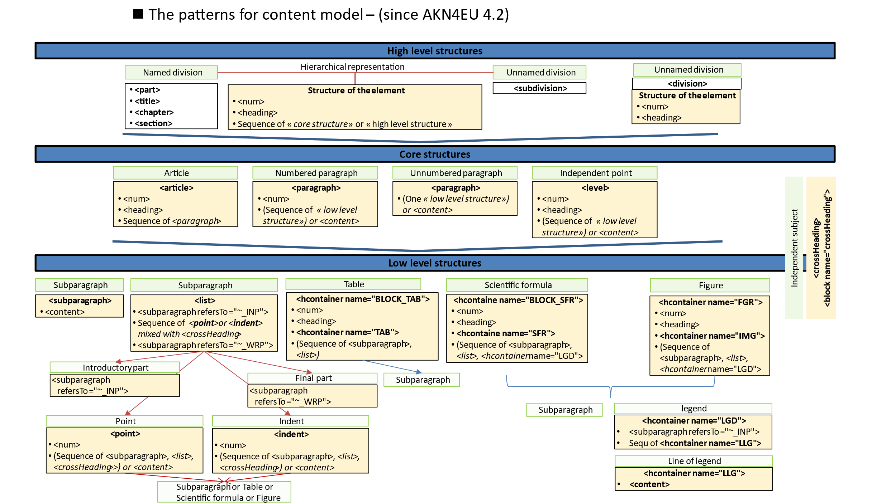

The high level structures
The high level structures are divided in two categories:
- Named structures
- Unnamed structures.
The main difference between these two categories is that, in named structures, each name of the structure corresponds to a level of hierarchy.

Named structures
AKN4EU uses the following named structures
- Title (element <title>),
- Part (element <part>),
- Chapter (element <chapter>),
- Section (element <section>),
- Subsection (element <subsection>),
This named structure will not be used anymore and remains only for legacy documents.
Structure of the named structures
The named structures contain the following elements:
- A mandatory <num> containing the name and the number of the structure
- A <heading> SHOULD exist containing the subject of the structure
- One of these alternatives
  - One or more core structure(s) and/or independent subjects,
  - a sequence of named high level structures, eventually preceded by one or more core structure(s) and/or independent subjects,
  - a sequence of unnamed high level structures, eventually preceded by one or more core structure(s) and/or independent subjects.
Example
<title>
<num>TITLE II</num> <heading>IMPLEMENTATION</heading>
<chapter>
<num>CHAPTER I</num>
<heading>Implementation, management and forms of support</heading>
...
</chapter>
...
</title>
The following rules are defined for the named structures:
Inside a document, if a named structure is parent of another named structure, it cannot also be the child of this named structure.
For example, the following structure is forbidden
<title>
<part>
<title>…</title> wrong
</part>
</title>

If a named structure has, as child, named structures, all these named structures must have the same type.

Unnamed structures
Unlike the named structure, the unnamed structure has no name, just a number.
Unnamed structures can be included in unnamed structure, recursively.
In AKN4EU, there are two models to represent the unnamed structures:
- Hierarchical model
marked with the element <subdivision>
- Flat model
marked with the element <division>

Hierarchical model (<subdivision>)
Structure of the <subdivision>
<subdivision> contain the following elements:
- A mandatory <num> containing the number of the structure
- A mandatory <heading> containing the subject of the structure
- One of these alternatives
  - One or more core structure(s) and/or independent subjects,
  - a sequence of unnamed structures (<subdivision>), eventually preceded by one or more core structure(s) and/or independent subjects.
Example
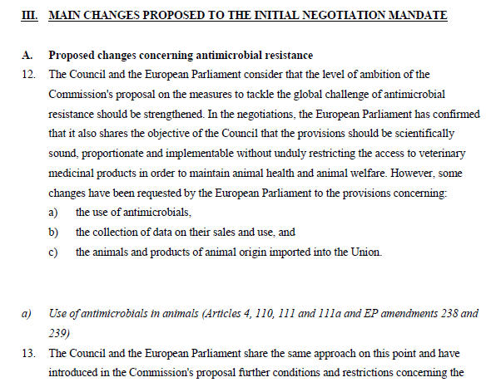
<subdivision>
<num>III</num>
<heading> MAIN CHANGES PROPOSED TO THE INITIAL NEGOTIATION MANDATE</heading>
<subdivision>
<num>A.</num>
<heading>Proposed changes concerning antimicrobial resistance</heading>
…
<subdivision>
<num>a)</num>
<heading> Use of antimicrobials in animals (Articles 4, 110, 111 and 111a and EP amendments 238 and 239)</heading>
…
</subdivision>
</subdivision>
</subdivision>

Flat model (<division>)
In AKN4EU, there is an alternative model to represent the unnamed structure: the mark-up flattens the hierarchy of unnamed structures.
In this model, the <division> element CAN ONLY contain
- a mandatory <num> element
- a mandatory <heading> element.
The attribute @class is MANDATORY and is used to conserve the information on the level in the hierarchy.
The value of the attribute @class MUST have the following value:
"type_"{number]
where {number} is a number indicating the level in the hierarchy ("1" = first level, "2" = second level, …).
The same example as above in the flat model will be the following:
<division class="type_1">
<num>III</num>
<heading> MAIN CHANGES PROPOSED TO THE INITIAL NEGOTIATION MANDATE</heading>
</division>
<division class="type_2">
<num>A.</num>
<heading>Proposed changes concerning antimicrobial resistance</heading>
</division>
…
<division class="type_3">
<num>a)</num>
<heading> Use of antimicrobials in animals (Articles 4, 110, 111 and 111a and EP amendments 238 and 239)</heading>
</division>
…
The following rules are defined for the unnamed structures:
As <division> is an "unnamed structure" (an hierarchical structure) represented in flat way.
The value of the @class attribute must be coherent with this underlying hierarchy of <division>.
For example, a <division classe="type_3"> cannot directly follow a <division class="type_1">

The core structure
The core structure groups the basic elements available.
The simplest document must have at least one of these structures. Which structure is available for a document is defined at the level of the AKN4EU file and its type.

Article <article>
An article is the basic structure of EU acts.
It MUST contain a number and at least one paragraph.
If an article contains unnumbered paragraphs, it cannot contain numbered paragraphs
If an article contains numbered paragraphs, it cannot contain unnumbered paragraphs.
<article> is used to mark an article.
<article> contains
- A mandatory <num>
- An optional <heading> for the subject
- 0, one or more <paragraph> (numbered or unnumbered paragraphs)

"Numbered paragraph" and "unnumbered paragraph" (<paragraph>)
<paragraph> is used to mark
- "numbered paragraph" and
- "unnumbered paragraph".
"Numbered paragraph" always starts with a <num> while "unnumbered paragraph" cannot start with a <num>.
When <paragraph> is a simple block of text, this block of text is inside a <content>/<p> element.
When <paragraph is a simple table, this table is inside a <content>/<table> element
Example
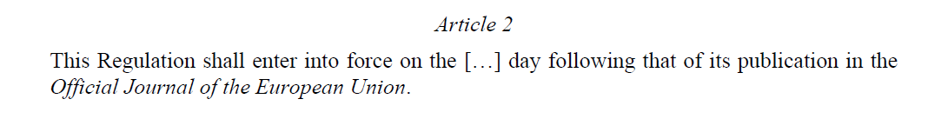
<article>
<num>Article 2</num>
<paragraph>
<content>
<p>This Regulation shall enter into force on the […] day following that of its publication in the <i>Official Journal of the European Union</i>. </p>
</content>
</paragraph>
</article>

The structures of "numbered paragraph" and of "unnumbered paragraph" are different.
The main difference is that the "unnumbered paragraph" can only have one "subparagraph" inside:
- Numbered paragraph is structured as
<paragraph>
<num>
One of these alternatives
  - <content>
  - <list>
  - <hcontainer name="FGR">
  - <hcontainer name="BLOCK_TAB">
  - <hcontainer name="BLOCK_SFR">
  - Sequence of at least two (<subparagraph> or <list> or <hcontainer name="FGR"> or <hcontainer name="BLOCK_TAB"> or <hcontainer name="BLOCK_SFR">

- Unnumbered paragraph is structured as
<paragraph>
One of these alternative
- <content>
- <list>
- <hcontainer name="FGR">
- <hcontainer name="BLOCK_TAB">
- <hcontainer name="BLOCK_SFR">
Example
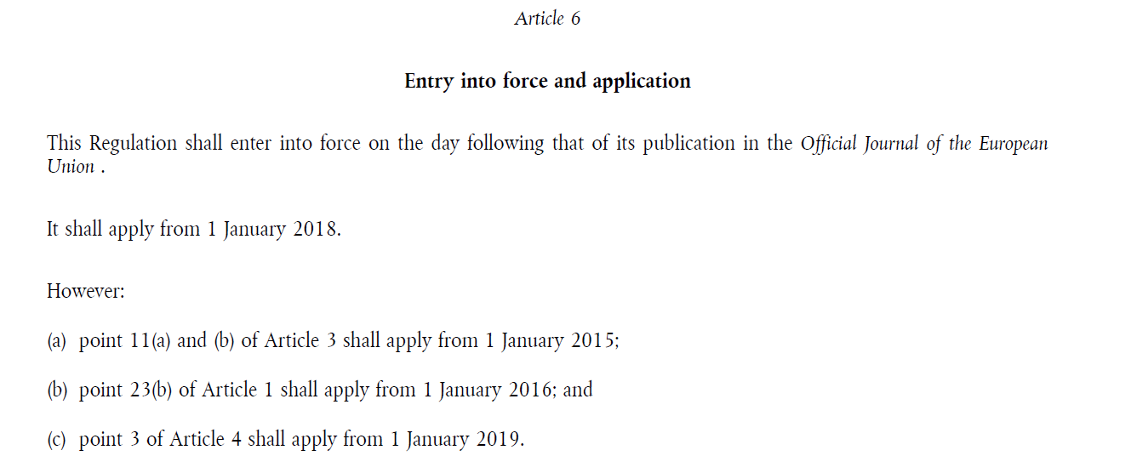
<article>
<num>Article 6</num>
<heading>Entry into force and application</heading>
<paragraph>
<content>
<p>This Regulation shall enter into force on the day following that of its publication in the <i>Official Journal of the European Union</i>.</p>
</content>
</paragraph>
<paragraph>
<content>
<p>It shall apply from 1 January 2018.</p>
</content>
</paragraph>
<paragraph>
<list>
...
</list>
</paragraph>
</article>

Example (numbered paragraph)
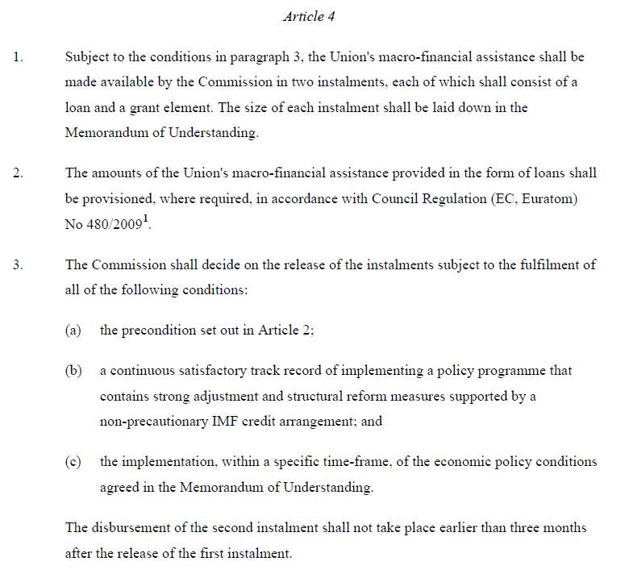
<article>
<num>Article 4</num>
<paragraph>
<num>1.</num>
<content>
<p>...</p>
</content>
</paragraph>
<paragraph>
<num>2.</num>
<content>
<p>...</p>
</content>
</paragraph>
<paragraph>
<num>3.</num>
<list>
...
</list>
<subparagraph>
<content>
<p>The disbursement of the second instalment ...</p>
</content>
</subparagraph>
</paragraph>
</article>

independent point (<level>)
The independent point is marked up with the element <level>.
The "independent point" has the following characteristics:
- It is never part of a <list>
- It cannot be included inside another "independent point".
- The "independent point" can be part of a high-level structure like title, part, chapter or section or unnamed structures.
- The "independent points" have a specific numbering system (decimal numbering) in order to represent the relationships between them (see next point). Such decimal numbering is composed of one or more numbers, each number ended by a dot.
For example, ‘”point 1.1.” indicates that the point is related to ‘point 1.’.
However, ‘point 1.1.’ cannot be considered as a sub-point of ‘point 1.’ because it is in reality an independent point.

The subject of independent points
An independent point can have a subject that is marked up with the element <heading>.

The structure of independent points
A <level> can comprise:
- a MANDATORY <num>
- an optional<heading>
- one of these two cases:
- <content> if the structure of a <level> is simple (one block of text or one table)
- <list> if the content is a sequence of points or indents with an introductory part and optionally, a closing part
- <hcontainer name="FGR">
- <hcontainer name="BLOCK_TAB">
- <hcontainer name="BLOCK_SFR">
- more than one "subparagraph" (<subparagraph> or <list> or <hcontainer name="FGR"> or <hcontainer name="BLOCK_TAB"> or <hcontainer name="BLOCK_SFR">) eventually mixed with <crossheading>
Example
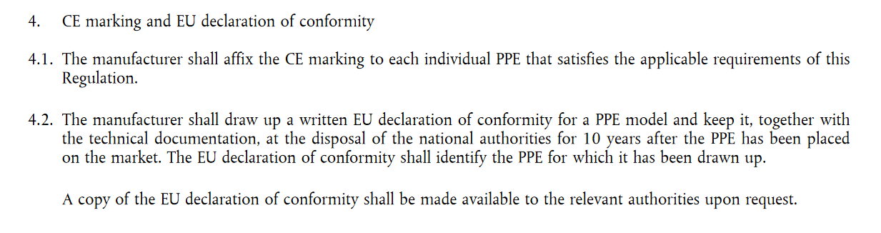
Will be marked as
<level><num>4.</num>
<content>
<p>CE marking and EU declaration of conformity</p>
</content>
</level>
<level><num>4.1.</num>
<content>
<p>The manufacturer shall affix the CE marking to each individual PPE that satisfies the applicable requirements of this Regulation.</p>
</content>
</level>
<level><num>4.2.</num>
<subparagraph>
<content>
<p>The manufacturer shall draw up a written EU declaration of conformity for a PPE model and keep it, together with the technical documentation, at the disposal of the national authorities for 10 years after the PPE has been placed on the market. The EU declaration of conformity shall identify the PPE for which it has been drawn up.</p>
</content>
</subparagraph>
<subparagraph>
<content>
<p>A copy of the EU declaration of conformity shall be made available to the
relevant authorities upon request.</p>
</content>
</subparagraph>
</level>

The low level structures
The low level structures are the "subparagraph", the structure available for complex "core structure".
AKN4EU defines the following mark-up for the "subparagraph"

<subparagraph>
It is the mark-up for a simple block of text or a simple table in a complex "core structure".
It MUST contain only one <content> element.

<list>
A <list> is a special type of subparagraph composed of
- an optional 'introductory part',
- a sequence of 'point' (numbered) mixed with <crossheading>
or
a sequence of 'indent' (unnumbered) mixed with <crossheading>
- an optional 'closing part'.

'introductory part'
The 'introductory part' is marked as a <subparagraph refersTo="~INP">.
It requires the following entry inside the metadata:
<TLCConcept xml:id="INP"
href="http://publications.europa.eu/resource/authority/subdivision/INP"
showAs="introductory part"/>

The structure of the <subparagraph> that refers to the <TLCConcept> “subdivision/INP” MUST be a <content> with one <p> element inside.

'point'
The 'point' is marked with the element <point>
Its structure is the following:
<point>
- A mandatory <num>
- One of this the following:
  - <content> with a <p> or a <table> or <foreign>;
  - <list>;
  - <hcontainer name="FGR">
  - <hcontainer name="BLOCK_TAB">
  - <hcontainer name="BLOCK_SFR">
  - A sequence of 2 or more <subparagraph> and/or <list> and/or <crossheading> and/or <hcontainer name="FGR"> and/or <hcontainer name="BLOCK_TAB"> and/or <hcontainer name="BLOCK_SFR">

'indent'
The 'indent' is marked with the element <indent>
Its structure is the following:
<indent> contains
- A mandatory <num>
- One of these alternatives
  - <content> with a <p> or a <table> or <foreign>
  - <list>
  - <hcontainer name="FGR">
  - <hcontainer name="BLOCK_TAB">
  - <hcontainer name="BLOCK_SFR">
  - A sequence of 2 or more <subparagraph> and/or <list> and/or <crossheading> > and/or <hcontainer name="FGR"> and/or <hcontainer name="BLOCK_TAB"> and/or <hcontainer name="BLOCK_SFR">

'closing part'
The 'closing part' is marked as a <subparagraph refersTo="~WRP">.
It requires the following entry, inside the metadata:
<TLCConcept xml:id="WRP"
href="http://publications.europa.eu/resource/authority/subdivision/WRP"
showAs="closing part"/>

The structure of the <subparagraph> that refers to the <TLCConcept> “subdivision/WRP” MUST be a <content> with one <p> element inside.
Example
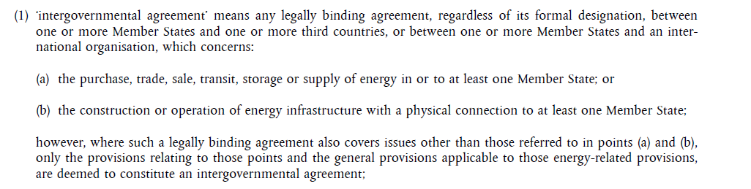
<point>
<num>(1)</num>
<list>
<subparagraph refersTo="~INP">
<content>
<p>‘intergovernmental agreement’ means any legally binding agreement, regardless of its formal designation, between one or more Member States and one or more third countries, or between one or more Member States and an international organisation, which concerns:</p>
</content>
</subparagraph>
<point><num>(a)</num>
<content>
<p>the purchase, trade, sale, transit, storage or supply of energy in or to at least one Member State; or</p>
</content>
</point>
<point><num>(b)</num>
<content>
<p>the construction or operation of energy infrastructure with a physical connection to at least one Member State;</p>
</content>
</point>
<subparagraph refersTo="~WRP">
<content>
<p>however, where such a legally binding agreement also covers issues other than those referred to in points (a) and (b), only the provisions relating to those points and the general provisions applicable to those energy-related provisions, are deemed to constitute an intergovernmental agreement;</p>
</content>
</subparagraph>
</list>
</point>
Example
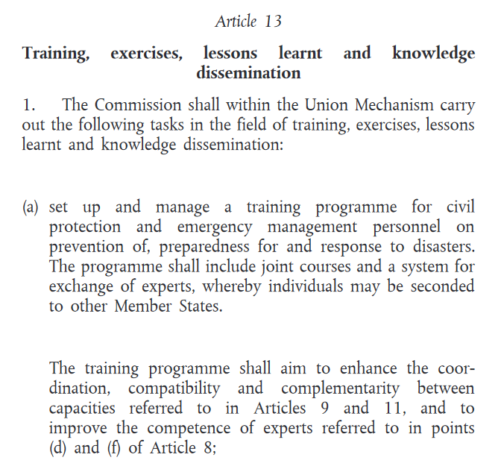
will be marked as
<article>
<num>Article 13</num>
<heading>Training, exercises, lessons learnt and knowledge dissemination</heading>
<paragraph>
<num>1.</num>
<list>
<subparagraph refersTo="~INP">
<content>
<p>The Commission shall within the Union Mechanism carry out the following tasks in the field of training, exercises, lessons learnt and knowledge dissemination:</p>
</content>
</subparagraph>
<point>
<num>(a)</num>
<subparagraph>
<content>
<p>set up and manage a training programme for civil protection and emergency management personnel on prevention of, preparedness for and response to disasters. The programme shall include joint courses and a system for exchange of experts, whereby individuals may be seconded to other Member States.</p>
</content>
</subparagraph>
<subparagraph>
<content>
<p>The training programme shall aim to enhance the coordination, compatibility and complementarity between capacities referred to in Articles 9 and 11, and to improve the competence of experts referred to in points (d) and (f) of Article 8;</p>
</content>
</subparagraph>
</point>

Special list: the “check” structure

Description of the structure
The “check” structures are subparagraphs that group a sequence of blocks that start with a “checked” () or “unchecked” () character.
A check structure accepts multiple “checked” blocks inside.
A block that starts with a “checked” or “unchecked” character can be a simple block, or it can be composed of
- Subparagraph(s) and/or
- sub-“check structure(s)”.
Example
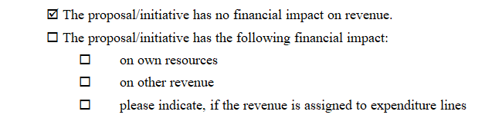

The mark-up in AKN4EU
We use the classical mark-up <list> with the following specific mark-up:
- a <list> that is a “CHECK” structure MUST have a @class attribute sets to “CHECK”
(<list class=”CHECK”).
- They CAN have an introductory part (<subparagraph refersTo=”~INP”>).
- A <list class=”CHECK”> CANNOT have <point> but MUST always have one or more <indent>.
- The <num> element of the <indent> of a ‘check structure’ or of a ‘radio structure’ cannot be empty and MUST only have as content one of these two <inline>:
  - <inline name=”checked”>
  - <inline name=”unchecked”>
These <inline> elements MUST contain ONE character that is the character used for the check or uncheck value.
The character MUST be encoded with a numeric character reference (between “&#” and “;”). The number is the ISO/IEC 10646 character code.
- For , the character reference MUST be “&#x2611;” (hexadecimal) or &#9745; (decimal)
- For , the character reference used MUST be “&#x2610;” (hexadecimal) or &#9744; (decimal).
For example:
  - <num><inline name-“checked”>&#x2611; </inline></num>,
  - <num><inline name=”unchecked”>&#x2610;</inline></num>
The upper example is marked as following:
<list class=”CHECK”>
<indent>
<num><inline name=“checked”>&#x2611;</inline></num>
<content>
<p>The proposal/initiative has no financial impact on revenue.</p>
</content>
</indent>
<indent>
<num><inline name=”unchecked”>&#x2610;</inline></num>
<list class=”CHECK”>
<subparagraph refersTo=”~INP”>
<content>
<p>The proposal/initiative has the following financial impact:</p>
</content>
</subparagraph>
<indent>
<num><inline name=”unchecked”>&#x2610;</inline></num>
<content>
<p>on own resources</p>
</content>
</indent>
<indent>
<num><inline name=”unchecked”>&#x2610;</inline></num>
<content>
<p>on other revenue</p>
</content>
</indent>
<indent>
<num><inline name=”unchecked”>&#x2610;</inline></num>
<content>
<p>please indicate, if the revenue is assigned to expenditure lines</p>
</content>
</indent>
</list>
</indent>
</list>

A figure as a low-level structure
Inside the main content of a document, the figure, containing an image can be considered as a special kind of low-level structure: a heading and subject can be associated as well as some additional subparagraphs like a legend or a source of information.
An envelope element is needed to group the object and its associated heading and subject.
The overall structure is the following
- The envelope element is <hcontainer>, with the mandatory @name attribute sets to ’FGR’ (authority code in the authority table ‘subdivision’ for ‘Figure’);
- The figure can contain heading (<num>) and subject (<heading>);
- Inside the figure, the image itself MUST be inside a specific <hcontainer> with the @name attribute sets to “IMG” (authority code in the authority table ‘subdivision’ for ‘Image’);
- Any other subparagraph that is inside the figure is marked with a <subparagraph> element.
Example
Image with heading and optional subject
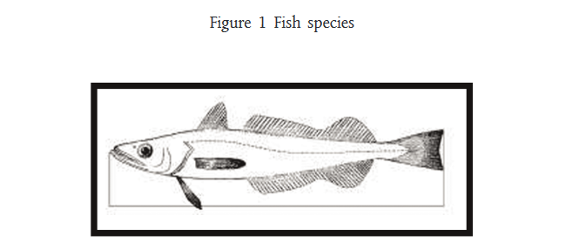

<hcontainer name="FGR">
<num>Figure 1</num>
<heading>Fish species</heading>
<hcontainer name="IMG">
<content>
<p><img src="…"/></p>
</content>
</hcontainer>
</hcontainer>

And the following example
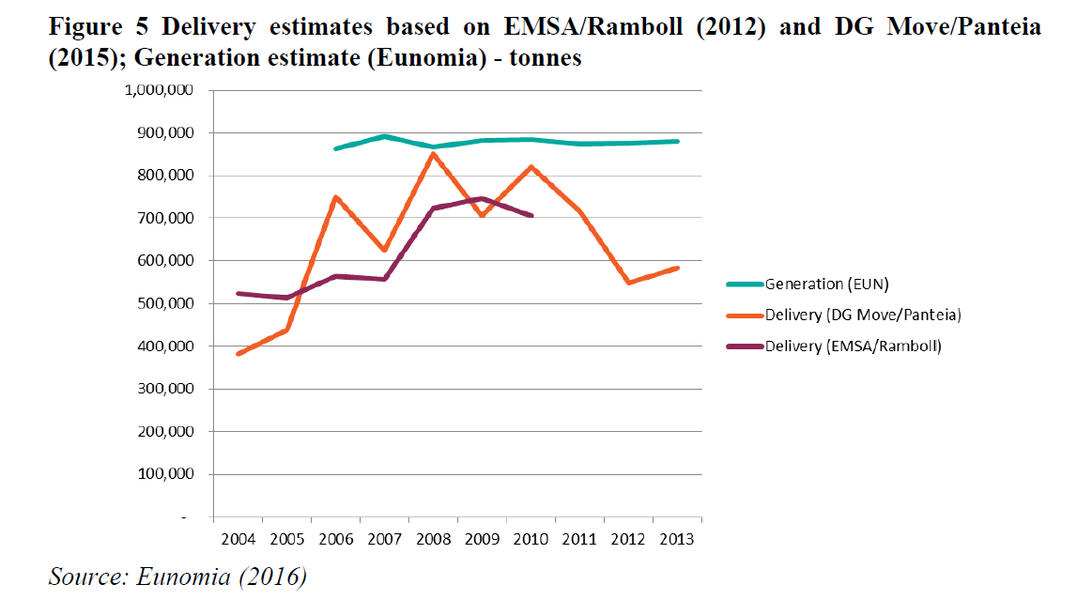
will be marked as follows:
<hcontainer name="FGR">
<num>Figure 5 </num>
<heading>Delivery estimates based on EMSA/Ramboll (2012) and DG Move/Panteia (2015); Generation estimate (Eunomia) - tonnes</heading>
<hcontainer name="IMG">
<content>
<p><img src="…"/></p>
</content>
</hcontainer>
<subparagraph>
<content>
<p>Source: Eunomia (2016)</p>
</content>
</subparagraph>
</hcontainer>

The example with the image encoded in svg
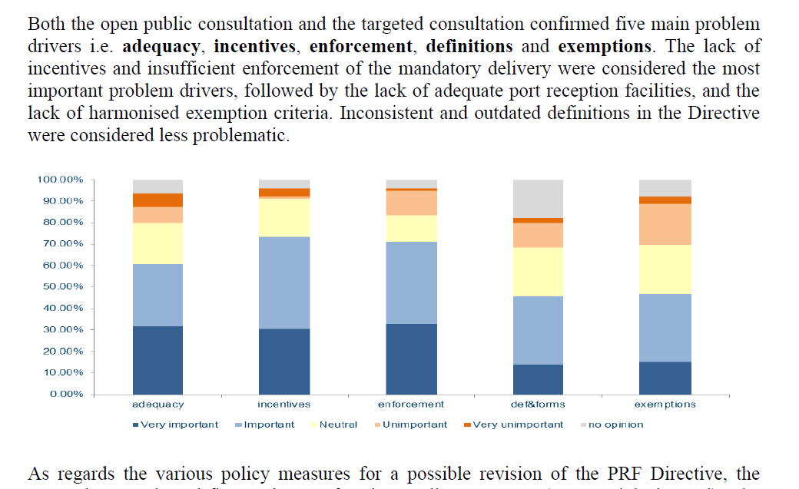
will be marked as follows:
<paragraph>
<content>
<p>Both the open public consultation and the targeted consultation confirmed five main…</p>
</content>
</paragraph>
<paragraph>
<hcontainer name=”FGR”>
<hcontainer name="IMG">
<content>
<p><img src=”….svg”/></p>
</content>
</hcontainer>
</hcontainer>
</paragraph>
<paragraph>
<content>
<p>As regards the various policy measures for …</p>
</content>
</paragraph>

A table as a low level structure
Inside the main content of a document, the table can be considered as a special kind of low-level structure: a heading and subject can be associated as well as some additional subparagraphs like a legend or a source of information.
An envelope element is needed to group the object and its associated heading and subject.
The overall structure is the following:
- The envelope element is <hcontainer> with the mandatory @name attribute sets to “BLOCK_TAB”;
- it can contain heading (<num>) and subject (<heading>);
- the table itself MUST be inside a specific <hcontainer> with the @name attribute sets to “TAB” (authority code in the authority table ‘subdivision’ for ‘Table’);
- any other subparagraph that is inside the table is marked with a <subparagraph> element inside the <hcontainer name=”BLOCK_TAB”>.
The example of a simple table
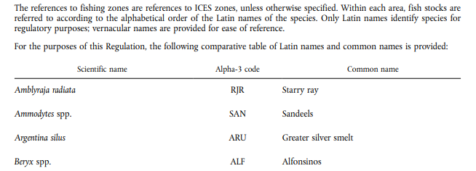
Is marked as follows
<paragraph>
<content>
<p>The references to fishing zones are references to ICES zones, unless…</p>
</content>
</paragraph>
<paragraph>
<content>
<p>For the purposes of this Regulation, the following comparative table of Latin names and common names is provided:</p>
</content>
</paragraph>
<paragraph>
<hcontainer name="BLOCK_TAB">
<hcontainer name="TAB">
<content>
<table>
< !-- The AKN4EU markup of a table -->
</table>
</content>
</hcontainer>
</hcontainer>
</paragraph>

An example table with heading and subject
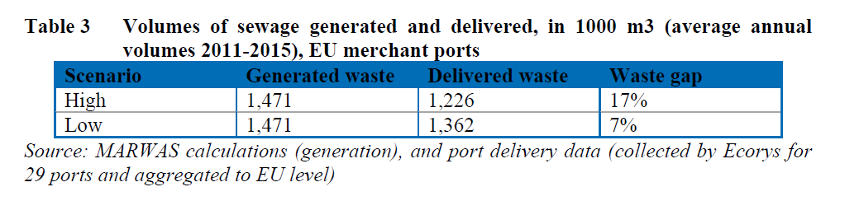
will be marked as follows
<hcontainer name="BLOCK_TAB">
<num>Table 3 </num>
<heading>Volumes of sewage generated and delivered, in 1000 m3 (average annual volumes 2011-2015), EU merchant ports</heading>
<hcontainer name="TAB">
<content>
<table xml:id="_d1e454">
< !-- The AKN4EU markup of a table -->
</table>
</content>
</hcontainer>
<subparagraph>
<content>
<p>Source: MARWAS calculations (generation), and port delivery data (collected by Ecorys for 29 ports and aggregated to EU level)</p>
</content>
</subparagraph>
</hcontainer>

The “scientific formula” as low level structure
Inside the main content of a document, the scientific formula can be considered as a special kind of low level structure: generally, a scientific formula has an introductory subparagraph.
An envelope element is needed to group the object and its associated introductory subparagraph.
The overall structure is the following:
- The envelope element is <hcontainer> with the mandatory @name attribute set to “BLOCK_SFR”;
- It can contain an introductory subparagraph (<subparagraph refersTo=”~INP”>);
- The scientific formula itself MUST be inside a specific <hcontainer> with the @name attribute sets to “SFR” (authority code in the authority table ‘subdivision’ for ‘Scientific formula).
For this example:
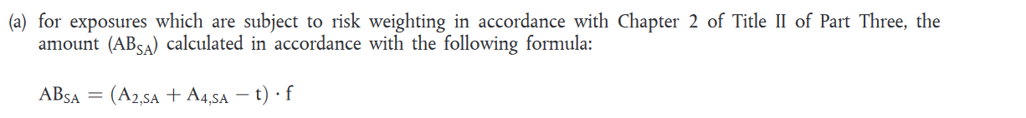
the mark-up is the following:

…
<point>
<num>(a)</num>
<hcontainer name="BLOCK_SFR">
<subparagraph refersTo=”~INP”>
<content>
<p>for exposures which are subject to risk weighting in accordance with Chapter 2 of Title II of Part Three, the amount (AB<sub>SA</sub>) calculated in accordance with the following formula:</p>
</content>
</subparagraph>
<hcontainer name="SFR">
<content>
<p><img src="…"/></p>
</content>
</hcontainer>
</hcontainer>
</point>

The mark-up of the CoV concept “legend”
Figure or mathematical formula can contain a legend.
Text that introduces the legend
The legend of the formula can be composed of multiple lines.
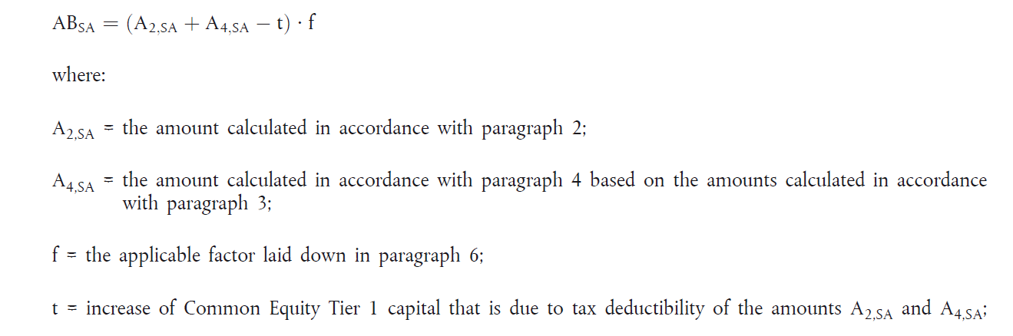
Line of a legend
legend

The mark-up of the legend itself
The legend MUST be included in a <hcontainer> element.
The <hcontainer> element has a mandatory @name attribute with the value “LGD” (authority code in the authority table ‘subdivision’)
The “where:” must be considered like a text that introduces the legend, and so is part of the legend.
It is marked with the element <subparagraph refersTo=”~INP”>.
Each line of a legend MUST be also marked with the element <hcontainer>. The <hcontainer> element has a mandatory @name attribute with the value “LLG” (authority code in the authority table ‘subdivision’).
The above example will be marked as follows:
…
<hcontainer name="LGD">
<subparagraph name="~INP">
<content>
<p>where:</p>
</content>
</subparagraph>
<hcontainer name="LLG">
<content>
<p>A<sub>2,SA</sub> = the amount calculated in accordance with paragraph 2;</p>
</content>
</hcontainer>
…
</hcontainer>

A <hcontainer name=”LGD”> MUST always be included in a <hcontainer name=”FGR”> or a <hcontainer name=”BLOCK_SFR”>.

The overall mark-up (example of a mathematical formula)
Taken as example a mathematical formula with its legend, the overall structure can be the following: it is marked as <hcontainer name=”BLOCK_SFR”>. It contains:
- Optionally, an introductory sentence (<subparagraph refersTo=”~INP”>)
- Mandatory, a <hcontainer name=”SFR”> containing the mathematical formula itself
- Optionally a (<hcontainer name= “LGD”>) that contain:
  - An optional introductory part (<subparagraph refersTo=”~INP”>) following by
  - one or more <hcontainer name=“LLG”>).
Therefore, for the following example,
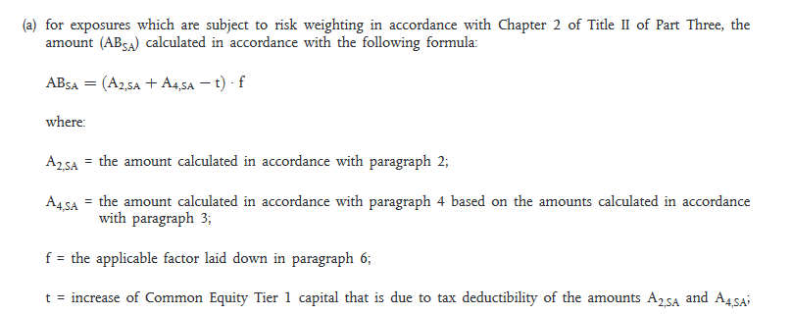
the mark-up will be the following:
<point>
<num>(a)</num>
<hcontainer name="BLOCK_SFR">
<subparagraph refersTo="~INP">
<content>
<p>for exposures which are subject to risk weighting in accordance with Chapter 2 of Title II of Part Three, the amount (AB<sub>SA</sub>) calculated in accordance with the following formula:</p>
</content>
</ subparagraph >
<hcontainer name="SFR">
<content>
<p><img src=”RSC_MATHML-clfcn8jjl00042a6chtwprxwb-en.mathml”/></p>
</content>
</hcontainer>
<hcontainer name="LGD">
<subparagraph refersTo=”~INP”>
<content> <p>where:</p>
</content>
</subparagraph>
<hcontainer name="LLG">
<content>
<p>A<sub>2,SA</sub> = the amount calculated in accordance with paragraph 2;</p>
</content>
</hcontainer>
<hcontainer name=”LLG”>
<content>
<p>A<sub>4,SA</sub> = the amount calculated in accordance with paragraph 4 based on the amounts calculated in accordance with paragraph 3;</p>
</content>
</hcontainer>
<hcontainer name="LLG">
<content>
<p>f = the applicable factor laid down in paragraph 6;</p>
</content>
</hcontainer>
<hcontainer name="LLG">
<content>
<p>t = increase of Common Equity Tier 1 capital that is due to tax deductibility of the amounts A<sub>2,SA</sub> and A<sub>4,SA</sub>;</p>
</content>
</hcontainer>
</hcontainer>
</hcontainer>
</point>

With the following MathML file (RSC_MATHML-clfcn8jjl00042a6chtwprxwb-en.mathml):
<math xmlns="http://www.w3.org/1998/Math/MathML" >
<mi>A</mi>
<msub>
<mi>B</mi>
<mrow>
<mi>S</mi>
<mi>A</mi>
</mrow>
</msub>
<mo>=</mo>
<mo>(</mo>
<msub>
<mi>A</mi>
<mrow>
<mn>2</mn>
<mo>,</mo>
<mi>S</mi>
<mi>A</mi>
</mrow>
</msub>
<mo>+</mo>
<msub>
<mi>A</mi>
<mrow>
<mn>4</mn>
<mo>,</mo>
<mi>S</mi>
<mi>A</mi>
</mrow>
</msub>
<mo>−</mo>
<mi>t</mi>
<mo>)</mo>
<mo>*</mo>
<mi>f</mi>
</math>

The element <content>
The <content> element is the element of a hierarchical element that contains the text. As the AKN4EU model requires to assign to each block of text a hierarchical element, the <content> can only contains one block that can be
- ONE <p> element, for a simple block of text. It can contain the marker <img/>
  - for a picture in jpeg or png or
  - for the scientific formula in MathML or using an image
While the second option “using an image” remains available primarily for backward compatibility, it should be avoided as much as possible as the alphanumeric content is not accessible.
- ONE <table> element
In Akoma Ntoso, a table is marked with the element <table>. <table> is a block element comprising sub-elements <tr> (and an optional <caption>). It can be a block element of the <content> element of a hierarchical element.
In AKN4EU, the sub-element <caption> MUST NOT be used.
See PART 1 – section 7.1 on the mark-up inside <table>.

The independent subject
The 'independent subject' is a subject that has no impact on the hierarchy and serves rather as a bookmark.
The 'independent subject' is marked with the following elements:
- <crossHeading> when the element is inside a hierarchical element
- <block name="crossheading"> when the element is directly below the <body> or <mainBody>
The 'independent subject' can be mixed with the core structures (for example, <level> or <paragraph>) and with the 'low level' structures (for example, <subparagraph> or <point> or <indent>) and with other independent subjects.
Example
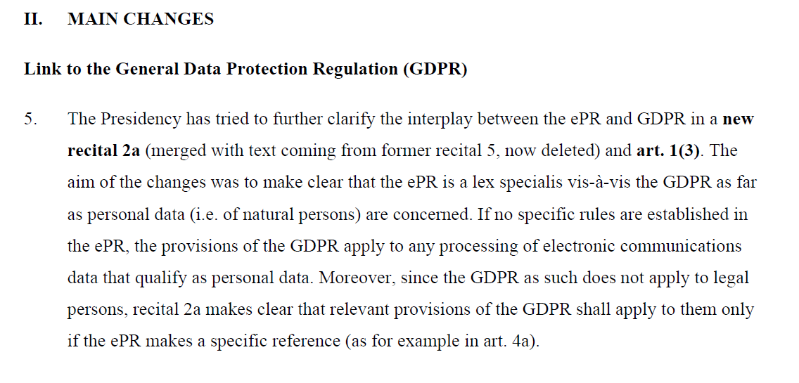
Independent subject
Will be marked as
<division>
<num>II.</num>
<heading>MAIN CHANGES</heading>
</division>
<block name="crossHeading">Link to the General Data Protection Regulation (GDPR)</block>
<level>
<num>5.</num>
<content>
<p>The Presidency has tried to further clarify the interplay between the ePR and GDPR in a <b>new recital 2a</b> (merged with text coming from former
recital 5, now deleted) and <b>art. 1(3)</b>. The aim of the changes was
to make clear that the ePR is a lex specialis vis-à-vis the GDPR as far
as personal data (i.e. of natural persons) are concerned. If no specific
rules are established in the ePR, the provisions of the GDPR apply to
any processing of electronic communications data that qualify as
personal data. Moreover, since the GDPR as such does not apply to legal
persons, recital 2a makes clear that relevant provisions of the GDPR
shall apply to them only if the ePR makes a specific reference (as for
example in art. 4a).</p>
</content>
</level>
Example of "independent subjects" between "indents":
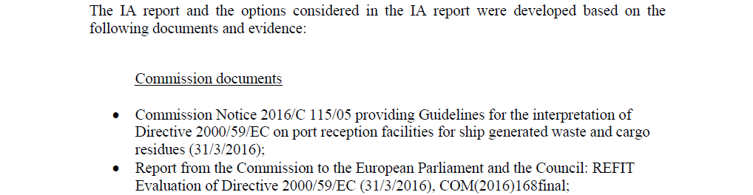

Will be marked as:
<list>
<subparagraph refersTo="~INP">
<content>
<p>The IA report and the options considered in the IA report were developed based on the following documents and evidence:</p>
</content>
</subparagraph>
<crossHeading>Commission documents</crossHeading>
<indent>
<num>•</num>
<content>
<p>Commission Notice 2016/C 115/05 providing Guidelines for the interpretation of Directive 2000/59/EC on port reception facilities for ship generated waste and cargo residues (31/3/2016);</p>
</content>
</indent>
<indent>
<num>•</num>
<content>
<p>Report from the Commission to the European Parliament and the Council: REFIT Evaluation of Directive 2000/59/EC (31/3/2016), COM(2016)168final;</p>
</content>
</indent>
<crossHeading>Documents from EMSA</crossHeading>
<indent>
<num>•</num>
<content>
<p>EMSA technical assessment on the list of open issues in the context of the IA for the revision of the PRF Directive (January 2017); supplement on enforcement (March 2017), available upon request;</p>
</content>
</indent>
</list>

AKN4EU file: the mark-up for <preamble>
The preamble of a document contains very specific information and forms part of documents like the EU acts, the International agreements and some EP documents like the EP Legislative Resolution. It contains citations, recitals and solemn forms.
AKN4EU defines the following elements acceptable in a preamble:
- <formula>
used for the solemn forms. Each line is on a specific <p> element.
  - @name="actingEntity" for the solemn form that contains the name of the acting entity(ies)
  - @name="enactingFormula" for the solemn form that ends the preamble
- <citations>
This element is optional and, when exist, must contain at least one <citation>
Normally, the <citations> is displayed without number or dash.
However if, for some document, a dash must be displayed on every <citation>, in this case, the <citations> element SHOULD have a @refersTo pointing to the meta <TLCConcept> that references the entry " CITATION_DASH" of the authority table "subdivision-content".
- <recitals>
This element is optional and, when exist, must contain at least one <recital>.
If there is an introductory part to the recitals, it is marked with the <intro> element and one <p> inside.
If the recitals are numbered, each <recital> MUST have a <num> element.

Specific case
Citation containing the legal basis
This citation MUST have a @refersTo attribute with a reference to the entry of the metadata with the reference to the eurovoc entry for "legal basis" (= "http://eurovoc.europa.eu/5456")
Example
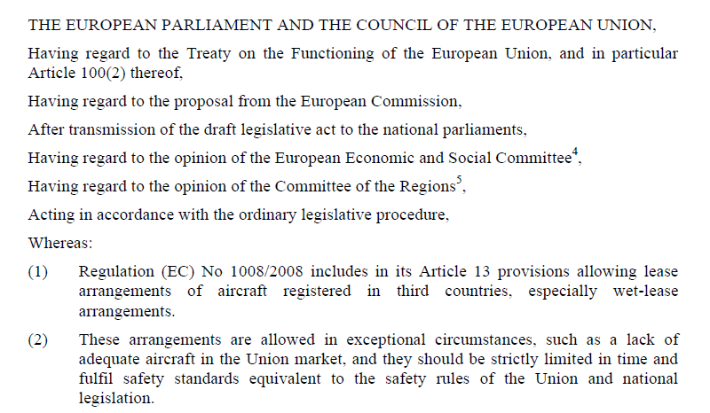
Enacting formula
Acting entity
citations
recitals
Introductory part
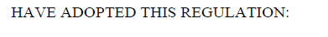
<preamble>
<formula name="actingEntity">
<p>THE EUROPEAN PARLIAMENT AND THE COUNCIL OF THE EUROPEAN UNION,</p>
</formula>
<citations>
<citation refersTo="~legalBasis">
<p>Having regard to the Treaty on the Functioning of the European Union, and in particular Article 100(2) thereof, </p>
</citation>
<citation>
<p>Having regard to the proposal from the European Commission, </p>
</citation>
<citation>
<p>After transmission of the draft legislative act to the national parliaments,</p>
</citation>
...
</citations>
<recitals>
<intro>
<p>Whereas: </p>
</intro>
<recital>
<num>(1)</num>
<p>Regulation (EC) No 1008/2008 includes in its Article 13 provisions allowing lease arrangements of aircraft registered in third countries, especially wet-lease arrangements.</p>
</recital>
<recital>
<num>(2)</num>
<p>These arrangements are allowed in exceptional circumstances, such as a lack of adequate aircraft in the Union market, and they should be strictly limited in time and fulfil safety standards equivalent to the safety rules of the Union and national legislation.
</p>
</recital>
</recitals>
<formula name="enactingFormula">
<p>HAVE ADOPTED THIS REGULATION: </p>
</formula>
</preamble>

AKN4EU file: the mark-up for <preface> and <longTitle>
The preface covers the information found at the beginning of a document.
The most important information of the preface is the title of the document, or the heading and the subject of an annex. Sometimes, it contains additional information like the procedure reference or the identifier of the document.
In AKN4EU, the <preface> is mandatory for any document type except for the <documentCollection> where it is optional.
A <preface> MUST always have a <longTitle>, composed of one <p> for the title of the document, except the <doc name="ANNEX"> which has a <container name="headerOfAnnex"> for the number and the subject of the annex.
<longTitle>
The title of the document contains a lot of information regarding the identification and the type of the document. Akoma Ntoso provides a large set of inline elements that can be used for the different part of the title of the document:
Name of the element | Meaning | Additional AKN4EU constraints
docType | String that contains the type of the document | It SHOULD have a @refersTo attribute pointing to a <TLCReference name="docType">
<docStage> | String containing the information on the role of the document inside the legislative procedure. | It can contain a <docType> element.
<docNumber> | String containing the number of the document
<docPurpose> | String identifying the subject of the document | If there are references to an EU act, these references SHOULD be marked with a <ref> element with the mandatory @href attribute containing the ELI URI of the EU act.
<date> | The date of the document

Sometimes, the line containing the title of the document contains also other information that is not part of the title of the document.
In this case, the title of the document MUST be inside a <docTitle> element.
Example
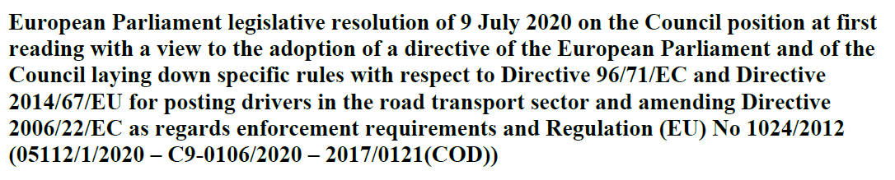
<longTitle>
<docTitle>

<longTitle>
<p><docTitle><docType refersTo="~RES_LEGIS">European Parliament legislative
resolution</docType> of <date date="2020-07-09">9 July 2020</date> <docPurpose>on the Council position at first reading …</docPurpose></docTitle>
<inline name="relatedProc">( … )</inline></p>
</longTitle>

For the title of a document not to be displayed, the <preface> MUST have the @status attribute set to "ignored".
Example
<preface status="ignored">
<longTitle>
<p><docType
refersTo="~EXPLANATORY_COUNCIL">Explanatory</docType></p>
</longTitle>
</preface>

Other <container> can also be present in <preface> like, for example:
- <container name="procedureReference">
containing the procedure reference
- <container name="mainDoc">
containing in a <block name="reference"> the reference of the current document.
This element MUST contain a <docNumber>. The <docNumber> CAN have a @refersTo attribute pointing to a <TLCReference name="identifier"> metadata.
- <container name="eeaRelevance">
containing the standard phrase on EEA relevance.
Table of content
The Table of Content can be part of the <preface> or of the <coverPage>.
In this case, a <blockContainer> is used that
- can contain a <heading> and
- contains a <toc> element.
(See PART 1 – 7.6 Table of content for the mark-up of the table itself)

AKN4EU file: the mark-up for <coverPage>
The <coverPage> element is used to mark the information comprising the cover page.
Every <documentCollection> MUST have a <coverPage>.
The element <coverPage> can be empty or be composed of one or more <container> element(s) and/or ONE <longTitle> element.
By default, <container> is composed of one <p> with optional inline elements.
The following <container> elements can be found in for AKN4EU official documents:
<container> | Meaning
container name="actingEntity" | It contains the organization responsible of the document.  It contains at least one <p> that MUST contain an <organization> element with a @refersTo pointing to a TLCOrganization metadata.  For EP documents, it can also contain an additional <p> element with the <legislature>
container name="associatedReferences" | Contains the references to documents that are associated to this document. For example, in the context of a Proposal for an act, it contains the reference to the related SWD (Staff Working Document) documents.  It is composed of <p> elements. Inside, each reference MUST be marked with a <docNumber> or a <ref> inline element. The <ref> element has a @href attribute containing the corresponding ELI reference.
container name="distribution" | Contains the information on the distribution, in a <p> element.
container name="docHeader" | This container contains the main information on the document when various pieces of information are grouped inside one center block on the cover page.  It CAN only contain <container> elements like  - <container name="otherReferences">  - <container name="typeOfDocument">  - <container name="titleOfDocument">  - <container name="stakeholders">
Container name=”eeaRelevance” | This container contains one <p> with the info that the document is “EEA relevant”
container name="logo" | Contains the picture of the logo of the organization responsible of the document  If this container exists, a <container name=”actingEntity”> MUST exist
longTitle | This container contains the title of the document when this title is isolated on the page
container name="mainDoc" | This container contains <block> elements:  - <block name="placeAndDate"> that SHOULD contain a <location> and a <date>  - <block name="reference">: this element MUST contain a <docNumber>. The <docNumber> CAN have a @refersTo attribute pointing to a <TLCReference name="identifier"> metadata.  - <block@name="mainDocOriginalLanguage">: it MUST contain a <inline name="language">
container name="mainDocLanguage" | This container contains the language of the document as it indicated in the cover page (generally, in the footer).  It MUST contain, inside a <p>, an <inline name="language"> with a @refersTo pointing to the metadata <FRBRlanguage>
container name="mainDocReference" | This container MUST contain a <block name="reference"> and is used when the reference of the document is not grouped with the place and date information.  The <block> element MUST contain a <docNumber>. The <docNumber> CAN have a @refersTo attribute pointing to a <TLCReference name="identifier"> metadata.
container name="otherReferences" | This container is composed of <block> elements. For the Council documents, the following blocks are defined:  - <block name="prevDoc">  - <block name="cionDoc">
container name="procedureIdentifier" | This container contains a <p> element.  Inside, the identifier of the legislative procedure MUST be in a <docketNumber> with a mandatory @refersTo attribute that points to a <TLCReference name="procedureReference">
container name="responsible" | In the Council document, this <container> contains the information on the service and the person(s) responsible for the document.  It contains one <p> element with the <organization> inline element and one<p> element with one or multiple <person> inline element(s). In both cases, the mandatory @refersTo attribute can be empty.
container name="stakeholders" | This container can have the following <block> elements:  - <block name="issuer">  - <block name="addressee">  - <block name="eventDate">
container name="subjectMatter" | This container is specific to the Council documents and can contain multiple <p> elements.  Each <p> element MUST have a <inline name="subjectCode"> element.
container name="titleOfDocument" | Contains the title of the document and  contains one <p> that MUST contain a <docTitle>.
container name="typeOfDocument" | Contains the information on the type of the document.  It SHOULD contain a <docType> element with a mandatory @refersTo pointing to a <TLCReference name="docType">.
<blockContainer> | The <blockContainer> is used to content the Table of content.  The <blockContainer>  - can contain a <heading> and  - contains a <toc> element.  (See PART 1 – 7.6 Table of content for the mark-up of the table itself)

AKN4EU file: the mark-up of the ‘notes’
The “note” pertaining to the document MUST be marked by the element <authorialNote>. <authorialNote> contains the text of the note (normally inside a <p> element) and has the following attributes, according to Akoma Ntoso:
- the @marker attribute (mandatory)
It must contain the sequential number or character-based marker of the note.
- the @placement attribute
Indicates the position where the note should be placed.
The value “bottom” without an attribute @placementBase means “end of the page”.
- the @placementBase attribute
This attribute is used when the note content is displayed at the end of some context and contains the reference to this context.
Example:
<p>Acting in accordance with the ordinary legislative procedure<authorialNote
placement="bottom" marker="1">
<p>Position of the European Parliament of 17 December 2014 (not yet published in the Official Journal) and decision of the Council of 18 December 2014.</p>
</authorialNote>,</p>

AKN4EU file: the mark-up in the textual content

AKN4EU representation of tables

Akoma Ntoso mark-up

Akoma Ntoso mark-up for style instruction
Akoma Ntoso provides some mark-up to help to store specific layouts introduced by authors or publishers that need to be preserved with the document. CSS is used for the stylesheet instruction.
Sharing an external standard CSS stylesheet, available from common repository
In this case, in order to display the XML file using this CSS, link the XML file with CSS using the processing instruction "xml-stylesheet". This processing instruction is to place in the XML file just after the "xml" declaration and before the root element
<?xml-stylesheet type="text/css" href="name_of_css_file.css"?>

Example:

<?xml version="1.0" encoding="UTF-8"?>
<?xml-stylesheet type="text/css" href="name_of_css_file.css"?>
<akomaNtoso>
…
</akomaNtoso>

General attributes for style
These attributes are taken from HTML and has the same role as in HTML
@style | Specifies an inline style for an element.
@class | specifies one or more classnames for an element. The class attribute is used to point to a class in a style sheet.  Multiple classnames can be specified, each separate with a blank.
@title | This attribute CANNOT be used in AKN4EU documents

Overall layout example: landscape versus portrait
Sometimes it is necessary to rotate a block element so that it fits on the page. This is common with tables.
A common mark-up must be defined in the specification so that this information can be stored in the AKN4EU document and can be exploited by everybody.
There are multiple possibilities:
- use the @style attribute at the corresponding element (<table>, <subdivision> ...) to have the information
- define a stylesheet class local to this document, use the @class attribute at the level of the top element that need to be landscaped and put the associated css stylesheet in the <presentation> section of the metadata
- define a AKN4EU stylesheet for the landscape of an element and indicate it in the @class attribute at the level of the top element that need to be landscaped
In Akoma Ntoso, a table is marked with the element <table>.
<table> is a block element comprising sub-elements <tr> (and an optional <caption>).
In AKN4EU, the sub-element <caption> MUST NOT be used.
<table> can be a block element of the <content> element of a hierarchical element.

Attributes specific to table
@border | to set a visible border width for a table.
@width | specifies the width of the table.
@cellspacing | specifies the space between cells.  Akoma Ntoso allows only integer as value for this field.  In AKN4EU, this value indicates a percentage and cannot be higher than 100
@cellpadding | specifies the space between the cell wall and the cell content  Akoma Ntoso allows only integer as value for this field.  In AKN4EU, this value indicates a percentage and cannot be higher than 100

Span of cell
The span of cell is expressed by two attributes, containing the number of cells spanned:
- @colspan when the cell spans multiple columns;
- @rowspan when the cell spans multiple rows
Example:
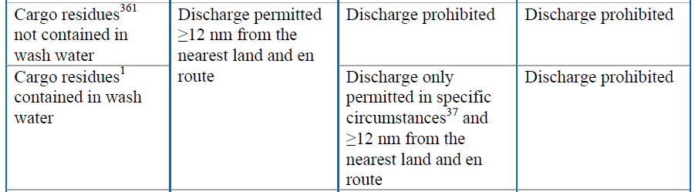
<tr>
<td>
<p>Cargo residues <authorialNote marker="36" placement="bottom">…</authorialNote> not contained in wash water </p>
</td>
<td rowspan="2">
<p>Discharge permitted ≥12 nm from the nearest land and en route </p>
</td>
<td>
<p>Discharge prohibited </p>
</td>
<td>
<p>Discharge prohibited </p>
</td>
</tr>
<tr>
<td>
<p>Cargo residues<sup>1</sup> contained in wash water </p>
</td>
<td>
<p>Discharge only permitted in specific circumstances <authorialNote marker="37"
placement="bottom">…</authorialNote> and ≥12 nm from the nearest land and en route </p>
</td>
<td>
<p>Discharge prohibited </p>
</td>
</tr>

AKN4EU structure in cell
The current version of Akoma Ntoso defines that the structure of a cell must be of the block level (<p>, <block>, <blockContainer>, <foreign>, <table>, <tblock>, <blockList>…) and does not allow having the "hierarchical element" inside the <td> element.
This section explains how to represent, in AKN4EU, complex structures in a cell with the current version of Akoma Ntoso.

Unnumbered paragraphs
By default, a cell (<td> or <th>) contains one <p>. This is the structure of a simple cell.
If there are multiples blocks, each block is marked with a <p> element (see below, column 1 and 2).

Sequence of points or indents
If a cell contains a sequence of points or a sequence of indents (with or without the introductory part), the workaround to mark-it in AKN4EU is the following:
An element <block name=complexContent> is used for the overall content of the cell.
This block contains only one element : <subFlow name="structuredContent">.
All the content of the cell is inside this element, using AKN4EU low level structures (<subparagraph>, <list>, ….
For example,
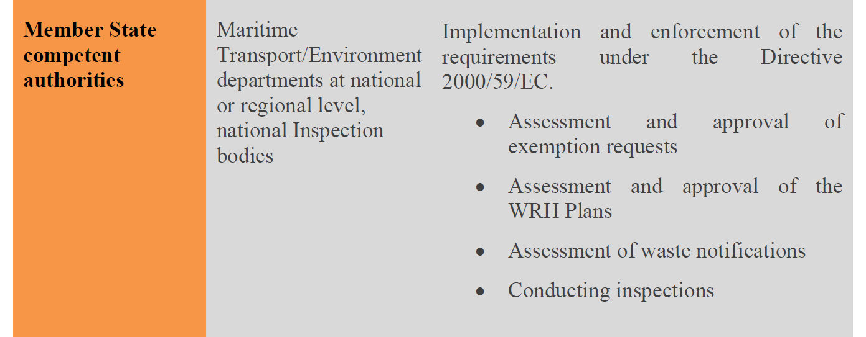
Will be marked as
<tr>
<th>
<p>Member State competent authorities</p>
</th>
<td>
<p>Maritime Transport/Environment departments at national or regional level, national Inspection bodies</p>
</td>
<td>
<block name="complexContent">
<subFlow name="structuredContent">
<subparagraph>
<content>
<p>Implementation and enforcement of the requirements under the Directive 2000/59/EC.</p>
</content>
</subparagraph>
<list>
<indent><num>•</num>
<content>
<p>Assessment and approval of exemption requests</p>
<content>
</indent>
…
</list>
</subFlow>
</block>
</td>
</tr>

The mark-up for images

The encoding of an image
The following encoding of an image can be available in AKN4EU:
- png, jpeg
- svg (SVG 1.1 only)

The <img> element
An image is marked with the element <img> and is inside a block element (<p>). It is a marker element (empty element) with the following attributes:
- @src (mandatory): contains the relative path to the image file;
- @alt (optional): holds the text to be displayed in case the loading of the external resource is not possible for any reason;
- @title (optional): This attribute contains single value text, which is used as the tooltip text for an element.
Example
<p><img src="EC.png" alt="EUROPEAN COMMISSION" title="EUROPEAN COMMISSION"/></p>

The mark-up for mathematical formula

The encoding of the scientific formula itself
Different options are available to encode a formula:
- using MathML 3.0, restricted to the presentation mark-up only
- using an image.
While the second option “using an image” remains available primarily for backward compatibility, it should be avoided as much as possible as the alphanumeric content is not accessible.
In any case, the content of the mathematical formula is in a specific file and reference to it is done using the element <img>.

The <img> element
A mathematical formula is marked with the element <img> and is inside a block element (<p>). The formula itself is in a specific file.

Local reference

Akoma Ntoso naming convention
In the Akoma Ntoso naming convention, fragment reference and local portion reference are both available.
Both use the @eId value as subdivision identifier.
The fragment reference is prefixed by a “#”, while the portion reference is prefixed by a “~”.

AKN4EU
In AKN4EU,
- @xml:id is the mandatory element identifier created at the drafting time and maintained during the whole life cycle of the document.
- @eId is a subdivision identifier, mainly used for final acts and for legacy documents. Its value is always meaningful and built on the localization of the element in the current file, using business concepts.
The syntax is aligned to the ELI convention for subdivisions, using the authority code of the authority table “subdivision”.
Both attributes can exist together inside the same file.
To be able to make reference using the two subdivision identifiers, AKN4EU provides the following specification:
- To express a local reference using the @xml:id as address information, AKN4EU uses the “~” prefix.
So, for example, “~INP” refers to an AKN4EU element, in the current file with @xml:id attribute sets to “INP”.
- To express a local reference using the @eId as address information, AKN4EU uses the “#” prefix.
So, for example, “#art_1” refers to an AKN4EU element, in the current file, with an @eId attribute set to “art_1”.

The syntax for the @xml:id in content

Introduction
For the content part of a XML file (excluding <meta> section), AKN4EU uses the following attributes :
- @xml:id, mandatory
this is a pure technical id
@xml:id is unique at the level of the AKN4EU file only.

Syntax of @xml:id
For the content part of an AKN4EU file only, the syntax for @xml:id in AKN4EU MUST be an alphanumerical value of up to 40 characters, autogenerated.
According to the standard syntax of @xml:id, it MUST start with a letter.

@xml:id and linguistic variants
See PART 1 - 11 Linguistic variants and synoptism.

Example
This example illustrates the mark-up with @xml:id for the <body> of an act.
<body> xml:id=”ue790H6SC9” >
<title xml:id="pgt894859W" >
<num xml:id="Z89W6h3JTRZ89W6h3JTRZ89W6h3JTRZ89W6h3JTR" >TITLE I</num>
<heading xml:id="t89W8gKaDu" >SCOPE, DEFINITIONS AND GENERAL PRINCIPLES</heading>
<chapter xml:id="c98uKhX3D3" >
<num xml:id="="FX3DdRd7xvFX3DdRd7xvFX3DdRd7xvFX3DdRd7xv" >CHAPTER I</num>
<heading xml:id="X3D3BbgQds" >Scope and definitions</heading>
<section xml:id="e7c5co1Kk" >
<num xml:id="o1KkPGLv9X" >Section 1</num>
<heading xml:id="o1KkX9L1Lfo1KkX9L1Lfo1KkX9L1Lfo1KkX9L1Lf" >Subject-matter and definitions</heading>
<article xml:id="s9B5350Cje" >
<num xml:id="BCjeIQYcep" >Article 1</num>
<heading xml:id="CjeP1k3OE" >
Subject-matter and scope</heading>
<paragraph xml:id="BCjeDeLRw7" >
<num xml:id="BCjecZyZekBCjecZyZekBCjecZyZekBCjecY78K4" >2.</num>
<content xml:id="BCjedWXflx" >
<p xml:id="BCjecQdgm1" >This Directive establishes rules on the procedures for procurement by contracting authorities with respect to public contracts as well as design contests, whose value is estimated to be not less than the thresholds laid down in Article 4.</p>
</content>
</paragraph>
<paragraph xml:id="BCjeSztxahBCjeSztxahBCjeSztxahBCjeSztxah" >
<num xml:id="BCjecZyZek" >2.</num>
<content xml:id="BCje3QXN8K" >
<p xml:id="BCje2xvJhq" >Procurement within the meaning of this Directive is the acquisition by means of a public contract of works, supplies or services by one or more contracting authorities from economic operators chosen by those contracting authorities, whether or not the works, supplies or services are intended for a public purpose.</p>
</content>
</paragraph>
...
</article>
...
</section>
</chapter>
</title>
…
</body>

Table of content
The mark-up of the content of the Table of content will be done using the Akoma Ntoso <toc> element, that is a block element.
The Akoma Ntoso <toc> element is only composed of <tocItem> for the item of the Table of Content. It does not contain element for a title of the Table of Content.
For this reason, the <toc> element MUST be encapsulated in a <blockContainer> that CAN contain a <heading> element.
For example:
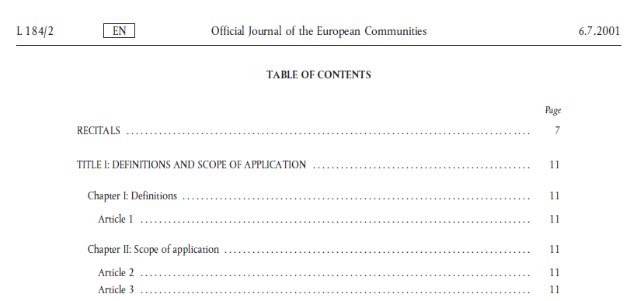
will be marked as:
<blockContainer>
<heading>TABLE OF CONTENTS</heading>
<toc>
…
</toc>
</blockContainer>
The element <toc> contains <tocItem> elements.
According to Akoma Ntoso, “the element “tocItem” is a component of the table of content and contains header information about sections or parts of the rest of the document”

<tocItem> is a block element that contains the following attributes:
- @href contains the reference to the corresponding subdivision
- @level that indicates the level in the hierarchy of subdivision
The elements <num> and <heading> are not allowed inside the <tocItem> element. So, to identify
- the number, the element <inline> with the @name set to "tocNumber",
- the subject, the element <inline> with the @name set to "tocHeading",
- the page, the element <inline> with the @name set to "tocPage".
For example,
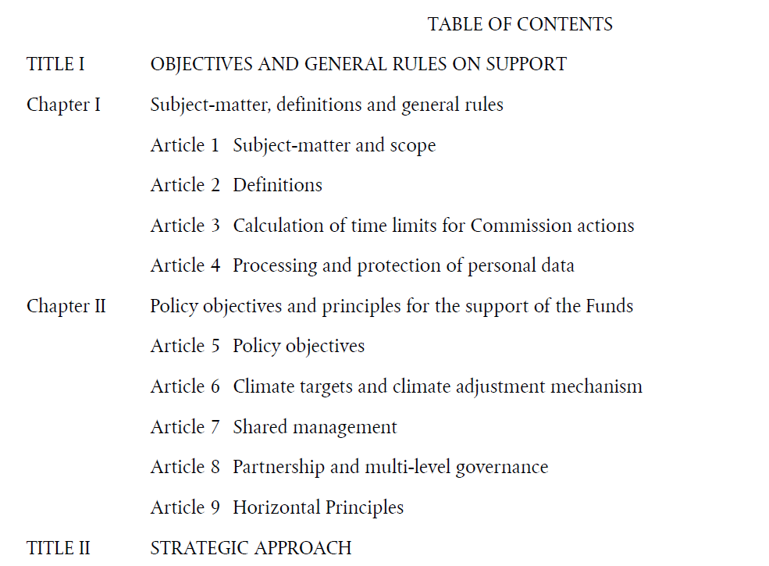
Will be marked as following:
<blockContainer>
<heading>TABLE OF CONTENTS</heading>
<toc>
<tocItem level="1" href=""><inline name="tocNumber">TITLE I </inline><inline name="tocHeading">OBJECTIVES AND GENERAL RULES ON SUPPORT </inline></tocItem>
<tocItem level="2" href=""><inline name="tocNumber">Chapter I </inline><inline name="tocHeading">Subject-matter, definitions and general rules</inline></tocItem>
<tocItem level="3" href=""><inline name="tocNumber">Article 1 </inline><inline name="tocHeading">Subject-matter and scope</inline></tocItem>
<tocItem level="3" href=""><inline name="tocNumber">Article 2 </inline><inline name="tocHeading">Definitions</inline></tocItem>
<tocItem level="3" href=""><inline name="tocNumber">Article 3 </inline><inline name="tocHeading">Calculation of time limits for Commission actions</inline></tocItem>
<tocItem level="3" href=""><inline name="tocNumber">Article 4 </inline><inline name="tocHeading">Processing and protection of personal data</inline></tocItem>
<tocItem level="2" href=""><inline name="tocNumber">Chapter II </inline><inline name="tocHeading">Policy objectives and principles for the support of the Funds</inline></tocItem>
<tocItem level="3" href=""><inline name="tocNumber">Article 5 </inline><inline name="tocHeading">Policy objectives</inline></tocItem>
<tocItem level="3" href=""><inline name="tocNumber">Article 6 </inline><inline name="tocHeading">Climate targets and climate adjustment mechanism</inline></tocItem>
<tocItem level="3" href=""><inline name="tocNumber">Article 7 </inline><inline name="tocHeading">Shared management</inline></tocItem>
<tocItem level="3" href=""><inline name="tocNumber">Article 8 </inline><inline name="tocHeading">Partnership and multi-level governance</inline></tocItem>
<tocItem level="3" href=""><inline name="tocNumber">Article 9 </inline><inline name="tocHeading">Horizontal Principles</inline></tocItem>
<tocItem level="1" href=""><inline name="tocNumber">TITLE II</inline><inline name="tocHeading">STRATEGIC APPROACH</inline></tocItem>
</toc>
</blockContainer>

Inline and marker elements for rendering

Soft page break
Sometimes, there is a need to force a page break, and this cannot be deduced from a structural mark-up.
Akoma Ntoso provides a “marker” element to indicate the page break: <eop/>.
This element is used, inside AKN4EU only as a “soft page break”.
It means that it is only used when there is no other semantic element that justify by itself a "page break" and the page break is a requirement for some external reason.
In consequence, the @number, @breakAt and @breakWith attributes are never used.
According to Akoma Ntoso, The <eop/> can be placed in any “block” or “inline” elements.
In AKN4EU, it is forbidden to place the <eop/> element inside a <table> element.
Example
Suppose that one table must be put, for any reason, on a new page.
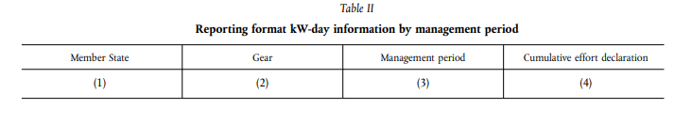
The corresponding mark-up will be:
<hcontainer name="BLOCK_TAB">
<num><eop/>Table II</num><heading>Reporting format kW-day information by management period</heading>
<hcontainer name="TAB" refersTo="ALPHA_GLOSSARY">
<content>
<table>
<tr >
…
</tr>
</table>
</content>
</hcontainer>
</hcontainer>

Soft line break
Sometimes there is a need to force a page break, and this cannot be deduced from a structural mark-up.
Akoma Ntoso provides a “marker” element to indicate the line break: <eol/>.
This element is used, inside AKN4EU as a “soft line break”.

Other elements for rendering
Normally, the mark-up of a text is defined so that the information on the rendering can be deduce from it.
But it arrives that there is no mark-up for specific rendering.
Akoma Ntoso provides mark-up for these information
<b> | Bold
<i> | Italic
<u> | Underline
<sub> | subscript text
<sup> | superscript text

AKN4EU file: the character set specification
Akoma Ntoso documents follows the Unicode Standard Version 14.0 and must be encoded using UTF-8 (8-bit Unicode Transformation Format). Using UTF-8 encoding allows to cover the official languages of the European Union and foreign alphabets.

The character set can be found in the Annex 2 together with the complete version of the Unicode character set.

The AKN4EU metadata

Attribute @source for the section of the metadata
According to Akoma Ntoso specifications,
‘Editors (i.e., the creators of the FRBR Manifestation) have two main tasks in the production process of Akoma Ntoso documents: on the one hand to identify and label (i.e. mark up) the fragments of the original content according to their role and structure, and on the other, to provide additional information about the document itself that is not contained in the official text as created by the original author.
Collectively, this additional information is called metadata. Since these are metadata elements, and since they are added at markup time, their specification is an editorial process, and not an authorial process, and come under the responsibility of the creator of the markup.’
For this reason, each section of the metadata has an attribute @source, containing the information on the provider of the section’s content.
In AKN4EU, the attribute @source MUST contain the reference to the TLCOrganization entry corresponding to the responsible organization that completes this section.
The element TLCOrganization has a mandatory attribute @href with, as value, the URI of the corresponding entry in the authority table ‘Corporate Body’ (https://publications.europa.eu/en/web/eu-vocabularies/at-dataset/-/resource/dataset/corporate-body).
Example:
<identification source="~PUBL">
…
<references source="~PUBL">
<TLCOrganization xml:id="PUBL"
href="http://publications.europa.eu/resource/authority/corporate-body/PUBL"
showAs="Publications Office"/>
…

The <identification> section of the metadata
In this version of AKN4EU, the following information is provided:

FRBRWork/preservation
The <preservation> is a metadata subsection containing an arbitrary list of elements detailing the preservation actions taken for the document is the respective level of the FRBR hierarchy.
Inside AKN4EU, the elements defined in <preservation> belong to the namespace “http://imfc.europa.eu/akn4eu” (prefix “akn4eu”)
<preservation> inside <FRBRWork> contains the following sub-elements:

<akn4eu:fileCUID>
It contains the CUID used in the name of the current file.
It is mandatory for any AKN4EU file that has a filename for which one component is a CUID.
Example:
<preservation xmlns:akn4eu="http://imfc.europa.eu/akn4eu">
<akn4eu:fileCUID value="[the CUID value of the file]"/>
</preservation>

<akn4eu:docCUID>
It contains the CUID used in the name of the AKN4EU_LEG file
It is mandatory for any AKN4EU file that is a sub-file of an AKN4EU_LEG document when the AKN4EU_LEG file has a CUID in its filename.

FRBRWork/FRBRcountry
For EU legislation, the value MUST be "EU":
<FRBRcountry value="EU"/>

FRBRWork/FRBRnumber
If it exists, the official number will be used to build the filename of the AKN4EU_LEG document as well as the file name of the “main” file (entry point of the AKN4EU_LEG).
In this case, it MUST be put in the @value attribute of the <FRBRnumber> metadata in the <FRBRWork> element for all component of the AKN4EU_LEG document.
If the official number is associated to a <TLCReference name=”identifier”> metadata, it is mandatory to make a link in the @refersTo attribute.
Every AKN4EU file MUST have a <akn4eu:docCUID> or an <FRBRnumber> metadata. It can have both.
Example
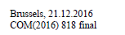
<meta>
<identification>
<FRBRWork>
…
<FRBRnumber value=”COM(2012) 466” refersTo="~prs3y"/>
</FRBRWork>
</identification>
<references>
…
<TLCReference xml:id="prs3y" name="identifier" href="http://publications.europa.eu/resource/authority/document-identifier-format/COM_NUMBER" showAs="COM(2012) 818" shortForm="COM/2012/466"/>
</references>
</meta>
<container name="mainDoc">
…
<block name="reference"> <docNumber refersTo="~prs3y">COM(2012) 818 <inline name="version" >final</inline></docNumber></block>
</container>

FRBRWork/FRBRprescriptive
This element is mandatory in the context of AKN4EU and provides information on which AKN4EU file is part of an act or a bill.
<FRBRprescriptive> has a @value attribute that is set to "true" if the AKN4EU file is part of an act or a bill (including the annexes and appendices) and "false" in other cases. It means for example, that
- every <documentCollection> has the @value of <FRBRprescriptive> set to "false";
- every <doc name="ANNEX"> has the @value of <FRBRprescriptive> set to "true" if the main document is a <bill> or an <act>;
- the "Explanatory Memorandum" of the "Proposal for an act" MUST have the @value of <FRBRprescriptive> set to "false".

FRBRExpression/preservation
This subsection contains the 3 following information: the drafting version of the whole document, the drafting version of the component and the translation version
- The drafting version of the whole document is in the @value attribute of the <akn4eu:docDraftVersion>,
- The drafting version of the component is in the @value attribute of the <akn4eu:fileDraftVersion>
- The translation version is in the @value of the docTranslationVersion.
Example:
<preservation xmlns:akn4eu="http://imfc.europa.eu/akn4eu">
<akn4eu:docDraftVersion value="1.0"/>
<akn4eu:fileDraftVersion value="5.0"/>
<akn4eu:docTranslationVersion value="1.0"/>
</preservation>

These pieces of information are MANDATORY if they are part of the filename, and SHOULD exist in the other case where the information is available.

FRBRExpression/FRBRversionNumber
If it exists, this metadata MUST contain, in its attribute @value the official version of the AKN4EU_LEG document.
Example:

<meta>
<identification>
<FRBRWork>
…
<FRBRnumber value=”COM(2012) 466” refersTo="~prs3y"/>
</FRBRWork>
<FRBRExpression>
<FRBRversionNumber value="final"</FRBRversionNumber>
</FRBRExpression>
</identification>
<references>
…
<TLCReference xml:id="prs3y" name="identifier" href="http://publications.europa.eu/resource/authority/document-identifier-format/COM_NUMBER" showAs="COM(2012) 818" shortForm="COM/2012/466"/>
</references>
</meta>
<container name="mainDoc">
…
<block name="reference"> <docNumber refersTo="~prs3y">COM(2012) 818 <inline name="version" >final</inline></docNumber></block>
</container>

FRBRExpression/FRBRlanguage
The attribute @language contains the language of the document.
The EU documents display the language in a two-letter code, following the rules and conventions of the Interinstitutional style guide (http://publications.europa.eu/code/en/en-000100.htm).
For this reason, the attribute @language MUST contain the two-letter code of the language of the XML document.
For multilingual documents, the two-letter code in AKN4EU is “mu”.
However, AKN4EU defines a method to provide the correspondence between the two-letter and the three-letter code of the language from the authority table 'Language':
In the references section of the metadata, a TLCReference entry MUST be provided, giving the information on the three-letter code. The @showAs of this element MUST be the corresponding two-letter code of the language.
Example:
<FRBRlanguage language="en"/>
...

<references source="…">
<TLCReference name="language"
href="http://publications.europa.eu/resource/authority/language/ENG"
showAs="en"/>
And for multilingual language:
<FRBRlanguage language="mu"/>
...

<references source="…">
<TLCReference name="language"
href="http://publications.europa.eu/resource/authority/language/MUL"
showAs="mu"/>

FRBRExpression/FRBRtranslation
This metadata contains information regarding the translation.
It has the following attributes:
- @fromLanguage
Mandatory, it contains the original language in a 2-letter code representing the language (‘mu’ for multilingual document).
- @href
optional, contains the AKN4EU file in the original language
- @by
optional, it contains, inside <organization> the service that is responsible for the translation.
If the original language is part of the filename, it is mandatory to have a <meta>/<identification>/<FRBRExpresion>/<FRBRTranslation> metadata with the @fromLanguage containing the original language code (2-letter code)
Example of linguistic information for a translation:
<meta>
<identification>
<FRBRExpression>
<FRBRLanguage language="fr"/>
<FRBRtranslation href="EXPL_MEMORANDUM-cjld2cyuq0000t3rmniod1foy-0.1-en.xml"
fromLanguage="en" by="~DGT"/>
…
</FRBRExpression>
…
</identification>
…
<TLCReferences>
<TLCOrganization xml:id="DGT"
href="http://publications.europa.eu/resource/authority/corporate-body/DGT"
showAs="Directorate-General for Translation"/>
<TLCReference name="language"
href=http://publications.europa.eu/resource/authority/language/FRA
showAs="fr"/>
<TLCReference name="language"
href=http://publications.europa.eu/resource/authority/language/ENG
showAs="en"/>
</TLCReferences>
</meta>

FRBRManifestation/preservation
As from the AKN4EU 4.0 baseline, this element is MANDATORY and is used to store the information related to the version of AKN4EU used for the mark-up of the instance.
From AKN4EU 4.1, this element MUST also contain the link to the official documentation page of AKN4EU.
Example
<preservation xmlns:akn4eu="http://imfc.europa.eu/akn4eu">
<akn4eu:akn4euVersion value="4.1.0.0"/>
<akn4eu:akn4euDocumentation href="https://op.europa.eu/en/web/eu-vocabularies/dataset/-/resource?uri=http://publications.europa.eu/resource/dataset/akn4eu"/>
</preservation>

The <references> section of the metadata
The references section contains entries pointing to the ontology.
General convention for the @xml:id attribute of reference metadata
By default, for any TLC metadata with the @href pointing to an entry of an authority table (+ TLCProcess”), the @xml:id attribute MUST be defined using the corresponding authority code.
For these TLC metadata,
- @href MUST be the URI of the corresponding entry in the authority table
- @showAs MUST be the label of this entry in the authority table, in the language of the AKN4EU file.
However, the following entries in <references> cannot follow this rule:
- <TLCReference name="identifier">, metadata relative to one identifier of document; the @showAs and @shortForm have a specific rule.
- <TLCReference name=”language”> : the @xml_id is optional and @showAs contains the 2-letter code of the language (‘mu’ for multilingual).
<TLCReference name="procedureReference">: @href contains the EUR-lex reference of the procedure page in the language of the document; @showAs contains the procedure reference; @shortForm has a specific rule.The types of references are the following:
Type of reference | Mark-up
Act amended (to be related with the <activeModifications> metadata)  See the section concerning amendments | <activeRef>
Type of document  Authority table “resource type” | <TLCReference name="docType">
Subject | <TLCReference name="contentSubject">
Location  Authority table “place” | <TLCLocation>
Institution or other organisation  Authority table “corporate body” or “Country” | <TLCOrganization>
Role  Authority table “role” | <TLCRole>
Language  Authority table “language” | <TLCReference name="language">  @showAs MUST contain the 2-letter code of the language.
Indicates the step in a Legislative process  Authority table “procedure phase” | <TLCProcess>
Provides the structure of a document identifier  Authority table “document identifier format” | <TLCReference name="identifier">  @href is the URI of entry in the authority table "document-identifier-format" corresponding to the type of document identifier (for example for the COM-NUMBER it would be "http://publications.europa.eu/resource/authority/document-identifier-format/COM_NUMBER")  @showAs contains the identifier as it is inside the document or according to the naming convention of the organization responsible of the document  @shortForm contains the normalized syntax of the identifier:  - splitting the identifier into its components separated by “/”  - removing leading zero(s) of the sequential number component.  Examples  </meta>  <TLCReference xml:id="prs3y" name="identifier"  href="http://publications.europa.eu/resource/authority/document-identifier-format/COM_NUMBER"  showAs="COM(2016) 818"  shortForm="COM/2016/818"/>  …  </meta>  …  <docNumber refersTo=”~prs3y”>COM(2016) 818</docNumber>  Or  <meta>  …  <TLCReference xml:id="vzs3y" name="identifier"  href="http://publications.europa.eu/resource/authority/document-identifier-format/COM_NUMBER"  showAs="COM(2016)0818"  shortForm="COM/2016/818"/>  …  </meta>  (<docNumber refersTo=”~vzs3y”>COM(2016)0818</docNumber – …)
Other references. Currently  Authority table:  - subdivision-content  - subdivisions | <TLCConcept>  - The content of a subdivision of text  - The type of a subdivision of text
Provides the information on one Legislative procedure | <TLCReference name="procedureReference">  @href contains the EUR-lex reference of the procedure page in the language of the document;  @showAs contains the procedure reference as it is inside the document or according to the naming convention of the organization responsible of the document;  @shortForm contains the normalized syntax of the procedure reference,  - splitting the procedure reference into its components separated by “/”  - removing leading zeros of the sequential number component.  Example  <TLCReference xml:id="procedure_2016_411"  name="procedureReference"  href=http://eur-lex.europa.eu/procedure/EN/2016_411  showAs="2016/0411 (COD)"  shortForm="2016/411/COD/RDG1"/>  …  </meta>  <docketNumber refersTo="~procedure_2016_411">2016/0411 (COD)</docketNumber>
Examples
<TLCReference xml:id="REG" name="docType"
href="http://publications.europa.eu/resource/authority/resource-type/REG"
showAs="Regulation"/>

<TLCLocation xml:id="BEL_BRU"
href="http://publications.europa.eu/resource/authority/place/BEL_BRU" showAs="Brussels"/>

<TLCOrganization xml:id="CONSIL" href="http://publications.europa.eu/resource/authority/corporate-body/CONSIL" showAs="Council of the European Union"/>
<TLCOrganization xml:id="EP" href="http://publications.europa.eu/resource/authority/corporate-body/EP" showAs="European Parliament"/>
<TLCRole xml:id="PRESID" href="http://publications.europa.eu/resource/authority/role/PRESID" showAs="President”/>
<TLCProcess xml:id="RDG1"
href="http://publications.europa.eu/resource/authority/procedure-phase/RDG1"
showAs="First reading"/>

The <analysis>/<otherReferences>
This section defines the following metadata:

<implicitReference>
This metadata is used to identify the document to which the current document reacts.
The following attributes MUST be used
- @refersTo
contains a reference to the metadata defining the type of the document;
- @href
provides the ELI URI of the document
- @showAs
provides the string that serves as the identifier of the document, with the syntax used inside the document or by the organization responsible of the document.
The following attribute CAN be used
- @for
Contains the reference to the corresponding <TLCReference name="identifier">
Example: the "Proposal for an act" that initiates the procedure, for an EP Text Adopted.
<analysis source="~PUBL">
<otherReferences source="~PUBL">
<implicitReference xml:id="com-2015-583" for="~prs3y1" refersTo="~PROP_ACT"
href="http://data.europa.eu/eli/prop_act/2015/583" showAs="COM(2015)0583"/>
</otherReferences>
</analysis>
<references source="~PUBL">
<TLCReference xml:id="PROP_ACT" name="docType"
href="http://publications.europa.eu/resource/authority/resource-type/PROP_ACT"
showAs="Proposal for an act"/>
<TLCReference xml:id="prs3y1" name="identifier"
href="http://publications.europa.eu/resource/authority/document-identifier-format/COM_NUMBER" showAs="COM(2015)0583" shortForm="COM/2015/583"/>
</references>

<alternativeReference>
This metadata is used to indicate an alternative reference for the legal reference.
Example: It is used, for example, for the EP Text Adopted, when there is a comment indicating the corresponding act inside the consolidated text abridged.
<alternativeReference xml:id="reg-2017-1129" href="http://data.europa.eu/eli/reg/2017/1129" showAs="Regulation (EU) 2017/1129"/>

AKN4EU mandatory metadata

Metadata that MUST be present in any AKN4EU file
- <identification> section
  - The metadata required by Akoma Ntoso even if not used by AKN4EU
    - In <FRBRWork>, <FRBRExpression> and <FRBRManifestation>, the following meta with empty value:
<FRBRthis value=""/>,
<FRBRuri value=""/>,
<FRBRdate date="2999-01-01" name=""/>,
<FRBRauthor href=""/>
  - In <FRBRWork>, the <FRBRcountry> with the value “EU” for every EU documents
  - In <FRBRWork>, the <FRBRprescriptive> is mandatory. Its value (“true” or “false”) depends on the document type.
  - In <FRBRExpression>, the <FRBRlanguage>.
The @value attribute contains the 2-letter code of the language of the file.
For the "main" file, it is the 2-letter code of the AKN4EU_LEG package (leg package).
It is mandatory to have, in the <reference> section of metadata, a <TLCReference name="language"> associated.
  - Every AKN4EU file MUST have
a <FRBRWork>/<FRBRnumber>
or
a <FRBRWork>/<preservation>/akn4eu:docCUID
  - In <FRBRManifestation>, a <preservation> with the following mandatory metadata:
    - <akn4eu:akn4euVersion> with the @value attribute containing the AKN4EU version used to mark this file;
    - <akn4eu:akn4euDocumentation> with the @href attribute containing the URI of the page with the AKN4EU documentation.

Metadata that MUST be present in AKN4EU file as th information is used in the filename of the AKN4EU_LEG package or AKN4EU file
General rules
- Every metadata used as component of the AKN4EU file MUST be present in the <identification> section of metadata of this file.
- The identifier part of the filename of the AKN4EU_LEG package must be present as metadata of all AKN4EU file of the package
(meta <akn4eu:docCUID> or <FRBRnumber>).
- If the filename of the AKN4EU_LEG package contains the version, <akn4eu:docDraftVersion> (in case of draft version) or <FRBRversionNumber> (in case of official version) must be present as metadata in all AKN4EU files included in the AKN4EU_LEG package.
Examples:
Filenames of AKN4EU_LEG package and its components | Related metadata
Simple way: filename is based on document type, CUID and language. | Mandatory per file  main  <akn4eu:docCUID value="c2jr8rsld00003t61c4ebttom"/>  <akn4eu:fileCUID value="c2jr8rsld00003t61c4ebttom"/>  <FRBRlanguage language="en"/>  EXPL_MEMORANDUM  <akn4eu:docCUID value="c2jr8rsld00003t61c4ebttom"/>  <akn4eu:fileCUID value="cynpjuz2v00013t61dbxc5ev9"/>  <FRBRlanguage language="en"/>  REG  <akn4eu:docCUID value="c2jr8rsld00003t61c4ebttom"/>  <akn4eu:fileCUID value="cacozvkv500033t61m9o2di0g"/>  <FRBRlanguage language="en"/>  ANNEX  <akn4eu:docCUID value="c2jr8rsld00003t61c4ebttom"/>  <akn4eu:fileCUID value="cmd7dm733000b3t61og8lkll7"/>  <FRBRlanguage language="en"/>  OPTIONAL  <akn4eu:docDraftVersion value="…"/> < !—version AKN4EU_LEG -->  <akn4eu:fileDraftVersion value="…"/>
Leg filename CAN also contain the draft version of AKN4EU_LEG package | Mandatory per file  main  <akn4eu:docCUID value="c2jr8rsld00003t61c4ebttom"/>  <akn4eu:fileCUID value="c2jr8rsld00003t61c4ebttom"/>  <FRBRlanguage language="en"/>  <akn4eu:docDraftVersion value="1.0"/>  EXPL_MEMORANDUM  <akn4eu:docCUID value="c2jr8rsld00003t61c4ebttom"/>  <akn4eu:fileCUID value="cynpjuz2v00013t61dbxc5ev9"/>  <FRBRlanguage language="en"/>  <akn4eu:docDraftVersion value="1.0"/>  REG  <akn4eu:docCUID value="c2jr8rsld00003t61c4ebttom"/>  <akn4eu:fileCUID value="cacozvkv500033t61m9o2di0g"/>  <FRBRlanguage language="en"/>  <akn4eu:docDraftVersion value="1.0"/>  ANNEX  <akn4eu:docCUID value="c2jr8rsld00003t61c4ebttom"/>  <akn4eu:fileCUID value="cmd7dm733000b3t61og8lkll7"/>  <FRBRlanguage language="en"/>  <akn4eu:docDraftVersion value="1.0"/>  Optional  <akn4eu:fileDraftVersion value="…"/>
The “fileDraftVersion” and the “docDraftVersion” are components of the filename | Mandatory per file  main  <akn4eu:docCUID value="c2jr8rsld00003t61c4ebttom"/>  <akn4eu:fileCUID value="c2jr8rsld00003t61c4ebttom"/>  <FRBRlanguage language="en"/>  <akn4eu:docDraftVersion value="1.0"/> < !—version AKN4EU_LEG -->  <akn4eu:fileDraftVersion value="1.0"/>  EXPL_MEMORANDUM  <akn4eu:docCUID value="c2jr8rsld00003t61c4ebttom"/>  <akn4eu:fileCUID value="cynpjuz2v00013t61dbxc5ev9"/>  <FRBRlanguage language="en"/>  <akn4eu:docDraftVersion value="1.0"/> < !—version AKN4EU_LEG -->  <akn4eu:fileDraftVersion value="2.0"/>  REG  <akn4eu:docCUID value="c2jr8rsld00003t61c4ebttom"/>  <akn4eu:fileCUID value="cacozvkv500033t61m9o2di0g"/>  <FRBRlanguage language="en"/>  <akn4eu:docDraftVersion value="1.0"/> < !—version AKN4EU_LEG -->  <akn4eu:fileDraftVersion value="1.0"/>  ANNEX  <akn4eu:docCUID value="c2jr8rsld00003t61c4ebttom"/>  <akn4eu:fileCUID value="cmd7dm733000b3t61og8lkll7"/>  <FRBRlanguage language="en"/>  <akn4eu:docDraftVersion value="1.0"/> < !—version AKN4EU_LEG -->  <akn4eu:fileDraftVersion value="5.0"/>
The filename of the leg package (and the main filename) are build with this official number and official version | Mandatory per file  main  <FRBRnumber value="COM(2018) 32" refersTo="…"/>  <FRBRversionNumber value="final"/>  <FRBRlanguage language="en"/>  EXPL_MEMORANDUM  <FRBRnumber value="COM(2018) 32" refersTo="…"/>  <FRBRversionNumber value="final"/>  <akn4eu:fileCUID value="cynpjuz2v00013t61dbxc5ev9"/>  <FRBRlanguage language="en"/>  REG  <FRBRnumber value="COM(2018) 32" refersTo="…"/>  <FRBRversionNumber value="final"/>  <akn4eu:fileCUID value="cacozvkv500033t61m9o2di0g"/>  <FRBRlanguage language="en"/>  ANNEX  <FRBRnumber value="COM(2018) 32" refersTo="…"/>  <FRBRversionNumber value="final"/>  <akn4eu:fileCUID value="cmd7dm733000b3t61og8lkll7"/>  <FRBRlanguage language="en"/>  OPTIONAL  <akn4eu:docCUID value="…"/>  <akn4eu:docDraftVersion value="…"/> < !—version AKN4EU_LEG -->  <akn4eu:fileDraftVersion value="…"/>
The COM number is component of the leg (and main) filename but the official version is uncknown | Mandatory per file  main  <FRBRnumber value="COM(2018) 32" refersTo="…"/>  <FRBRlanguage language="en"/>  EXPL_MEMORANDUM  <FRBRnumber value="COM(2018) 32" refersTo="…"/>  <akn4eu:fileCUID value="cynpjuz2v00013t61dbxc5ev9"/>  <FRBRlanguage language="en"/>  REG  <FRBRnumber value="COM(2018) 32" refersTo="…"/>  <akn4eu:fileCUID value="cacozvkv500033t61m9o2di0g"/>  <FRBRlanguage language="en"/>  ANNEX  <FRBRnumber value="COM(2018) 32" refersTo="…"/>  <akn4eu:fileCUID value="cmd7dm733000b3t61og8lkll7"/>  <FRBRlanguage language="en"/>  OPTIONAL  <akn4eu:docCUID value="…"/>  <akn4eu:docDraftVersion value="…"/>  <akn4eu:fileDraftVersion value="…"/>
Providing the translation to the following file:
The “docDraftVersion” and the “fileDraftVersion” are part of the filename, no official number:
3
If the filename for the translated package contains the original language and the translation version. | Mandatory per file  main  <akn4eu:docCUID value="c2jr8rsld00003t61c4ebttom"/>  <akn4eu:fileCUID value="c2jr8rsld00003t61c4ebttom"/>  <FRBRlanguage language="fr"/>  <akn4eu:docDraftVersion value="1.0"/> <!— AKN4EU_LEG -->  <akn4eu:fileDraftVersion value="1.0"/>  <FRBRtranslation href=" main-c2jr8rsld00003t61c4ebttom-1.0_1.0-en.xml" fromLanguage="en" by="~DGT"/>  <akn4eu:docDraftTranslation value="1.0"/>  EXPL_MEMORANDUM  <akn4eu:docCUID value="c2jr8rsld00003t61c4ebttom"/>  <akn4eu:fileCUID value="cynpjuz2v00013t61dbxc5ev9"/>  <FRBRlanguage language="fr"/>  <akn4eu:docDraftVersion value="1.0"/> <!— AKN4EU_LEG -->  <akn4eu:fileDraftVersion value="2.0"/>  <FRBRtranslation href="EXPL_MEMORANDUM-cynpjuz2v00013t61dbxc5ev9-1.0_2.0-en.xml" fromLanguage="en" by="~DGT"/>  <akn4eu:docDraftTranslation value="1.0"/>  REG  <akn4eu:docCUID value="c2jr8rsld00003t61c4ebttom"/>  <akn4eu:fileCUID value="cacozvkv500033t61m9o2di0g"/>  <FRBRlanguage language="fr"/>  <akn4eu:docDraftVersion value="1.0"/> <!— AKN4EU_LEG -->  <akn4eu:fileDraftVersion value="1.0"/>  <FRBRtranslation href="REG-cacozvkv500033t61m9o2di0g-1.0_1.0-en.xml" fromLanguage="en" by="~DGT"/>  <akn4eu:docDraftTranslation value="1.0"/>  ANNEX  <akn4eu:docCUID value="c2jr8rsld00003t61c4ebttom"/>  <akn4eu:fileCUID value="cmd7dm733000b3t61og8lkll7"/>  <FRBRlanguage language="fr"/>  <akn4eu:docDraftVersion value="1.0"/> <!— AKN4EU_LEG -->  <akn4eu:fileDraftVersion value="5.0"/>  <FRBRtranslation href="ANNEX-cmd7dm733000b3t61og8lkll7-1.0_5.0-en.xml" fromLanguage="en" by="~DGT"/>  <akn4eu:docDraftTranslation value="1.0"/>
If the original language and the translation version are not part of the filename of the translated leg package: | Mandatory per file  main  <akn4eu:docCUID value="c2jr8rsld00003t61c4ebttom"/>  <akn4eu:fileCUID value="c2jr8rsld00003t61c4ebttom"/>  <FRBRlanguage language="fr"/>  <akn4eu:docDraftVersion value="1.0"/> < !—version AKN4EU_LEG -->  <akn4eu:fileDraftVersion value="1.0"/>  EXPL_MEMORANDUM  <akn4eu:docCUID value="c2jr8rsld00003t61c4ebttom"/>  <akn4eu:fileCUID value="cynpjuz2v00013t61dbxc5ev9"/>  <FRBRlanguage language="fr"/>  <akn4eu:docDraftVersion value="1.0"/> < !—version AKN4EU_LEG -->  <akn4eu:fileDraftVersion value="2.0"/>  REG  <akn4eu:docCUID value="c2jr8rsld00003t61c4ebttom"/>  <akn4eu:fileCUID value="cacozvkv500033t61m9o2di0g"/>  <FRBRlanguage language="fr"/>  <akn4eu:docDraftVersion value="1.0"/> < !—version AKN4EU_LEG -->  <akn4eu:fileDraftVersion value="1.0"/>  OPTIONAL  <FRBRtranslation href="…" fromLanguage="en" by="…"/>  <akn4eu:docDraftTranslation value="…"/>
Providing the translation to the following file:
The official number and the official version are part of the filename:
The translated package: | Mandatory per file  main  <FRBRnumber value="COM(2018) 32" refersTo="…"/>  <FRBRversionNumber value="final"/>  <FRBRlanguage language="fr"/>  EXPL_MEMORANDUM  <FRBRnumber value="COM(2018) 32" refersTo="…"/>  <FRBRversionNumber value="final"/>  <akn4eu:fileCUID value="cynpjuz2v00013t61dbxc5ev9"/>  <FRBRlanguage language="fr"/>  REG  <FRBRnumber value="COM(2018) 32" refersTo="…"/>  <FRBRversionNumber value="final"/>  <akn4eu:fileCUID value="cacozvkv500033t61m9o2di0g"/>  <FRBRlanguage language="fr"/>  OPTIONAL  <akn4eu:docCUID value="…"/>  <FRBRtranslation href="…" fromLanguage="en" by="…"/>  <akn4eu:docDraftTranslation value="…"/>

Amending acts in AKN4EU

The organization of the amendments
In an amending act, the amendment (the specification of a modification to another act) is always specified inside a structure, generally a point. In case of multiple amendments, their order follows the order of the structures affected in the amended act.
Each amendment specifies the location affected in the amended act and the operation to perform on this fragment.
The points containing an amendment can be grouped by the structure of the amended document, for example:
- by article;
- by paragraph of article;
- by subparagraph;
- by point.
In practical terms, the standard structure of the amending part of an act is the following:
Structure of the amending act | Content
article | all the amendments on one act
intermediate points inside the article | all the amendments on one structure of an act where there are multiple amendments on it
last level of point | one amendment

Example:
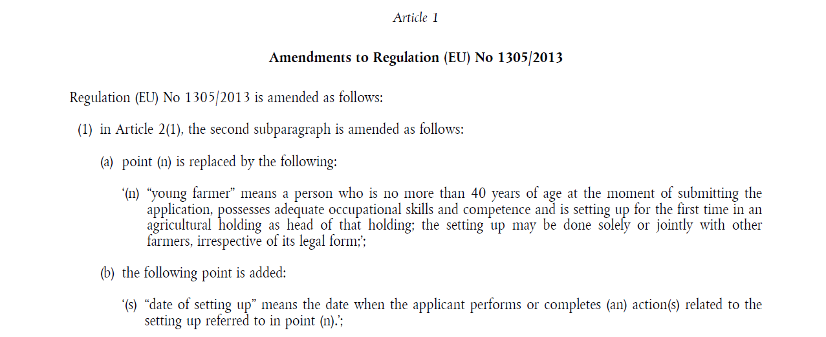

The reference to the amended act
The amending act contains a reference to the amended act. This reference is generally included in the introductory part introducing all the amendments to this act (see previous example).
The reference inside an act is a reference without information on a precise version of the amended act.

The overall structure of an amendment
The amendment contains:
- the description of the amendment (the precise location of the modification inside the amended act and the operation to apply);
- if the amendment is a modification or an addition/insertion of a new subdivision, the 'text of the amendment', that is:
  - the new subdivision(s) of text that replace(s) existing subdivision(s) or is(are) added/inserted. In these cases, all new subdivisions of one amendment are encompassed by the same quotation marks;
  - when the amendment is a fragment of structure (text or sentence), the old and the new text are inside their own quotation marks.
Example of amendment:
Description of the amendment
Text of the amendment
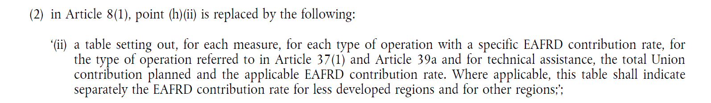

The description of the amendment
The description of each amendment is composed of the following components:

The location
The reference is not a complete reference but only the last part of a reference. The complete reference for the previous example above would be:
Regulation (EU) No 1305/2013, Article 8(1), point (h)(ii)

The operation
The operation of the amendment on the amended act can be one of the values of the first ("Text") column in the table below.
Text | Characteristics
is replaced by  are replaced by | Provides the new content for a structure.
is added  are added | Introduces a new structure at the end of the parent structure.
is inserted  are inserted | Introduces a new structure before or in-between the sibling structures.
is deleted  are deleted | Removes the structure referenced.

The 'text of the amendment'
The 'text of the amendment' is in the amending act and corresponds to the text to be added, inserted or which replaces the existing text in the act to be amended.
The text of the amendment is always completely encompassed by quotation marks. Notes are also inside the quoted structure (see below ).
text of the amendment
Example:
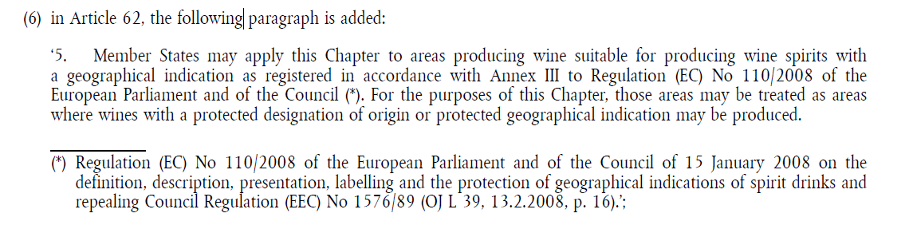
The amendment can be:
- on a complete structure,
- on text. In this case, the amendment can be general or specific to a particular position. In the latter case, the amending provision contains also the old word(s) to be replaced.
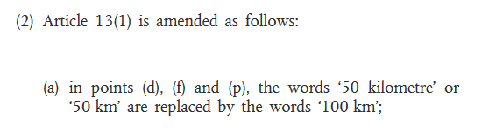
text of the amendment
A note in a text of amendment is not considered as a note of the current document (amending act). They are considered as note of the amended act. For this reason, they are not numbered in the flow of the classical notes of the document. The call is indicated by a system of “*”.
All the notes of one text of amendment are displayed at the end of this text of the amendment and not at the bottom of the page.
Their final number will in fact be assigned at the consolidation time, when the amendment is applied and the text of amendment is included in its final place in the amended act.
text of the amendment
Example
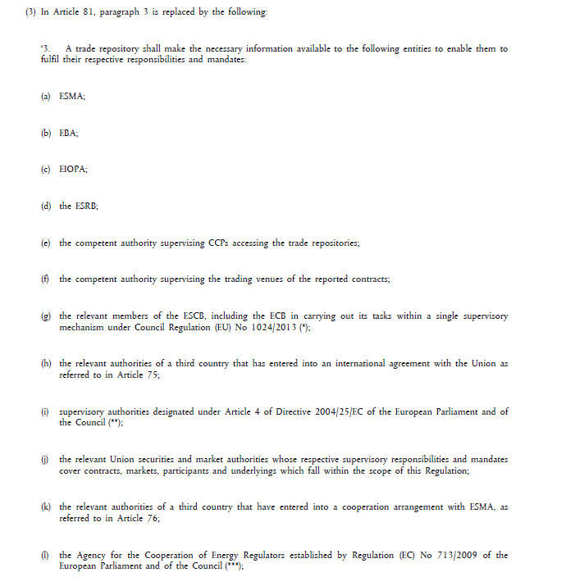
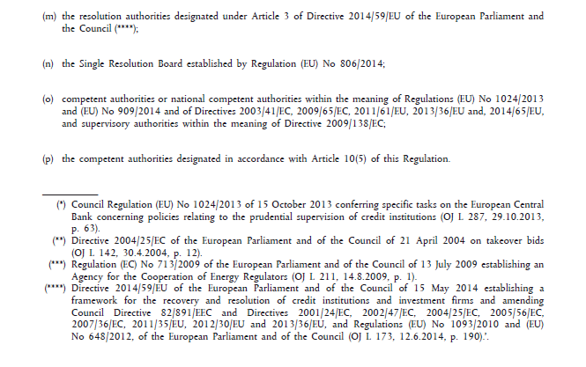
Notes of the ‘text of amendment ‘

The amendment of an annex

The addition, insertion or replacement of a complete annex
To express the addition, insertion or replacement of an annex, the amending act can have the following structures:
- In the enacting terms, an amending provision indicating:
  - the operation to perform;
  - the relevant annex in the amended act; and
  - the annex of the amending act that contains the new annex.
- An annex of the amending act containing the new annex.
Example:
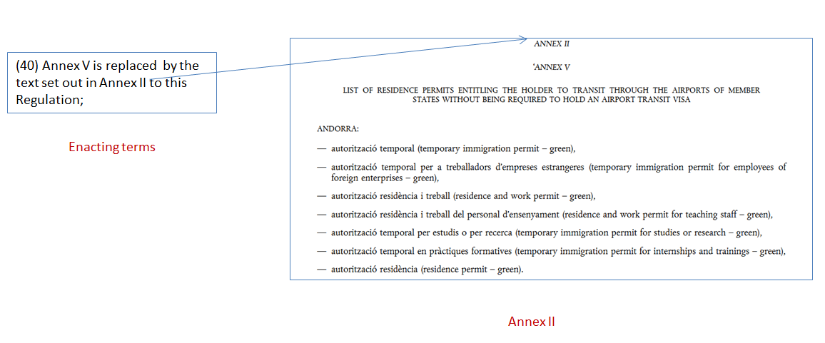
http://data.europa.eu/eli/reg/2019/1155/art_1/unp_1/pnt_40

Modification inside an annex
When only part of an annex is changed, the amendments are described like the amendments to the enacting terms of an act.
Sometimes, the amendment is expressed completely in the enacting terms, but often the amendments are expressed in the annex and one provision of the enacting terms provides the information on:
- The annex(es) that is(are) amended;
- The annex of the amending act that contains all the amendments to the annex(es).
Example:
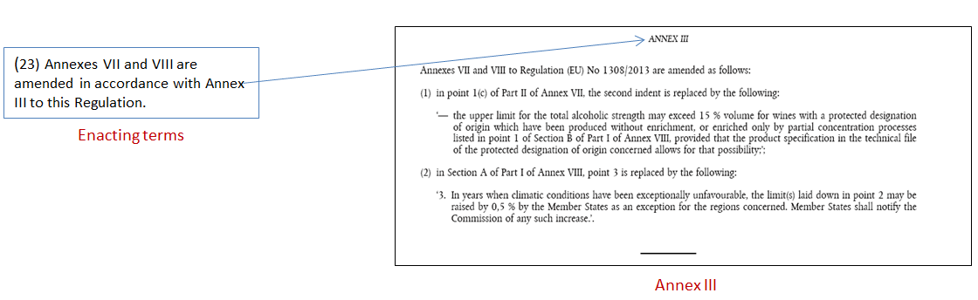
http://data.europa.eu/eli/reg/2017/2393/art_4.par_1.sub_1.pnt_23

Deletion of an annex
The amending provision is in the enacting terms.
Example:
(42) Annexes VII, VIII and IX are deleted;

Special cases

Addition of an annex in an act that has only one annex.
When an act has only a single annex, the annex is not numbered.
For adding a new annex, two amending provisions are provided:
- One to assign a number to the existing annex;
- One to provide the information on the annex(es) to be added.
Example:
(44) the Annex becomes Annex I;
…
(46) the text set out in the Annex to this Regulation is added as Annex II.

The AKN4EU mark-up for the amendment
Akoma Ntoso provides two types of mark-up for amendments:
- the mark-up of the text;
- the metadata expressing in a standardized way the operation to be applied.

The reference to the amended act
Inside the text, the reference to the amended act (see The reference to the amended act) SHOULD be marked up with the element <affectedDocument>. If <affectedDocument> is used, the @href attribute MUST contain the ELI URI of the act.
The reference inside an act will be a reference without information on a precise version of the amended act (a ‘relative’ or ‘virtual reference’, so the ELI URI does not end with "/oj").
Therefore, in the following example:
the mark-up will be as follows:
<p><affectedDocument href="http://data.europa.eu/eli/reg/2013/1305">Regulation (EU) No 1305/2013</affectedDocument> is amended as follows:</p>
In the amending act, there is no indication of the specific version of the amended act to be modified. The version to be amended is the version ‘in force’ at the moment in time when the amendment is to be applied, which is not necessarily the last version published in the Official Journal.
In our example, the amended act Regulation (EU) No 1305/2013 had been modified several times prior to the modifications stated in the amending act of the example. The OP builds a consolidated version of the act, i.e. a new Expression of the act after applying the amendments of the successive amending acts on this act.
For the example amended act Regulation (EU) No 1305/2013 OP had created consolidated versions with the following dates:
- 05/02/2018
- 01/01/2018
- 20/05/2017
- 23/05/2015
- 24/12/2014
- 25/09/2014
- 01/01/2014
The consolidated versions do not have legal value, so they cannot be referenced as is in the content of an act. This is the reason why the value of the @href attribute of the <affectedDocument> MUST only contain an ELI virtual reference (= dynamic reference). It corresponds to a reference to a Work.
If a reference to the specific consolidation (Expression) exists, it is inserted in the metadata <activeRef>, in the <references> section.
According to Akoma Ntoso, ‘The element activeRef is a metadata reference to the Akoma Ntoso IRI of a document that is modified by this document (i.e., an active reference).’
The following attributes of <activeRef> MUST be used:
- @href MUST contain the ELI reference of the relevant version to take into account (the latest consolidated version at the time of the amendment or the original version in case there had been no amendment to this act before).
- @showAs MUST contain the content of the element <affectedDocument> and between parentheses,
  - the date of the consolidation used or
  - "OJ" if the original version is used.
Examples:
The reference to a consolidated version of the act:
<meta>
…
<activeRef href="http://data.europa.eu/eli/reg/2013/1305/2017-05-20" showAs="Regulation (EU) No 1305/2013 (consolidation 2017-05-20)"/>
</meta>

The reference to the original version as published in the OJ:
<meta>
…
<activeRef href="http://data.europa.eu/eli/reg/2013/1305/oj"showAs="Regulation (EU) No 1305/2013 (OJ)"/>
</meta>

If no consolidated version exists, but the current version is not the version published in the Official Journal, the <activeRef> MUST not be used.

The mark-up of the text of an amendment

The element <mod>
To encapsulate all the text of an amendment, Akoma Ntoso provides the element <mod>. Only the text specific to one amendment is to be marked-up with the element <mod>.
Consequently, in the following example, the part in green must be in a <mod> element (there are two <mod> in the following example):


The elements <quotedStructure> and <quotedText>
To encapsulate the 'text of the amendment', two elements are provided:
- <quotedStructure> MUST be used if the content is a complete subdivision
- <quotedStructure> MUST be used if the content is a complete annex
- <quotedText> MUST be used if the content is a fragment of a subdivision (word or sentence).
Both elements have the following attributes to manage the quotation marks:
- @startQuote containing the opening quotation mark of the ‘text of the amendment’,
- @endQuote containing the closing quotation mark of the ‘text of the amendment’,
- @inlineQuote containing the character showing continuation of a quote e.g at the beginning of each line of the quote (not used).

Examples:

When the content is a complete subdivision
<quotedStructure startQuote="‘" endQuote="‘">
<point><num>(n)</num>
<content><p>“young farmer” means a person who is no more than 40 years of age at the moment of submitting the application, possesses adequate occupational skills and competence and is setting up for the first time in an agricultural holding as head of that holding; the setting up may be done solely or jointly with other farmers, irrespective of its legal form;</p></content>
</point>
</quotedStructure>
When the content is a complete annex
In this case, the <quotedStructure> MUST only contain a <documentRef> element. The @href mandatory attribute of this element MUST contain the relative path to the xml file containing the text of the annex.
<quotedStructure startQuote="‘" endQuote="‘">
<documentRef href="annex2-annex5.xml" showAs="ANNEX V"/>
</quotedStructure>
When the content is a fragment of a subdivision
the words <quotedText startQuote="'" endQuote="'">50 kilometre</quotedText> or <quotedText startQuote="'" endQuote="'">50 km</quotedText> are replaced by the words <quotedText startQuote="'" endQuote="'">100 km</quotedText>…

The last punctuation character of an amendment
If exists, the last punctuation character included at the end of <mod>, but outside the <quotedStructure> SHOULD be marked with the element <inline> with value "punctuationMod" for the mandatory @name attribute.
This mark-up CAN be used to mark the last punctuation mark of a <mod> element even if there is no 'text of the amendment'.
<mod>in paragraph 5, the second subparagraph is deleted<inline name="punctuationMod" >.</inline></mod>

General example of mark-up of the text of an amendment
For the following example:
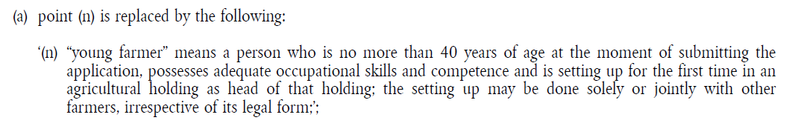
the mark-up will be as follows:
<point>
<num>(a)</num>
<content>
<p><mod>point (n) is replaced by the following:
<quotedStructure startQuote="‘" endQuote="‘">
<point><num>(n)</num>
<content><p>“young farmer” means a person who is no more than 40 years of age at the moment of submitting the application, possesses adequate occupational skills and competence and is setting up for the first time in an agricultural holding as head of that holding; the setting up may be done solely or jointly with other farmers, irrespective of its legal form;</p></content>
</point>
</quotedStructure><inline name="punctuationMod>;</inline></mod></p>
</content>
</point>

The note in an amendment
If the amendment modifies a text containing one or more note, all the footnotes included inside a ‘text of an amendment’ are displayed at the end of this ‘text of the amendment’ and the closing quotation mark is placed just after the text of the last footnote. The numbering of the note is expressed by a number of "*".
The mark-up of the note MUST be an element <authorialNote> with the following characteristics:
- The @marker is not a number but one or more '*' (the number of '*' is the number of the note; the numbering is related to the current ‘text of the amendment’)
- The @placement MUST be "bottom"
- The @placementBase MUST always reference the last element in the <quotedStructure>, because the footnote must be displayed as last element of <quotedStructure>, just before the closing quotation mark.

The above example will be marked up as follows (here the <quotedStructure> contains only one <paragraph> that is also the last element in the <quotedStructure>, so the @placementBase references this <paragraph>):

<p xml:id=”e280d1e280e280d1e280e280d1e280e280d1e280”><mod xml:id=”e332d1e332e332d1e332e332d1e332e332d1e332”>in Article 62, the following paragraph is added:
<quotedStructure startQuote="‘" endQuote="‘" xml:id=”e281d1e281e281d1e281e281d1e281e281d1e281”>
<paragraph xml:id="e283d1e283e283d1e283e283d1e283e283d1e283”>
<num xml:id=”e286d1e286e286d1e286e286d1e286e286d1e286”>5.</num>
<content xml:id=”e291d1e291e291d1e291e291d1e291e291d1e291”>
<p xml:id="e299d1e299e299d1e299e299d1e299e299d1e299”>Member States may apply this Chapter to areas producing wine suitable for producing wine spirits with a geographical indication as registered in accordance with Annex III to Regulation (EC) No 110/2008 of the European Parliament and of the Council<authorialNote placement="bottom" placementBase="~e283d1e283e283d1e283e283d1e283e283d1e283" marker="*" xml:id=”e314d1e314e314d1e314e314d1e314e314d1e314”><p xml:id=”e318d1e318e318d1e318e318d1e318e318d1e318”>Regulation (EC) No 110/2008 of the European Parliament and of the Council of 15 January 2008 on the definition, description, presentation, labelling and the protection of geographical indications of spirit drinks and repealing Council Regulation (EEC) No 1576/89 (OJ L 39, 13.2.2008, p. 16).</p></authorialNote>. For the purposes of this Chapter, those areas may be treated as areas where wines with a protected designation of origin or protected geographical indication may be produced.</p>
</content>
</paragraph>
</quotedStructure><inline name="punctuationMod xml:id=”e324d1e324e324d1e324e324d1e324e324d1e324”>;</inline></mod></p>

The metadata associated to an amendment
The following subsections inside the metadata section <analysis> concern amendments:
- <activeModifications> groups the metadata related to the modification that the current amending act applies to another act.
The metadata is linked to the <activeRef> metadata of the <references> section, which contains the reference to the Expression that is modified by the current amending act.
- <passiveModifications> groups the metadata related to the modification that represent the source of the current consolidation of the act. The metadata is linked to the <passiveRef> metadata of the <references> section, which contains the reference to the act that modifies the current Expression.
Inside <activeModifications> and <passiveModifications>, the <textualMod> metadata provides the textual modification.

<textualMod>
The <textualMod> metadata provides metadata related to a textual modification.
Each amendment in an amending act (or bill) MUST be inside its own <mod> element and the “text of the amendment” uniquely identified in a <quotedStructure> or <quotedText>.
Each <mod> element CAN have at least one corresponding <textualMod> metadata formalizing the operation of the amendment.

Attributes of <textualMod>
- @type, mandatory
The type of the amendment can have the following values:
@type | operation in the text of the amending act | entry of the authority table  'modification type'
repeal | deleted | http://publications.europa.eu/resource/authority/modification-type/DELETION
substitution | replaced | http://publications.europa.eu/resource/authority/modification-type/REPLACEMENT
insertion | added  or  inserted | http://publications.europa.eu/resource/authority/modification-type/INSERTION
replacement | / | /
renumbering | / | http://publications.europa.eu/resource/authority/modification-type/RENUMBERING
split | / | /
join | / | /

The four last values of the table are not used in the amendments of an amending act.
- @incomplete
Value: "true" or "false"
When the metadata is incomplete, this attribute MUST be used and set to "true"
Example:
In the following example, the <textualMod> is about a provision in the enacting terms that modifies two annexes. However, the real amendments on these annexes are in an annex of the amending act. For this reason, the <textualMod> related to the provision in the enacting terms has the @incomplete attribute set to "true". The <source> sub element that points to the provision in the enacting terms has also the @incomplete attribute set to "true".
<meta>
…
<textualMod type="substitution" incomplete="true">
<source href="~e269d1e269e269d1e269e269d1e269e269d1e269" incomplete="true"/>
<source href="annex3.xml"/>
<destination href="http://data.europa.eu/eli/reg/2013/1305/ann_7/>
<destination href="http://data.europa.eu/eli/reg/2013/1305/ann_8"/>
</textualMod>
…
</meta>
…
<p xml:id=”e262d1e262e262d1e262e262d1e262e262d1e262”><mod xml:id="e269d1e269e269d1e269e269d1e269e269d1e269">Annexes VII and VIII are amended in accordance with Annex III to this Regulation<inline name="punctuationMod" xml:id=”e264d1e264e264d1e264e264d1e264e264d1e264”>.</inline></mod>
</p>
…

Sub-elements of <textualMod>
The main sub-elements are the following:
- <source>
metadata element specifying the IRI of the source of the modification (reference to the <mod> element),
- <destination>
metadata element specifying the IRI of the destination of the modification (part of the act that is modified by this amendment),
- <old>
metadata element containing the old text of the modification,
- <new>
metadata element containing the new text of the modification.
For information, the following sub-elements are also available to correctly define the legal scope of the modification:
- <force>
metadata element specifying the period of the force modification,
- <efficacy>
metadata element specifying the period of the efficacy modification,
- <application>
metadata element specifying the period of the application modification,
- <duration>
metadata element specifying the period of the duration modification,
- <condition>
metadata element specifying an open set of conditions on the modification (not managed by Akoma Ntoso),
- <previous>
used for the renumbering.
In AKN4EU the elements <old> and <new> MUST only be used in the following cases:
- when the <mod> element contains multiple <quotedStructure> or multiple <quotedText>, (with some for the old, and some for the new text), <old> and <new> are used to mark the distinction;
- when the <quotedStructure> is outside the element <mod>: for example, in case of an amendment that inserts or replaces a complete annex (the new version of the annex is in one annex of the amending act but the amendment is in the enacting terms), or when the result of the amendment is provided in a consolidated version (consolidated amendment of EP, for example).
The attribute @href of the <source> element MUST contain a reference to an element <mod>, using the @xml:id of this element (technical reference).

Examples: AKN4EU mark-up for amendments

Amendment of a subdivision
Considering the following amendment:
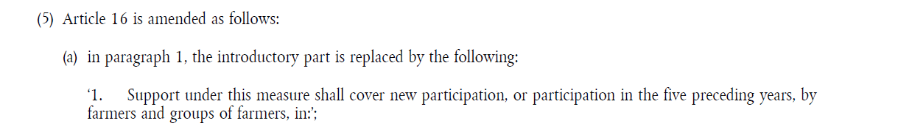
Context: textual subdivision identifier during the drafting and after the publication of a document: the technical and functional identifier
A technical identifier is an identifier that carries no meaning.
A functional identifier is an identifier that is meaningful. It is a machine-readable form of the way the user references a subdivision, based on its location inside the document.
During the drafting process, the main feature of the identifier of a subdivision is its immutability (once initialized, never to be changed thereafter), allowing to follow the evolution of the same text throughout the drafting process.
As the structure of the document evolves a lot during the drafting without necessarily following a strict formal procedure, the use of a functional (business) identifier built on the location of the subdivision does not make sense. Therefore, the identifier of a subdivision is, during the drafting, a technical identifier (@xml:id).

After the publication of a document, the users (e.g. lawyers) make reference to a subdivision by providing its location in the text, especially when the document is a legal act. This makes sense as the document will not evolve a lot and any modification is formalized by amendments following a legislative procedure. Modifications never comprise implicit renumbering, so a subdivision’s location remains stable and references correct.
For the reference to a subdivision, ELI defines a syntax that is mapped to the business approach to referencing. The subdivision reference is based on the CoV concepts structuring the text.
In Akoma Ntoso, the identifier used for the business reference is stored in the @eId , in a well-defined structure and machine readable way.

The following example mark-up is based on this logic:
- in the proposal, the identifier is the @xml:id attribute.
- for the amended act already published in the Official Journal, the identifier is (for the example) stored in the @eId attribute to indicate that it corresponds to a business way to identify the subdivision. This value serves as the subdivision part of the ELI reference.

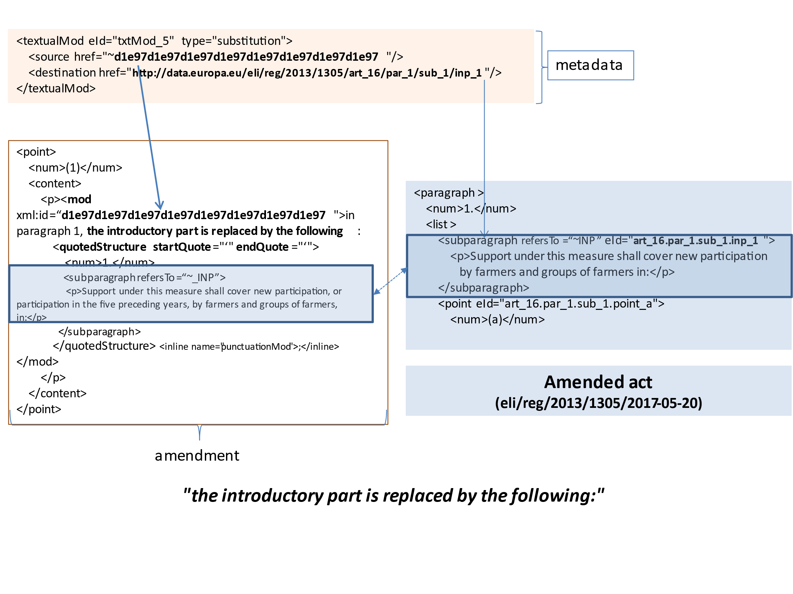
The mark-up for <textualMod> (metadata) is based on the following principles:
- the @type MUST be completed following the table ;
- the @href attribute of the <source> element MUST reference the element <mod>;
- the @href attribute of the <destination> MUST be an ELI reference to the subdivision specified in the amendment (see the syntax for the ELI references).

Example of an amendment of text
The following amendment:
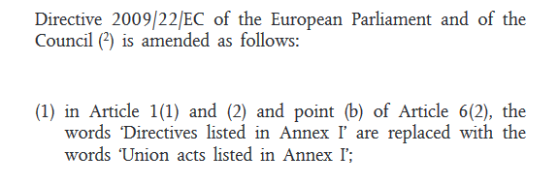
…
Is represented as follows:

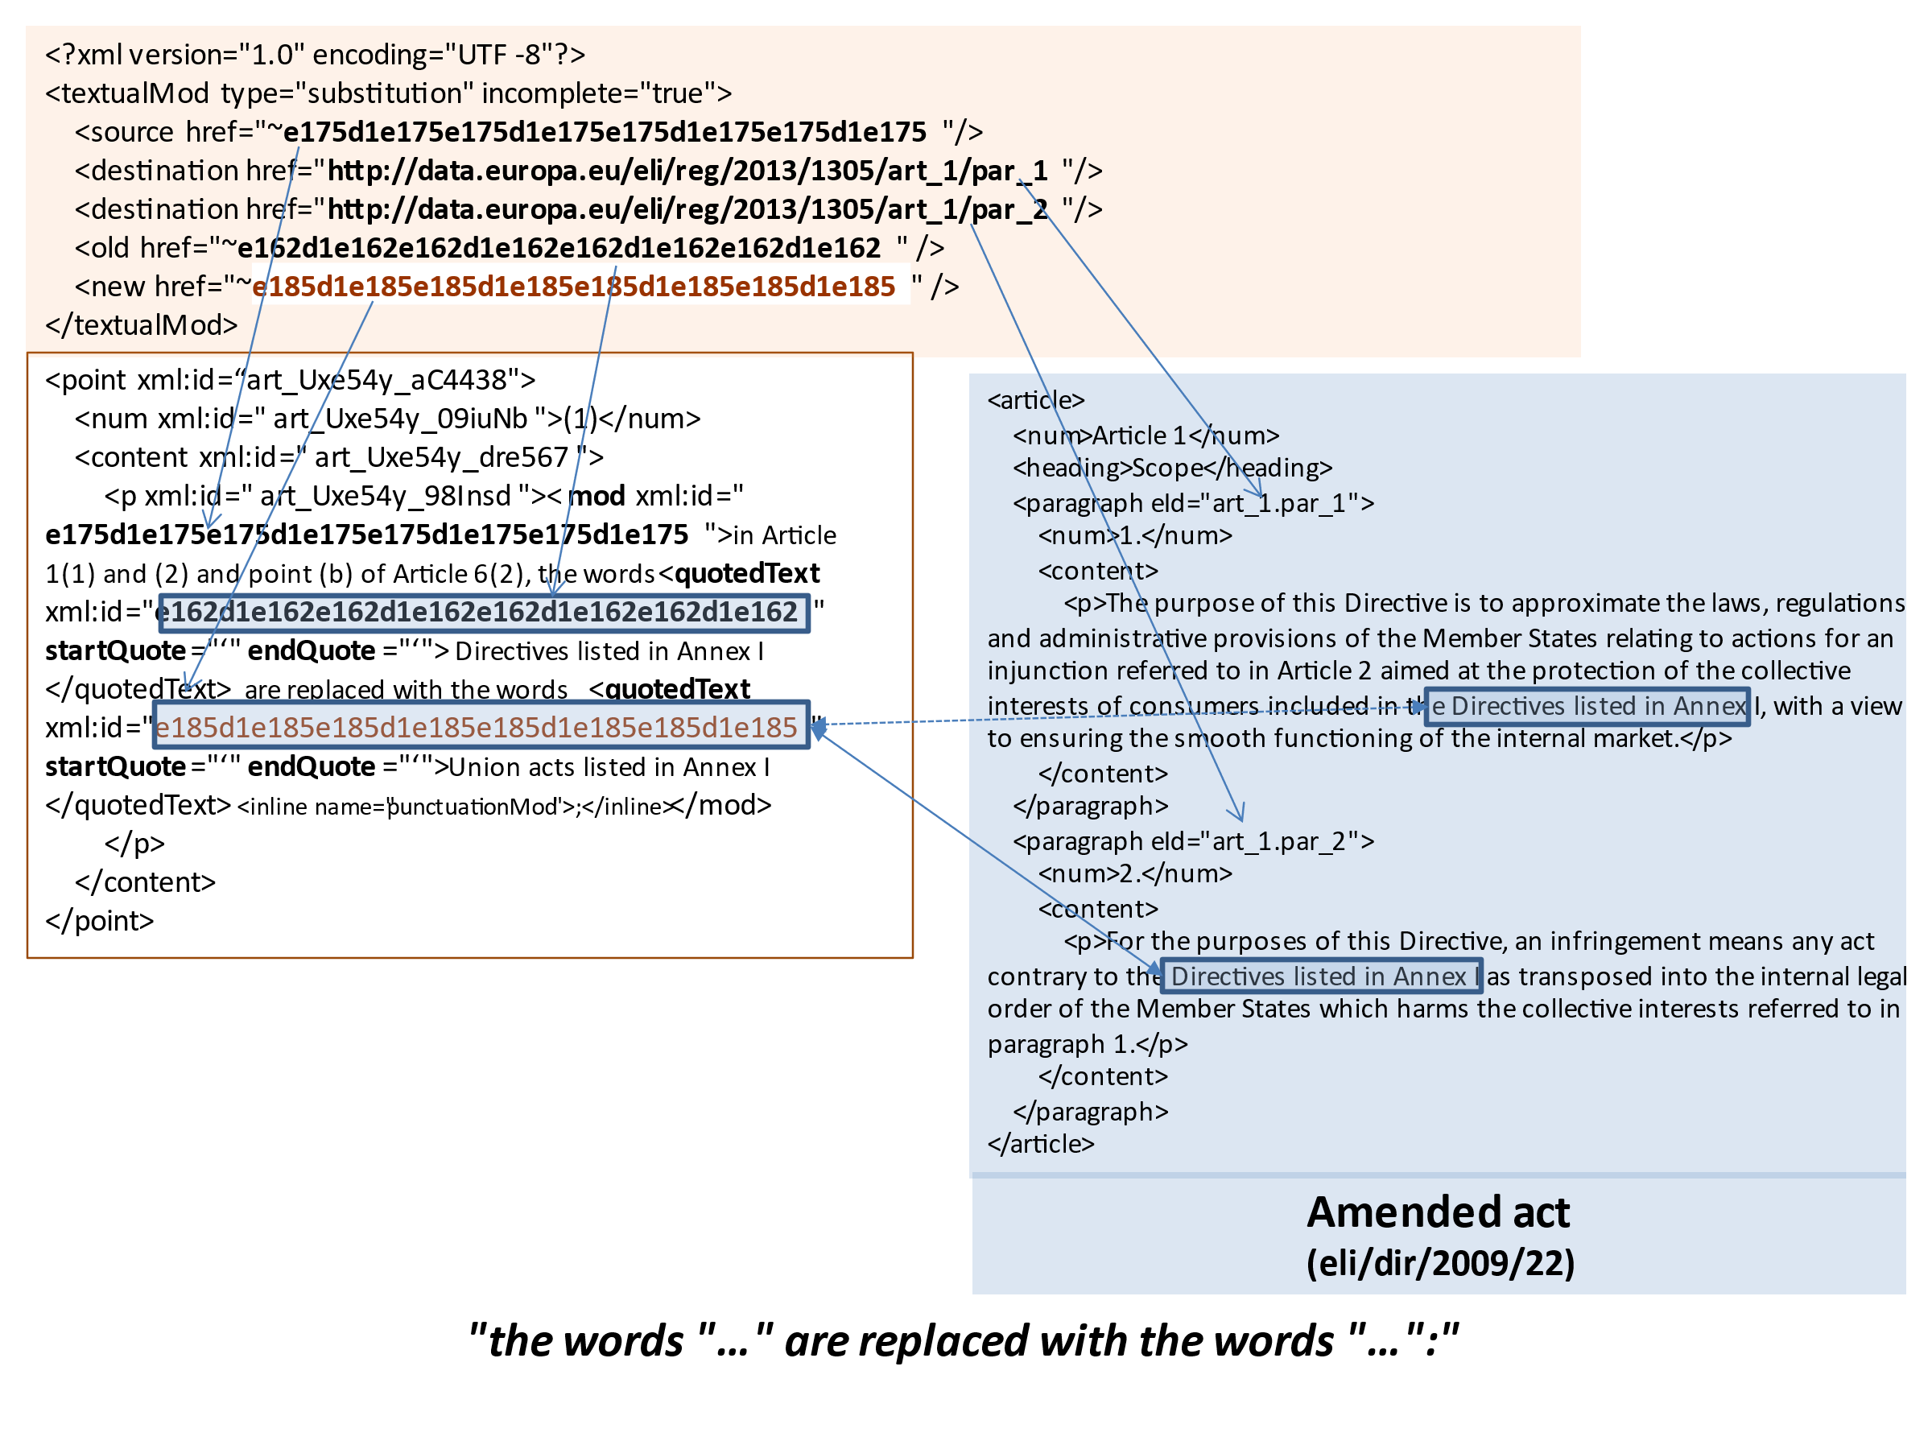
The mark-up for <textualMod> (metadata) is based on the following principles:
- The @type MUST be completed following the table.
- The @incomplete attribute MUST be used to indicate that the change cannot be automated.
- The @href attribute of the <source> element MUST reference the element <mod>.
- The @href attribute of the <old> element references the element <quotedText> with the old value.
- The @href attribute of the <new> element references the <quotedText> with the new value.
- The @href attribute of the <destination> MUST be an ELI reference to the subdivision specified in the amendment (see URI template for European Union legislation and preparatory acts (draft)).
If multiple subdivisions are provided, two cases can be distinguished:
  - uses one <destination> and the attribute @upTo to indicate the end of the interval.
  - provides one element <destination> per first level subdivision of the text that is affected by the amendment.

Metadata for a replacement
The replacement of a structure ("substitution" as AKN type) has the following characteristics:
- The ‘text of the amendment’ MUST be in a <quotedStructure>.
- The corresponding <textualMod> in the <activeModification> has the following characteristics:
  - The @type of the <textualMod> MUST have the value "substitution".
  - The @href of the <source> MUST point to the corresponding <mod> element.
  - The @href of the <destination> sub-element MUST point to the structure of the amended act that is referenced in the amendment.
  - If a range of structures is modified, two options are available to specify the destination:
    - there is one <destination> sub-element and the @upTo attribute of this element points to the last structure modified in the amended act.
    - there is one <destination> per first level of subdivision modified.

Metadata for an insertion
The insertion of a structure ("insertion" as AKN type) inserts a new structure before or after an already existing structure. As the principle of the amendment is to never renumber the existing structure, the insertion uses a specific type of numbering.
For the insertion, the characteristics are as follows:
- The 'text of the amendment' MUST be in a <quotedStructure>.
- The corresponding <textualMod> in the <activeModification> has the following characteristics:
  - The @type of the <textualMod> MUST have the value "insertion".
  - The @href of the <source> MUST point to the corresponding <mod> element.
  - The <destination> sub-element has the following attributes:
    - The @href MUST point to the structure indicated in the amendment as the "reference structure".
    - The @pos MUST be used with the following value:
      - "after" if the referenced structure is the preceding structure;
      - "start" if the referenced structure is the parent structure;
      - "before" if the referenced structure is the following structure.

Metadata for an addition
The addition of a structure ("insertion" as AKN type) adds a new structure at the end of an existing structure. In this case, if the new structure is a numbered structure, it is an increment of the last sibling structure.
For an addition, the characteristics are as follows:
- The 'text of the amendment' MUST be in a <quotedStructure>.
- The corresponding <textualMod> in the <activeModification> has the following characteristics:
  - The @type of the <textualMod> MUST have the value "insertion".
  - The @href of the <source> MUST point to the corresponding <mod> element.
  - The <destination> sub-element has the following attributes:
    - The @href MUST point to the parent structure.
    - The @pos MUST be used with the value "end" = insert at the end of the parent structure.

Metadata for a deletion
For a deletion, the characteristics are as follows:
- There is no text of the amendment.
- The corresponding <textualMod> in the <activeModification> has the following characteristics :
  - The @type of the <textualMod> MUST have the value "repeal".
  - The @href of the <source> MUST point to the corresponding <mod> element.
  - the <destination> element has the following attribute:
    - the @href MUST point to the structure to be deleted.
In case of deletion of an interval of subdivisions, two alternative mark-ups are possible:
    - One <destination> element with the @href attribute pointing to the start of the interval and @UpTo attribute pointing to the end of the interval.
    - Multiple <destination> elements (one per subdivision of the sequence), each with the @href attribute pointing to the corresponding subdivision (no @upTo attribute used in this case).
Example 1:

<point>
<num>(c)</num>
<content>
<p><mod xml:id="e216d1e216e216d1e216e216d1e216e216d1e216">paragraph 3 is deleted<inline name="punctuationMod>;</inline></mod></p>
</content>
</p>

will have the following metadata:
<meta>
…
<textualMod type="repeal">
<source href="~e216d1e216e216d1e216e216d1e216e216d1e216"/>
<destination href="http://data.europa.eu/eli/reg/2013/1305/art_152/par_3"/>
</textualMod>
…
</meta>
Example 2: Mark-up of the provision for deletion of annex(es)
(42) Annexes VII, VIII and IX are deleted;

<point>
<num>(42)</num>
<content>
<p><mod xml:id="e292d1e292e292d1e292e292d1e292e292d1e292">Annexes VII, VIII and IX are deleted<inline name="punctuationMod">.</inline></mod></p>
</content>
</point>

or
<meta>
…
<textualMod type="repeal">
<source href="~e292d1e292e292d1e292e292d1e292e292d1e292"/>
<destination href="http://data.europa.eu/eli/reg/2013/1308/ann_7"/>
<destination href="http://data.europa.eu/eli/reg/2013/1308/ann_8"/>
<destination href="http://data.europa.eu/eli/reg/2013/1308/ann_9"/>
</textualMod>

Special cases

Modification of the first unnumbered structure of a numbered structure
When the first substructure of a modified structure is on the same line as the number of the englobing structure, generally, the whole line is included in the quoted structure, including this number.
In this case, the mark-up in the <quotedStructure> MUST be isolate in two sibling elements, the amended text and the contextual text (generally the number of the parent structure) like in the following examples:
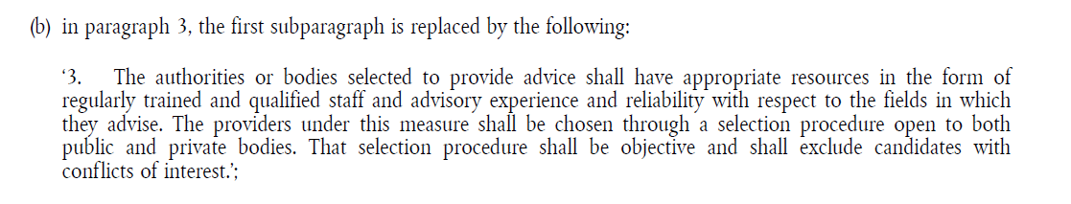
The corresponding mark-up will be as follows:
<p><mod xml:id="e305d1e305e305d1e305e305d1e305e305d1e305">in paragraph 3, the first subparagraph is replaced by the following:
<quotedStructure xml:id="e310d1e310e310d1e310e310d1e310e310d1e310" startQuote="‘" endQuote="‘">
<num>3.</num>
<subparagraph>
<content>
<p>The authorities or bodies selected to provide advice shall have appropriate resources in the form of regularly trained and qualified staff and advisory experience and reliability with respect to the fields in which they advise. The providers under this measure shall be chosen through a selection procedure open to both public and private bodies. That selection procedure shall be objective and shall exclude candidates with conflicts of interest.</p>
</content>
</subparagraph>
</quotedStructure><inline name="punctuationMod>;</inline></mod></p>
With the following metadata
<meta>
…
<textualMod type="substitution">
<source href="~e305d1e305e305d1e305e305d1e305e305d1e305 "/>
<destination href="http://data.europa.eu/eli/reg/2013/1305/art_15/par_3/sub_1"/>
</textualMod>
…
</meta>
The amendment:
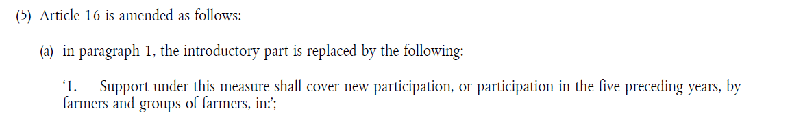
will be marked as follows:
<point>
<num>(a)</num>
<content>
<p><mod xml:id="e318d1e318e318d1e318e318d1e318e318d1e318">in paragraph 1, the introductory part is replaced by the following:
<quotedStructure xml:id="qstruc_1" startQuote="‘" endQuote="‘">
<num>1.</num>
<subparagraph refersTo="~INP">
<p>Support under this measure shall cover new participation, or participation in the five preceding years, by farmers and groups of farmers, in:</p>
</subparagraph>
</quotedStructure><inline name="punctuationMod>;</inline></mod></p>
</content>
</point>

The corresponding metadata refers to the <quotedStructure>:
<meta>
…
<textualMod type="substitution">
<source href="~e318d1e318e318d1e318e318d1e318e318d1e318"/>
<destination href="http://data.europa.eu/eli/reg/2013/1305/art_16/par_1/sub_1/inp_1"/>
</textualMod>
…
<references>
<TLCConcept xml:id="INP"
href="http://publications.europa.eu/resource/authority/subdivision/INP"
showAs="introductory part"/>
</references>
…
</meta>

General rule: the consolidation will never take into account a <num> element that is the first child of the <quotedStructure>

Amendment of multiple sibling structures
When an amendment modifies multiple sibling structures, only these structures are included in the <quotedStructure>.
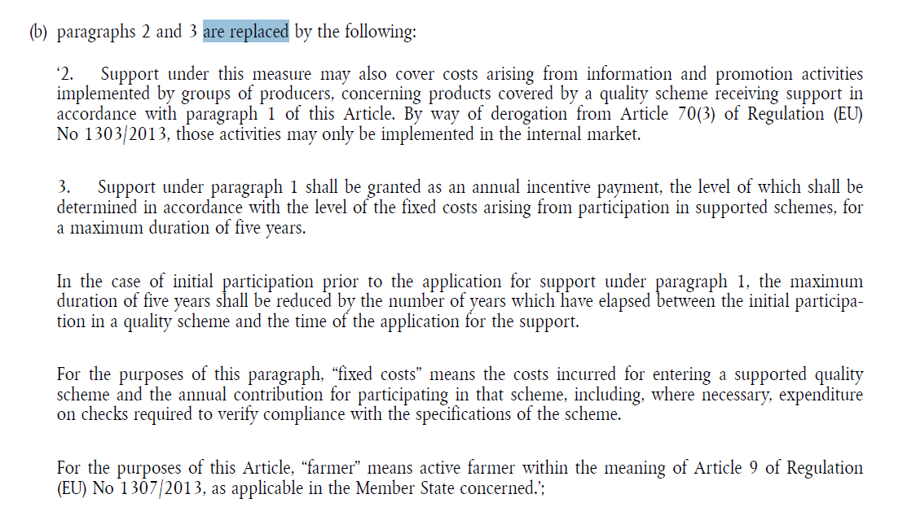
The mark-up will be as follows:
<p><mod xml:id="e328d1e328e328d1e328e328d1e328e328d1e328">paragraphs 2 and 3 are replaced by the following:
<quotedStructure startQuote="‘" endQuote="‘">

<paragraph>
<num>2.</num>
<content>
<p>Support under this measure may also cover costs arising from information and promotion activities implemented by groups of producers, concerning products covered by a quality scheme receiving support in accordance with paragraph 1 of this Article. By way of derogation from Article 70(3) of Regulation (EU) No 1303/2013, those activities may only be implemented in the internal market.</p>
</content>
</paragraph>

<paragraph>
<num>3.</num>
<subparagraph>
<content>
<p>Support under this measure may also cover costs arising from information and promotion activities implemented by groups of producers, concerning products covered by a quality scheme receiving support in accordance with paragraph 1 of this Article. By way of derogation from Article 70(3) of Regulation (EU) No 1303/2013, those activities may only be implemented in the internal market.</p>
</content>
</subparagraph>
<subparagraph>
<content>
<p>In the case of initial participation prior to the application for support under paragraph 1, the maximum duration of five years shall be reduced by the number of years which have elapsed between the initial participation in a quality scheme and the time of the application for the support. </p>
</content>
</subparagraph>
<subparagraph>
<content>
<p>For the purposes of this paragraph, “fixed costs” means the costs incurred for entering a supported quality scheme and the annual contribution for participating in that scheme, including, where necessary, expenditure on checks required to verify compliance with the specifications of the scheme. </p>
</content>
</subparagraph>
<subparagraph>
<content>
<p>For the purposes of this Article, “farmer” means active farmer within the meaning of Article 9 of Regulation (EU) No 1307/2013, as applicable in the Member State concerned. </p>
</content>
</subparagraph>
…
</paragraph>
</quotedStructure><inline name="punctuationMod>;</inline></mod></p>

Inside the metadata, there are two alternative options to specify the <destination>:
    - One <destination> element with the @href attribute pointing to the start of the interval and @UpTo attribute pointing to the end of the interval.
    - Multiple <destination> elements (one per subdivision of the sequence), each with the @href attribute pointing to the corresponding subdivision (no @upTo attribute used in this case).
The mark-up of the metadata can be as follows:
<meta>
…
<textualMod type="substitution">
<source href="~e328d1e328e328d1e328e328d1e328e328d1e328"/>
<destination href="http://data.europa.eu/eli/reg/2013/1305/art_16/par_2"/>
<destination href ="http://data.europa.eu/eli/reg/2013/1305/art_16/par_3"/>
</textualMod>
…
</meta>
The sibling structure can be an introductory part and one or more following points of a list. For example:
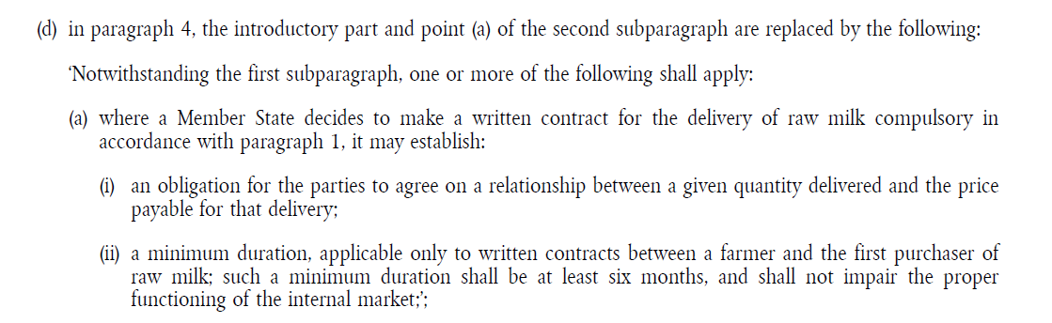
In this case, only the modified subdivisions MUST be included in the <quotedStructure>; the subdivision <list> MUST NOT be part of the <quotedStructure>.
The mark-up will be as follows:
<p><mod xml:id="e344d1e344e344d1e344e344d1e344e344d1e344”">in paragraph 4, the introductory part and point (a) of the second subparagraph are replaced by the following:
<quotedStructure xml:id="e349d1e349e349d1e349e349d1e349e349d1e349" startQuote="‘" endQuote="‘">

<subparagraph refersTo="~INP">
<content>
<p>Notwithstanding the first subparagraph, one or more of the following shall apply:</p>
</content>
</subparagraph>
<point>
<num>(a)</num>
<list>
<subparagraph refersTo="~INP">
<content>
<p>where a Member State decides to make a written contract for the delivery of raw milk compulsory in accordance with paragraph 1, it may establish:</p>
</content>
</subparagraph>
<point>
<num>(i)</num>
<content>
<p>an obligation for the parties to agree on a relationship between a given quantity delivered and the price payable for that delivery;</p>
</content>
</point>
<point>
<num>(ii)</num>
<content>
<p>a minimum duration, applicable only to written contracts between a farmer and the first purchaser of raw milk; such a minimum duration shall be at least six months, and shall not impair the proper functioning of the internal market;</p>
</content>
</point>
</list>
</point>
</quotedStructure><inline name="punctuationMod>;</inline></mod></p>
The corresponding metadata can be as follows:
<meta>
…
<textualMod type="substitution">
<source href="~e344d1e344e344d1e344e344d1e344e344d1e344"/>
<destination href="http://data.europa.eu/eli/reg/2013/1305/art_16/par_4/sub_2/inp_1"/>
<destination href="http://data.europa.eu/eli/reg/2013/1305/art_16/par_4/sub_2/pnt_a"/>
</textualMod>
…
</meta>

Modification of the subject of an article
For the following example:
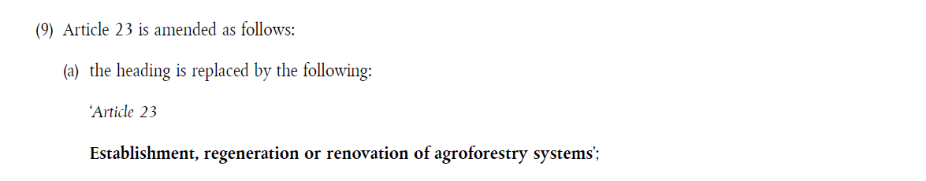
the amendment will be marked as follows:
<p><mod xml:id="e359d1e359e359d1e359e359d1e359e359d1e359">the heading is replaced by the following:
<quotedStructure startQuote="‘" endQuote="‘">
<num>Article 23 </num>
<heading>Establishment, regeneration or renovation of agroforestry systems </heading>
</quotedStructure><inline name="punctuationMod>;</inline></mod></p>
And the corresponding metadata:

<meta>
…
<textualMod type="substitution">
<source href="~e359d1e359e359d1e359e359d1e359e359d1e359"/>
<destination href="http://data.europa.eu/eli/reg/2013/1305/art_23/tit"/>
</textualMod>
…
</meta>

Insertion of multiple numbered structures
The following example:
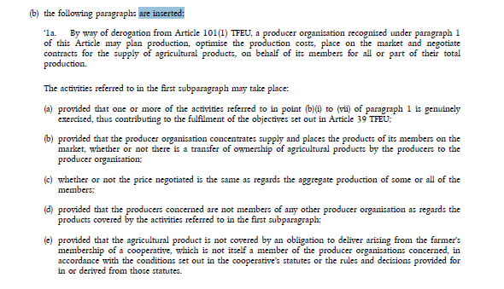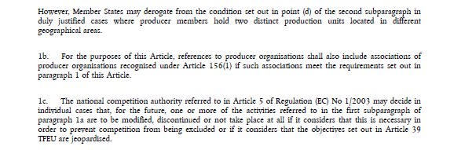
will have the following metadata:
<meta>
…
<textualMod type="insertion">
<source href="~e367d1e367e367d1e367e367d1e367e367d1e367"/>
<destination href=http://data.europa.eu/eli/reg/2013/1305/art_152/par_1" pos="after"/>
</textualMod>
…
</meta>

Addition, insertion or replacement of an annex
The overall mark-up for this kind of amendment corresponds to the following schema:
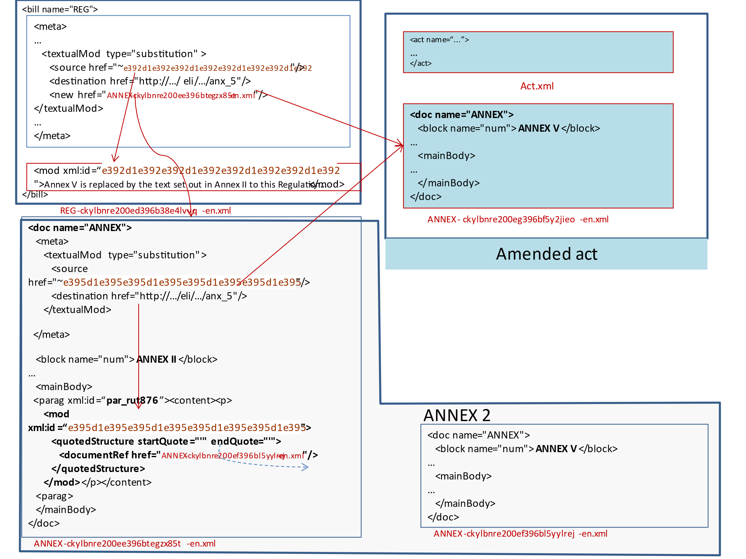
Mark-up of the text and metadata are needed in both the main part of the amending act and the annex of the amending act, as both components contain part of the information on the amendment.

In enacting terms
The amending provision MUST be marked with a <mod> element but the <mod> element MUST be without <quotedStructure>, as the text of the amendment is not there.
The punctuation after the <mod> element SHOULD be marked with the <inline name="punctuationMod"> element as usual.
For example:
(40) Annex V is replaced by the text set out in Annex II to this Regulation.
The mark-up will be as follows:

<point>
<num>(40)</num>
<content>
<p><mod xml:id="e369d1e369e369d1e369e369d1e369e369d1e369"> Annex V is replaced by the text set out in Annex II to this Regulation<inline name="punctuationMod">.</inline></mod></p>
</content>
</point>

The corresponding metadata in the main document will contain:
- in the attribute @type, the operation,
- in the sub-element <source>, the link to the <mod> in the enacting terms,
- in the sub-element <destination>, in the @href attribute, the location in the amended act,
When the operation is insertion or addition:
  - @href attribute contains the reference point (for addition it is the uri of the act) and
  - @pos attribute indicates where to put the insertion/ addition ("end" or "after" or "before").
- There MUST be a sub-element <new> that contains the information related to the place where the 'text of the amendment' is. In this case, it MUST be the relative path to the annex of the amending act, which contains the text of the amendment.
Example
<meta>
…
<textualMod type="substitution">
<source href="~e369d1e369e369d1e369e369d1e369e369d1e369"/>
<destination
href="http://data.europa.eu/eli/reg/2009/818/ann_V"/>
<new href="ANNEX-ckylbnre200ee396btegzx85t-en.xml"/>
</textualMod>
…
</meta>

In the corresponding annex of the amending act
In this case, the content of the annex is the new annex. For example:
ANNEX II
‘
ANNEX V
LIST OF RESIDENCE PERMITS ENTITLING THE HOLDER TO TRANSIT THROUGH THE AIRPORTS OF MEMBER STATES WITHOUT BEING REQUIRED TO HOLD AN AIRPORT TRANSIT VISA
…..
… .’.

In this case, the annex MUST contain:
- the heading of the annex with its numbering; then
- between quotation marks, the new annex;
- finally, (optionally) the last punctuation mark.

The new annex MUST be marked-up by a <quotedStructure> element inside a <mod> element.
The <mod> SHOULD contain also the last punctuation mark. If it exists, it MUST be in an <inline name="punctuationMod"> element.
<mod> is the only content of the <paragraph> element.
AKN4EU does not allow for a subdocument inside a document.
The content of the annex as amended is not put directly in the annex of the amending act, but in a separate file. The relative path MUST be referenced in this annex in the @href attribute of the element <documentRef>.

So, the above example will be marked as follows:
<doc name="ANNEX">
...
<preface>
<container name="headerOfAnnex">
<block name="num">ANNEX II</block>
</container>
</preface>
<mainBody>
<paragraph>
<p><mod xml:id="e346d1e346e346d1e346e346d1e346e346d1e346">
<quotedStructure startQuote="‘" endQuote="‘">
<documentRef href="ANNEX-ckylbnre200ef396bl5yylrej-en.xml" showAs="ANNEX V"/>
</quotedStructure>
<inline name="punctuationMod">.</inline></mod></p>
<paragraph>
</mainBody>
</doc>

<doc name="ANNEX">
...
<preface>
<container name="headerOfAnnex">
<block name="num">ANNEX V</block>
<block name="heading">LIST OF RESIDENCE PERMITS ENTITLING THE HOLDER TO TRANSIT THROUGH THE AIRPORTS OF MEMBER STATES WITHOUT BEING REQUIRED TO HOLD AN AIRPORT TRANSIT VISA</block>
</container>
</preface>
<mainBody>
...
</mainBody>
</doc>
ANNEX-ckylbnre200ef396bl5yylrej-en.xml
New version of annex V

The corresponding metadata in the annex of the amending act SHOULD contain a <textualMod> corresponding to the amendment. It is very similar to the corresponding <textualMod> of the main part of the amending act, except that it MUST not have a <new> element, as the text of the amendment is in the same file.
Therefore, the <textualMod> has the following information:
- in the attribute @type, the operation (here: “substitution”, as it is defined in the enacting terms of the amending act),
- in the sub-element <source>, the link to the <mod> in the annex,
- in the sub-element <destination>, the location in the amended act (same as it is defined in the enacting terms of the amending act).
Example:
<meta>
…
<textualMod type="substitution">
<source href="~e346d1e346e346d1e346e346d1e346e346d1e346"/>
<destination
href="http://data.europa.eu/eli/reg/2009/818/ann_V"/>
</textualMod>
…
</meta>

Modifications of an annex
The overall mark-up for this kind of amendment corresponds to the following schema:

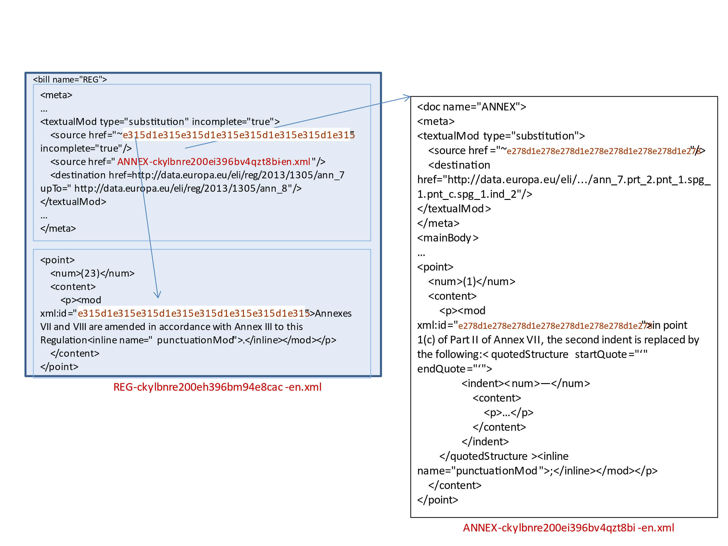

In the enacting terms
The point related to the modification inside an annex in the enacting terms is not really an amendment: it does not contain the list of modifications to apply to an annex but only the reference to the annex that contains these amendments.
Nevertheless, for technical reason, this content MUST be marked with a <mod> element and a corresponding metadata <textualMod> SHOULD exist (the @href attribute of the <source> element of the <textualMod> references this <mod>).
For example:
(23) Annexes VII and VIII are amended in accordance with Annex III to this Regulation.
In this case, the mark-up will be the following:
<point xml:id="e281d1e281e281d1e281e281d1e281e281d1e281">
<num>(23)</num>
<content>
<p><mod xml:id="e278d1e278e278d1e278e278d1e278e278d1e278">Annexes VII and VIII are amended in accordance with Annex III to this Regulation<inline name="punctuationMod">.</inline></mod></p>
</content>
</point>
and the corresponding metadata will contain:
- in the attribute @type, the operation 'substitution',
- an @attribute @incomplete MUST be set to "true" (this point is not really an amendment but only a reference to the annex containing the amendments),
- It MUST comprise two sub-elements <source>:
  - in a first sub-element <source>,
    - the link to the <mod>.
    - the attribute @incomplete is set to "true" as the source does not contain all the information and is not really an amendment;
  - in a second sub-element <source>, the reference to the amending annex,
- one or more sub-element(s) <destination> that MUST contain the location(s) in the amended act, it means, the reference to the annexes that are amended.
Example
<meta>
…
<textualMod type="substitution" incomplete="true">
<source href="~e278d1e278e278d1e278e278d1e278e278d1e278" incomplete="true"/>
<source href="ANNEX-ckylbnre200ei396bv4qzt8bi-en.xml"/>
<destination href="http://data.europa.eu/eli/reg/2013/1305/ann_7"
upTo="http://data.europa.eu/eli/reg/2013/1305/ann_8"/>
</textualMod>
…
</meta>
or
<meta>
…
<textualMod type="substitution" incomplete="true">
<source href="~e278d1e278e278d1e278e278d1e278e278d1e278" incomplete="true"/>
<source href="annex3.xml"/>
<destination href="http://data.europa.eu/eli/reg/2013/1305/ann_7"/>
<destination href="http://data.europa.eu/eli/reg/2013/1305/ann_8"/>
</textualMod>
…
</meta>

In the amending annex
The introductory part of the sequence of amendments contain the reference to the amended act. In this case, it SHOULD be marked with the element <affectedDocument>.
In such case, the annex MUST contain <mod> elements for each amendment and each <mod> SHOULD have a <textualMod> metadata associated to this amendment.
For example

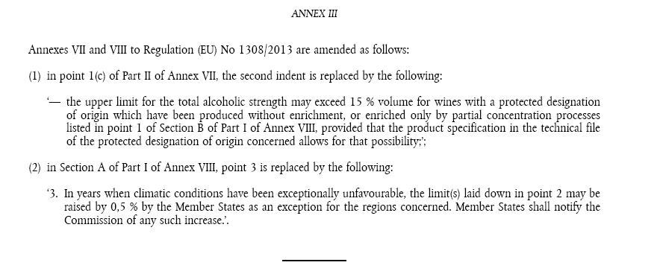

The introductory part will be marked as follows:

<p>Annexes VII and VIII to <affectedDocument href="http://data.europa.eu/eli/reg/2013/1308">Regulation (EU) No 1308/2013</affectedDocument> are amended as follows:</p>

The first amendment will be marked as follows:

<point>
<num>(1)</num>
<content>
<p><mod xml:id="e225d1e225e225d1e225e225d1e225e225d1e225">in point 1(c) of Part II of Annex VII, the second indent is replaced by the following:<quotedStructure startQuote="‘" endQuote="‘">
<indent><num>—</num>
<content>
<p>the upper limit for the total alcoholic strength may exceed 15 % volume for wines with a protected designation of origin which have been produced without enrichment, or enriched only by partial concentration processes listed in point 1 of Section B of Part I of Annex VIII, provided that the product specification in the technical file of the protected designation of origin concerned allows for that possibility;</p>
</content>
</indent>
</quotedStructure><inline name="punctuationMod">;</inline></mod></p>
</content>
</point>

and the corresponding metadata will contain:
- in the attribute @type, the operation (here, “substitution”),
- in the sub-element <source>, the link to the <mod> in the annex,
- in the sub-element <destination>, the location in the amended act.

<meta>
…
<textualMod type="substitution">
<source href="~e225d1e225e225d1e225e225d1e225e225d1e225"/>
<destination
href="http://data.europa.eu/eli/reg/2013/1308/ann_7/prt_1/pnt_1/sub_1/pnt_c/sub_1/ind_2"/>
</textualMod>

Addition of an annex in an act that has only one annex.
The case of the addition of an annex in an act that has only a single annex is to expressed with two amendments:
- the previous sole annex, that had no numbering, receives a number;
- the new annex is added.
Each amendment MUST be marked with a <mod> element.
For example,
(44) the Annex becomes Annex I;
…
(46) the text set out in the Annex to this Regulation is added as Annex II.
will be marked as
<point><num>(44)</num>
<content>
<p><mod xml:id="d1e93d1e93d1e93d1e93d1e93d1e93d1e93d1e93"> the Annex becomes Annex I<inline name="punctuationMod">;</inline></mod></p>
</content>
</point>
…
<point><num>(46) </num>
<content>
<p><mod xml:id="e127d1e127e127d1e127e127d1e127e127d1e127"> the text set out in the Annex to this Regulation is added as Annex II<inline name="punctuationMod">.</inline></mod></p>
</content>
</point>
In the metadata related to the amendment, two <textualMod> SHOULD be defined:
- one <textualMod type="substitution" incomplete="true"> :
the @href attribute of <source> MUST point to the <mod> regarding the renumbering of the existing annex. The <source> MUST have an @incomplete attribute set to "true".
The @href of <destination> MUST be an ELI reference to the heading (<num> element) of the sole annex.
- one <textualMod type="insertion"> :
the @href attribute of <source> MUST point to the <mod> regarding the addition of the new annex inside the enacting terms.
The @href of <destination> MUST be an ELI reference to the act and the @pos attribute of <destination> has the "end" value.
The <new> element MUST contain the relative path (inside .leg file) of the annex of the amending act that contains the new annex.
<meta>
…
<textualMod type="substitution" incomplete="true">
<source href="d1e93d1e93d1e93d1e93d1e93d1e93d1e93d1e93" incomplete="true"/>
<destination href="http://data.europa.eu/eli/.../anx_1/num" />
</textualMod>
<textualMod type="insertion">
<source href="~e127d1e127e127d1e127e127d1e127e127d1e127" />
<destination href="http://data.europa.eu/eli/<ACT>..." pos="end"/>
<new href="ANNEX-ckylbnre200ej396bsw65ia7j-en.xml"/>
</textualMod>

Case of an amending act: a text that repeals an act
The act may contain one or more article(s) that repeal another act.
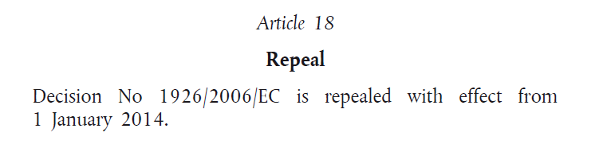
in such case the title of the act contains also the information:
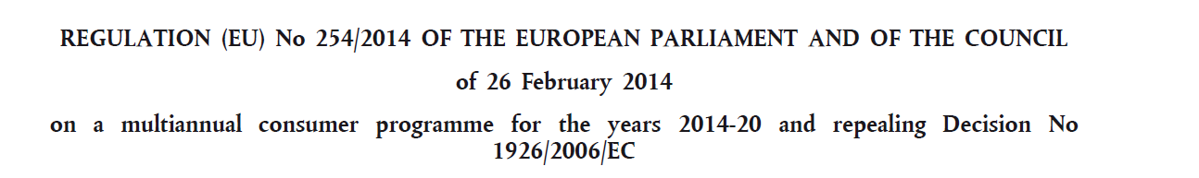
For the repeal of an act, the characteristics of the mark-up are as follows:
- The text that indicates this repeal is not marked with a <mod>
- The corresponding <textualMod> metadata SHOULD exist and if it does, it MUST have the following characteristics :
- empty <source> child,
- the attribute @href of the sub-element <destination> MUST contain the ELI IRI of the act.
Example
<meta>
…
<textualMod type="repeal">
<source/>
<destination href="http://data.europa.eu/eli/dec/2006/1926"/>
</textualMod>
…
</meta>

<longTitle>
<p><docType refersTo=~"REG">REGULATION <docNumber>(EU) No 254/2014</docNumber> OF THE EUROPEAN PARLIAMENT AND OF THE COUNCIL</docType> of <date date="2014-02-26">26 February 2014</date>
<docPurpose>on a multiannual consumer programme for the years 2014-20 and repealing <ref href="http://data.europa.eu/eli/dec/2006/1926">Decision No 1926/2006/EC</ref></docPurpose></p>
</longTitle>
…
<article>
<num>Article 18</num>
<heading>Repeal</heading>
<paragraph>
<content>
<p>Decision No 1926/2006/EC is repealed with effect from <date date="2014-01-01">1 January 2014</date>.</p>
</content>
</paragraph>
</article>

Summary: AKN4EU mark-up for amendments
Amendment type | Mark-up in the text | Related metadata
Replacement
Replacement of a structure | The text of the new version is in the <quotedStructure> of a <mod> element.  NB: Special case  - If the structure replaced is the first structure of a point or of a numbered paragraph, then, the <num> element of the parent structure is the first element of the <quotedStructure>. | <textualMod>  - @type="substitution"  <source>  - @href points to the <mod> element  <destination> (alternative 1) :  - @href is the ELI URI of the first subdivision modified.  - @upTo (optional) is the ELI URI of the last subdivision modified.  multiple <destination> (alternative 2):  There is one <destination> per top level subdivision modified.  - @href is the ELI URI of the corresponding subdivision
Replacement of the subject of a structure | The text of the new version is in the <quotedStructure> of a <mod> element. | <textualMod>  - @type="substitution"  <source>  - @href points to the <mod> element  <destination>  - @href is the ELI URI of the subject.
Replacement of an annex | Enacting terms:  The amending provision is in a <mod> element without <quotedStructure>  Annex with the text of the amendment  The content (<mainBody>) of the annex is composed of one <paragraph> with as content, one <p> with a <mod> with a <quotedStructure>.  The content of the <quotedStructure> is a <documentRef> with a @href attribute containing the relative path to the file with the new version of the annex.  File with the new version of the annex  This document is simply an annex. | Metadata in the enacting terms  <textualMod>  - @type="substitution"  <source>  - @href points to the <mod> element  <destination>  - @href is the ELI URI of the annex replaced.  <new>  - @href is the relative path to the annex containing the <quotedStructure>  Metadata in the annex with the text of the amendment  <textualMod>  - @type="substitution"  <source>  - @href points to the local <mod> element  <destination>  - @href is the ELI URI of the annex replaced.
Insertion
Insertion of one or more structure(s) | The text of the amendment is in a <quotedStructure> of a <mod> element | <textualMod>  - @type="insertion"  <source>  - @href points to the <mod> element  <destination>  - @href points to the subdivision related to which the insertion is done  - @pos can have the following values  - "after"  - "before"  - "start"
Insertion of an annex | Enacting terms:  The amending provision is in a <mod> element without <quotedStructure>  Annex with the text of the amendment  The content (<mainBody>) of the annex is composed of a <paragraph> with inside <content>, a <p> with a <mod> element with a <quotedStructure>.  The content of the <quotedStructure> is a <documentRef> with a @href attribute containing the relative path to the new annex.  File with the new annex  This document is simply an annex. | Metadata in the enacting terms  <textualMod>  - @type="substitution"  <source>  - @href points to the <mod> element  <destination>  - @href is the ELI URI of the annex relatively to which the insertion is done  - @pos = "after" or "before".  <new>  - @href is the relative path to the annex containing the new annex  Metadata in the annex with the text of the amendment  <textualMod>  - @type="substitution"  <source>  - @href points to the <mod> element  <destination>  - @href is the ELI URI of the annex replaced
Addition
Addition of one or more structure(s) | The text of the amendment is in a <quotedStructure> of a <mod> element | <textualMod>  - @type="insertion"  <source>  - @href points to the <mod> element  <destination>  - @href points to the parent subdivision  - @pos = “end” .
Addition of an annex | Enacting terms:  The amending provision is in a <mod> element without <quotedStructure>  Annex with the text of the amendment  The content (<mainBody>) of the annex is composed of a <paragraph> with inside <content>, a <p> with a <mod> element with a <quotedStructure>.  The content of the <quotedStructure> is a <documentRef> with a @href attribute containing the relative path to the new annex.  File with the new annex  This document is simply an annex. | Metadata in the enacting terms  <textualMod>  - @type="substitution"  <source>  - @href points to the <mod> element  <destination>  - @href is the ELI URI of the annex replaced.  <new>  - @href is the relative path to the annex containing the <quotedStructure>  Metadata in the annex with the text of the amendment  <textualMod>  - @type="substitution"  <source>  - @href points to the <mod> element  <destination>  - @href is the ELI URI of the annex replaced
Addition of an annex in an act that has a sole annex | Enacting terms:  Two amending provision exist for this operation  - the previous sole annex, that had no numbering, receives a number.  - the new annex is added.  Each amending provision is inside a <mod> element without <quotedStructure>  Annex with the text of the amendment  The content (<mainBody>) of the annex is composed of a <paragraph> with inside <content>, a <p> with a <mod> element with a <quotedStructure>.  The content of the <quotedStructure> is a <documentRef> with a @href attribute containing the relative path to the new annex.  File with the new annex  This document is simply an annex. | Metadata in the enacting terms  For the addition of a number to the sole Annex  <textualMod>  - @type="substitution"  - @incomplete="true"  <source>  - @href points to the <mod> element  - @incomplete="true"  <destination>  - @href is the ELI URI to the subject of the annex (tit).  <new>  - @href is the relative path to the annex containing the <quotedStructure>  For the addition of an annex:  <textualMod>  - @type="insertion"  <source>  - @href points to the <mod> element  <destination>  - @href is the ELI URI of the amended act  - @pos="end"  <new>  - @href is the relative path to the file containing the annex with the new annex  Metadata in the annex with the text of the amendment  <textualMod>  - @type="insertion"  <source>  - @href points to the <mod> element  <destination>  - @href is the ELI URI of the act  - @pos="end"
Deletion
Deletion of one or more structure(s) | The provision for the deletion of the structure is in a <mod>.  There is no <quotedStructure> inside. | <textualMod>  - @type="repeal"  <source>  - @href points to the <mod> element  <destination> (alternative 1) :  - @href is the ELI URI of the first subdivision deleted.  - @upTo is the ELI URI of the last subdivision deleted.  multiple <destination> (alternative 2):  There is one <destination> per top level subdivision modified.  - @href is the ELI URI of the corresponding deleted subdivision
Deletion of annex(es) | Enacting terms:  The provision for the deletion of the structure is in a <mod>.  There is no <quotedStructure> inside. | Metadata in the enacting terms  <textualMod>  - @type="repeal"  <source>  - @href points to the <mod> element  <destination> (alternative 1) :  - @href is the ELI URI of the first annex deleted.  - @upTo is the ELI URI of the last annex deleted.  multiple <destination> (alternative 2):  There is one <destination> per top level subdivision modified.  @href is the ELI URI of the corresponding deleted annex
Repeal of an act | No provision is marked with a <mod> element for this operation | <textualMod>  - @type="repeal"  <source>  - empty  <destination>  - @href is the ELI URI of the act repealed.
Replacement of a text
Replacement of a text | The amendment is in a <mod> element. Each term is in a <quotedText> element. | <textualMod>  - @type="substitution"  - @incomplete="true"  <source>  - @href points to the <mod> element  <old>  - @href points to a <quotedText> (old version of text)  <new>  - @href points to a <quotedText> (new version of the text).  <destination> (alternative 1) :  - @href is the ELI URI of the first subdivision modified.  - @upTo (optional) is the ELI URI of the last subdivision modified.  multiple <destination> (alternative 2):  There is one <destination> per top level subdivision modified.  - @href is the ELI URI of the corresponding subdivision
Modification of an annex
Modification of an annex | Enacting terms  The provision that specifies the annex containing the amendment and which annex(es) is (are) affected, is in a <mod> element.  Annex with the amending provision  The introductory part of the sequence of amendments contains the reference to the amended act. (marked with <affectedDocument>)  Each amending provision is in a <mod> element with or without <quotedStructure> depending on the type of the amendment. | Metadata in the enacting terms  <textualMod>  - @type="substitution"  - @incomplete="true"  <source>  - @href points to the <mod> element  - @incomplete="true"  <source>  - @href is the relative path of the annex containing the amendments  <destination> (alternative 1) :  - @href is the ELI URI of the first subdivision modified.  - @upTo (optional) is the ELI URI of the last subdivision modified.  multiple <destination> (alternative 2):  There is one <destination> per top level subdivision modified.  - @href is the ELI URI of the corresponding subdivision  Metadata in the annex with the annex containing the amendment(s):  one <textualMod> per amendment.

Linguistic variants and synoptism
The AKN4EU_LEG package contains one linguistic variant of a version of an official document.
When multiple linguistic variants exist in AKN4EU format, for a version of an official document, different rules are defined to align the text of the different variants
The following rules are defined:
- In every AKN4EU_LEG package (.leg package) that are linguistic variants, the split of the text into AKN4EU files and resource files must be identical.
Each linguistic variant must have the same number of files and each AKN4EU file of a linguistic variant must correspond to one file in any other linguistic variants.
- The filename of the AKN4EU_LEG package and of any of the AKN4EU files that compose this AKN4EU_LEG package MUST be identical for any linguistic variants EXCEPT for the part of the filename that is built on the language information (language of the document, original language, version of the translation).
Example
If a AKN4EU_LEG package in the original language is named
PROP_ACT-c2jr8rsld00003t61c4ebttom-1.0-en.leg,
the AKN4EU_LEG package for the french translation needs to have the same
“PROP_ACT-c2jr8rsld00003t61c4ebttom-1.0” part in its filename.
It can be named:
  - PROP_ACT-c2jr8rsld00003t61c4ebttom-1.0-fr.leg or
  - PROP_ACT-c2jr8rsld00003t61c4ebttom-1.0-en-1.0-fr.leg
- Inside an AKN4EU file, there must be an alignment between the @xml:id attribute values:
  - For every structural element (not “inline” element), the corresponding element in any linguistic variant must always have the same value for the @xml:id attribute.
  - An element <authorialNote>, <mod>, <quotedStructure>, <embeddedStructure>, <img/> in all linguistic variants must have the same value for the @xml:id attribute.

Example: English and German linguistic variants of the same version of document:
EN | DE
<article xml:id="e271d1e271e271d1e271e271d1e271e271d1e271">  <num xml:id="e273d1e273e273d1e273e273d1e273e273d1e273">Article 1</num>  <paragraph xml:id="e276d1e276e276d1e276e276d1e276e276d1e276">  <content xml:id="e278d1e278e278d1e278e278d1e278e278d1e278">  <p xml:id="e280d1e280e280d1e280e280d1e280e280d1e280">  <mod xml:id="e281d1e281e281d1e281e281d1e281e281d1e281">In Article 13(3)(b) of  <affectedDocument href="http://data.europa.eu/eli/reg/2008/1008" xml:id="e283d1e283e283d1e283e283d1e283e283d1e283">Regulation (EC) No 1008/2008</affectedDocument>, the introductory phrase is replaced by the following:  <quotedStructure startQuote="&#34;" endQuote="&#34;" xml:id="e286d1e286e286d1e286e286d1e286e286d1e286">  <subparagraph refersTo="~INP" xml:id="e288d1e288e288d1e288e288d1e288e288d1e288">  <content xml:id="e289d1e289e289d1e289e289d1e289e289d1e289">  <p xml:id="e291d1e291e291d1e291e291d1e291e291d1e291">otherwise provided for in an international agreement concluded by the Union, one of the following conditions is fulfilled</p>  </content>  </subparagraph>  </quotedStructure>  </mod></p>  </content>  </paragraph>  </article> | <article xml:id="e271d1e271e271d1e271e271d1e271e271d1e271">  <num xml:id="e273d1e273e273d1e273e273d1e273e273d1e273">Artikel 1</num>  <paragraph xml:id="e276d1e276e276d1e276e276d1e276e276d1e276">  <content xml:id="e278d1e278e278d1e278e278d1e278e278d1e278">  <p xml:id="e280d1e280e280d1e280e280d1e280e280d1e280">  <mod xml:id="e281d1e281e281d1e281e281d1e281e281d1e281">In Artikel 13 Absatz 3 Buchstabe b der <affectedDocument href="http://data.europa.eu/eli/reg/2008/1008" xml:id="e283d1e283e283d1e283e283d1e283e283d1e283">Verordnung (EG) Nr. 1008/2008</affectedDocument> erhält der einleitende Satz folgende Fassung:  <quotedStructure startQuote="&#34;" endQuote="&#34;" xml:id="e286d1e286e286d1e286e286d1e286e286d1e286">  <subparagraph refersTo="~INP" xml:id="e288d1e288e288d1e288e288d1e288e288d1e288">  <content ml:id="e289d1e289e289d1e289e289d1e289e289d1e289">  <p xml:id="e291d1e291e291d1e291e291d1e291e291d1e291">in einer von der Union geschlossenen internationalen Übereinkunft ist eine der folgenden Bedingungen erfüllt:</p>  </content>  </subparagraph>  </quotedStructure>  </mod></p>  </content>  </paragraph>  </article>

ANNEXES
- AKN4EU Characters set
- Controls and basic Latin
0020-007E.
- Controls and Latin-1 Supplement
00A0-00A3, 00A5-00A7, 00A9, 00AB-00AC, 00AE, 00B0-00B1, 00B5, 00B7, 00BB-00FF.
- Latin Extended-A
0100-0107, 010A-0113,0116-011B, 011E-0123, 0126-0127, 012A-012B, 012E-0133, 0136-0137, 0139-0148, 014A-014D, 0150-015B, 015E-0165, 016A-016B, 016E-0173, 0178-017E.
- Latin Extended-B
0192, 01C4-01CC, 0218-021B.
- Greek and Coptic
0374, 037E, 0386-038A, 038C, 038E-03A1, 03A3-03CE.
- Cyrillic
0401-0405, 0407-042A, 042C, 042E-044A, 044C, 044E-044F, 0451-0455, 0457-045F, 0490-0491.
- Area for foreign alphabets
0530-1FFF.
- General Punctuation
2010, 2013-2014, 2018-2022, 2026, 2030, 2032-2034, 2039-203A, 203E.

- Currency Symbols
20AC
- Letter like Symbols
2116, 2122.
- Number forms
2153-2154, 215B-215E.
- Arrows
2190-2199, 21D0-21D9, 21E6-21E9.
- Mathematical operators
2200-22FF.
- Miscellaneous Technical
2300-23FF.
- Geometric Shapes
25A0, 25C7
- Miscellaneous Symbols
2605-2606, 2640, 2642.
- Private area
F106-F10A, F1B1, FB01-FB02.

- Some Akoma Ntoso background

The Akoma Ntoso document types
The purpose of Akoma Ntoso is to define an XML representation of the parliamentary, legislative, legal and judiciary documents. The standard captures the universal concepts that are found in this kind of documents.
First very important point, the standard is document-centric. The schema is applicable on each major type of documents in this domain: legislation, debate, judgment …
All Akoma Ntoso documents share the same root element <akomaNtoso>, under which the specific document type is selected.
In Akoma Ntoso, all document types share the same partitions of document namely coverPage, preface, preamble, conclusions… Not all are mandatory.
The only part that is more specific is the main content as its structure varies: a hierarchical structure for act or bill (called <body>), an open structure for doc (called <mainBody>)
A special kind of document is the collection document that may contain one or more AKN documentType (including other collections). The <documentCollection> is the generic type for document that is a collection of documents.

The Akoma Ntoso parts of document
As said, in Akoma Ntoso all document types share the same parts of document:
- <meta>
contains the metadata related to the document
- <coverPage>
contains the cover information of a document
- <preface>
contains the front information of a document
- <preamble>
In act, preamble has a well-known meaning, it is the introductory part of an act that specify its purpose, aims, and justification
- The body of the document is the main part of a document.
Akoma Ntoso defines different elements for this part, as the internal structure can be quite different (<body>, <mainBody>, <collectionBody>, …)
- <conclusions>
Contains the closing formulas, the date and signature
- <attachments>
Contains informative or technical data which, for practical reasons, does not appear in the body of the document but are put at the end of document.

The Akoma Ntoso categories of content model
Akoma Ntoso defines the content model of its elements based on ‘categories of content model (‘refer to families of elements that share the same conceptual organization of the internals’).
As explained in the Akoma Ntoso Version 1.0. Part 1: XML Vocabulary, there are six categories of content models:
- The markers: markers are content-less elements placed inside the document. Inside the content, they are meaningful for their position, their names and their attributes. Metadata are also markers.
- The inlines: an inline element is an element to identify a text fragment as relevant for some reason. (semantic or presentation)
- The blocks: a block is a container of text or inlines.
- The subFlow: a subFlow element is an element placed within a mixed content element to identify a completely separate context that, for any reason, appears within the flow of the text, but does not belong to it or does not follow its rules.
- The containers: containers are sequences of specific elements, some of which can be optional. The shared characteristic of containers is that no text is allowed directly inside them, but only a collection of other elements.
- The hierarchy: a hierarchy is a set of sections nested to an arbitrary depth, usually provided with title and numbering. No text is allowed directly inside the hierarchy, but only within a block element that is contained within a container element (not considering, of course, titles and numbering). Akoma Ntoso uses only one hierarchy, with predefined names and no constraints on their order or systematic layering.
Therefore, only elements that are inline or block can contain textual content.

The Akoma Ntoso overall structure of metadata
Every Akoma Ntoso document has a section <meta> containing all the metadata regarding the document. Each metadata element is a marker.
The block <meta> is composed of different main sections; only the sections in bold are currently used.
identification | The <identification> contains all the metadata needed to identify the document (uri, date, author, language, format etc.)  It is a mandatory section.
publication | This section contains the information regarding the official publication of an act.
classification | This section contains the keywords defined for this document.
lifecycle
workflow | This section contains the events in the legislative process.
analysis | This section contains assertions on the text.  The metadata regarding the amendments contained in the document as well as the information regarding the changes inside the document (consolidation version) are grouped in this section.
temporalData | definition of time interval
references | external resources connected with the document
notes | editorial annotations
proprietary | proprietary metadata
presentation | information regarding the rendering of the document

- ELI Naming convention
Important remark: The syntax regarding the identification of preparatory documents as well as the syntax regarding the identification of subdivisions are draft. They are likely to change significantly.

URI template for European Union legislation and preparatory acts (draft)
ELI's HTTP URIs enables users to access legislation in a persistent way. The URIs are formally described by machine-readable templates, using semantic components from a legal and an end-user point of view.
Example (!!! this is currently a draft):
http://data.europa.eu/eli/reg/2013/1305/art_5/par_3/sub_2/pnt_a

identification
of
the subdivision
identification
of
the act
identification
of
the resolver

This kind of reference can exist regardless of whether it is marked and regardless of whether the target document is in the AKN4EU format or not.The template for the act and consolidated legislation is defined here: https://eur-lex.europa.eu/eli-register/eu_publications_office.html

ELI-DL: URI template for preparatory documents associated to a legislative procedure
http://data.europa.eu/eli/dl/proc/2016/414/cod/doc/com/COM_2016_826/FINAL

identification
of
the document
identification
of
the legislative procedure
identification
of
the resolver

Limitation: only the documents with an inter-institutional procedure can be identified using this URI.
http://data.europa.eu/eli/dl/proc/{year}/{naturalnumber}/doc/{author}{doc_identifier_component}/version
where
- {year} is the year part of the <procedure identifier>
- {naturalnumber} is the number part of the <procedure identifier>-
- {author} is the author of the document in lowercase.
- doc_identifier_component is the part of the URI build on the <docNumber> of the document, separating each component by an “_”

Example:
The COM proposal COM(2016) 826 final, in the context of the legislative procedure 2016/0414(COD):
http://data.europa.eu/eli/dl/proc/2016/414/cod/doc/com/COM_2016_826/FINAL
The Council document ST 15782 2016 INI , in the context of the same procedure:
http://data.europa.eu/eli/dl/proc/2016/414/cod/doc/consil/ST_15782_2016_INIT
For the EP document P8_TA-PROV(2016)0339
http://data.europa.eu/eli/dl/proc/2016/414/cod/doc/ep/P8_TA_PROV_2016_339

Reference to subdivision in ELI URI templates (!!! draft !!!)
The ELI subdivision in the ELI URI templates must be built on a generic, format-independent reference, based on the Common Vocabulary. The objective is to ensure that for an EU act, the subdivision used reflects the vocabulary used by drafters/users, is standardised and machine readable and can be interpreted uniquely.
For the current draft, the following syntax is used :
- The information on the subdivision is inserted just after the part identifying the document.
- When a succession of subdivision is needed, each subdivision information is separated by a "/".
For example :
http://data.europa.eu/eli/dir/2000/31/art_1/par_2
- The type of subdivision is separated from the number by using an "_";
- The acronym for the subdivision type of an act is the following :
<doc name=”ANNEX”> | anx
<article> | art
<authorialNote> | ftn
<body> | enc
<chapter> | cpt
<citation> | cit
<clause> | cls
<hcontainer name="BLOCK_SFR"> | sfr
<hcontainer name=”BLOCK_TAB”> | tab
<hcontainer name="FGR"> | fgr
<hcontainer name="IMG"> | img
<hcontainer name="LGD"> | lgd
<hcontainer name="LLG"> | llg
<indent> | idt
<list> | sub
<paragraph> with <num> | par
<paragraph> without <num> | unp
<part> | prt
<point> | pnt
<preamble> | pbl
<recital> | rct
<section> | sct
<heading> | tit
<subparagraph> | sub
<subparagraph refersTo="~INP"> | inp
<subparagraph refersTo="~WRP"> | wrp
<subsection> | sbs
<table> | tab
<title> | tis
<blockContainer> with <toc> inside | toc

The European Legislation Identifier (ELI) is a system to make legislation available online in a standardised format, so that it can be accessed, exchanged and reused across borders. ELI URIs are web identifiers for legal information. See https://eur-lex.europa.eu/eli-register/about.html
http://publications.europa.eu/resource/authority/resource-type
http://publications.europa.eu/resource/authority/file-type
<coverPage> is mandatory in “main” document but it can be be empty .
Appendices are not yet covered by AKN4EU.
Used for Council internal documents and other OLP documents.
See AKN4EU Part I – 1.2 AKN4EU_LEG package and the AKN4EU file naming convention for the naming convention of the resource files.
See AKN4EU Part I – 1.2 AKN4EU_LEG package and the AKN4EU file naming convention for the naming convention of the resource files.
In some cases (e.g. adoption) the PDF rendering of the leg file may be mandatory.
documentCollection, doc, bill, act, etc.
documentCollection, doc, bill, act, etc.
The CUID is the same for all linguistic variants.
A CUID (Collision Resistant Unique Identifier) is a method of creating a unique identifier that was developed by Eric Elliott. More details can be found here.
docDraftVersion= Version of the AKN4EU-ZIP package; fileDraftVersion= Version of one AKN4EU file
The elements are: clause, section, part, paragraph, chapter, title, article, book, tome, division, list, point, indent, alinea, rule, subrule, proviso, subsection, subpart, subparagraph, subchapter, subtitle, subdivision, subclause, sublist, level, transitional.
"block" is to be understood as "a simple subparagraph, not composed of point, indent and introductory sentence". We don't use the term "subparagraph" in the text to be more specific, as one of the hierarchical element is called <subparagraph>.
<subsection> is not used anymore and will only be used for legacy documents.
The UTF-8 encoding is “E2 98 90” for and “E2 98 91” for
Or <hcontainer name=”LGD”> if it is a legend (see below, section 6)
The encoding is an image; the mark-up of the structure is a mathematical formula.
See 'A table with heading and/or a subject and/or additional information' on how to mark the subject of a table.
This might change with the next version of Akoma Ntoso, as one of the change requests is to allow hierarchical structures inside <td>.
.tiff only for conversion of FORMEX documents
The encoding is an image; the mark-up of the structure is a mathematical formula.
https://docs.oasis-open.org/legaldocml/akn-nc/v1.0/os/akn-nc-v1.0-os.html#_Toc531692281
For the acts published in the Official Journal, the ELI HTTP URI template considers subdivisions as an ELI template component. ELI HTTP URI provides a way to access subdivisions without using fragments.
See “PART 1 - The <references> section of the metadata" for the syntax of the @xml:id attribute of metadata elements.
See 9.3 The <references> section of the metadata
https://publications.europa.eu/en/web/eu-vocabularies/at-dataset/-/resource/dataset/language
AKN4EU requires that for each language code, the corresponding <TLCReference name="language"> MUST be present.
In AKN4EU 4.0, the prefix “_” was mandatory. Releases since AKN4EU 4.1.1 are not backward compatible with AKN4EU 4.0.
RDG1 is information on the reading withing the procedure and is optional.
Draft syntax of ELI URI
These metadata CAN be present but if present, the attribute @value CANNOT be empty
These metadata CAN be present but if present, the attribute @value CANNOT be empty
If the official version is not part of the filename, the <FRBRversionNumber> cannot be present.
A GRITL rule on this is pending.
<activeRef> is the reference in relation with <activeModification>, so it references the amended act.
Only part of the destinations are in the mark-up.
The second alternative is preferred, to manage evolution during the legislative procedure (easier way to manage the change of the destination (for example, from "paragraph 3 to 15" to "paragraph 3 to 6" and "paragraph 10 to 15".
The second alternative is preferred, to manage evolution during the legislative procedure (easier way to manage the change of the destination (for example, from "paragraph 3 to 15" to "paragraph 3 to 6" and "paragraph 10 to 15".
For example, if the amendment insert an "article 3a", the reference structure is the "article 3"
The second alternative is preferred, to manage evolution during the legislative procedure (easier way to manage the change of the destination (for example, from "paragraph 3 to 15" to "paragraph 3 to 6" and "paragraph 10 to 15".
The reference page for this annex is https://www.unicode.org/charts/ where all the characters and ranges can be found.
This includes alphabets like the following: Armenian, Hebrew, Arabic, Syriac, Arabic Supplement, Thaana, NKo, Samaritan, Mandaic, …, Greek Extended.
The Oasis specification is Akoma Ntoso 1.0 and corresponds to the AKN schema 3.0 (namespace http://docs.oasis-open.org/legaldocml/ns/akn/3.0)

